November 16, 2024

Ademitan Fajemirokun

GREATEST PREMIER LEAGUE MANAGER

A WEB SCRAPING PROJECT

INTRODUCTION

The Invincibles. The Centurions. The Mighty Red Devils. The English Premier League has witnessed to number of great teams, teams whose names would forever go down in history. A lot can be said about how individuals can light up a game but to win the league, you’d have to do it consistently across 20 plus games. That’s why I believe for a team to truly be great and leave its mark on this fantastic league, it needs an all-team effort. This includes the staff. And this analysis will focus on the people who call the shots, who have their teams playing a certain style, who hold the players accountable and motivate them to perform week in, week out. I’m talking about the managers/head coaches. You have probably heard of the names Sir Alex Ferguson, Arsene Wenger, Jose Mourinho, Pep Guardiola. These men have set their names apart from their peers by hauling in multiple trophies, giving talented players the right platform to shine and helping build a massive global fanbase in their respective clubs.

English football has been going for a long time, its origins trace back to days before my country got its independence. Back then, stat compiling and records were not as prevalent as they are now. So, this analysis will begin from the 1992/1993 season as the English Premier League as we know it was founded as the FA Premier League on 20 February 1992, following the decision of First Division (the top-tier league from 1888 until 1992) clubs to break away from the English Football League. The analysis will also end in the 2023/2024.

ABOUT DATASETS

The datasets for this project were obtained through web scraping websites such as Transfermarkt and the official Premier League website. Python and several libraries were the tools used for the web scraping. This information is publicly available, in later sections I will show how the data was obtained. The data consists of three main tables:

* All the league tables from the 1992/1993 season to the 2023/2024 season. Each league table for each season consists of 20 rows for each team and 10 columns for Table Position, Team Name, Number of Games Played, Number of Games Won, Number of Games Drawn, Number of Games Lost, Goals (Scored : Against), Goal Difference, Points Gained, Manager(s) In Charge of The Team over the Course of the season. (The League Tables for the 1992/1993 season to the 1995/1996 season have 22 rows). The league tables were later consolidated into one in Power BI adding a new column to indicate what season the league table was originally from.
* The manager history table consists of 487 and 15 columns for Manager ID, Team ID, Team Name, Manager Name, Date Appointed, End of Time, Time in Post, Number of Matches Managed, Number of Games Won, Number of Games Drawn, Number of Games Lost, Points Per Game, Points Accumulated, Win Ratio, Seasons Managed.
* The matches table consists of 11953 rows and 14 columns for Match ID, Match Day In Season, Date Match Was Played, Home Team, Home Team ID, Home Team Manager, Home Team Manager ID, Home Team Score, Away Team Score, Away Team, Away Team ID, Away Team Manager, Away Team Manager ID, Season Match Was Played.

DATA CLEANING

The datasets had no null values but had some missing values in the matches dataset because some of the caretaker managers were not logged into the Transfermarkt database. For this I searched for the data of these matches and using a function (this would be shown later) I was able to log in the missing data. Some of these managers are foreign so I used the unidecode library to correct any foreign characters to their respective English characters. Also, some team names were in the short form so I changed those to the appropriate official names. Below are the summary of steps taken in the project.

Steps taken:

* The data was collected via web scraping from the Transfermarkt site and the Premier League official website.
* I knew I’d need 3 main datasets. One for the all the end of season league tables. Another dataset for the manager history (e.g. containing their appointed date, win ratio, matches coached, matches lost etc.) And lastly, a dataset for all the matches played in the range of my analysis (1992/93 to 2023/24)
* First, to get a whole list of teams that had played in the EPL. I collected data from the premier league site. Then using the team names, I was able to create team ids for all the teams. Then collected the league tables for all the seasons to be analyzed from Transfermarkt. After this was done, I collected the manager history table from Transfermarkt. I also created a manager ID by using characters from the manager’s name and the team id of the teams they managed. For Example, Jose Mourinho would have three manager ids for his time at Chelsea, Manchester United and Tottenham. Then I mapped each manager id to a home and away team in the matches dataset to indicate which manager was appointed for each game for the range of my analysis.
* I made sure to include only managers who had managed teams in the EPL during the range of analysis. So, names like Kieran McKenna are not included because he had not managed Ipswich Town during their time in the EPL until the 2024/2025 season.
* For data cleaning, I mainly had to change the manager names to acceptable English format using unidecode.

Tools used: VS Code, Python, Selenium, Pandas, BeautifulSoup, Unidecode, Matplotlib

1. **League Tables**

All league tables were scraped from the Transfermarkt website. These are steps taken to achieve that.

Import necessary libraries.

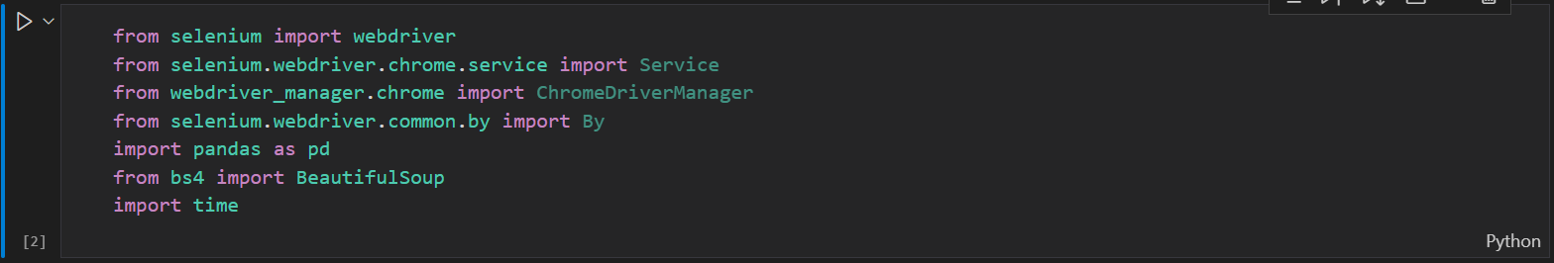

Initialize WebDriver and provide URL to scrape







Provide HTML tag elements and CSS selectors were data to be scraped is located

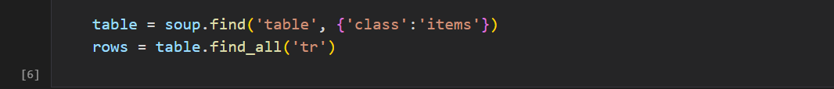

Initialize empty lists to store the data

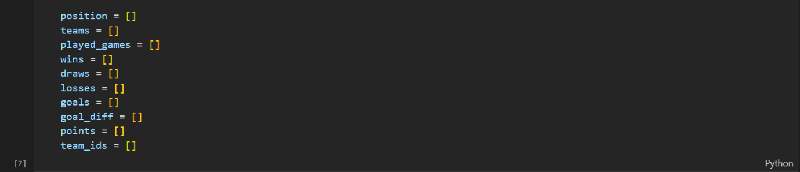

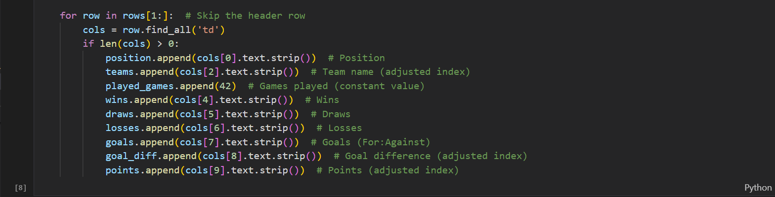

Save the scrape data into columns to be saved in a pandas dataframe

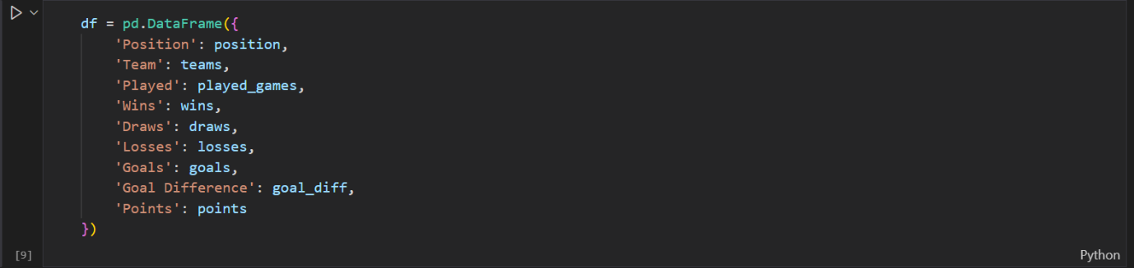

After running df.head(), we can see the league table has been scraped and saved into the data frame. Now we have to clean the team to show the proper team names. To achieve this, we will use df.replace()

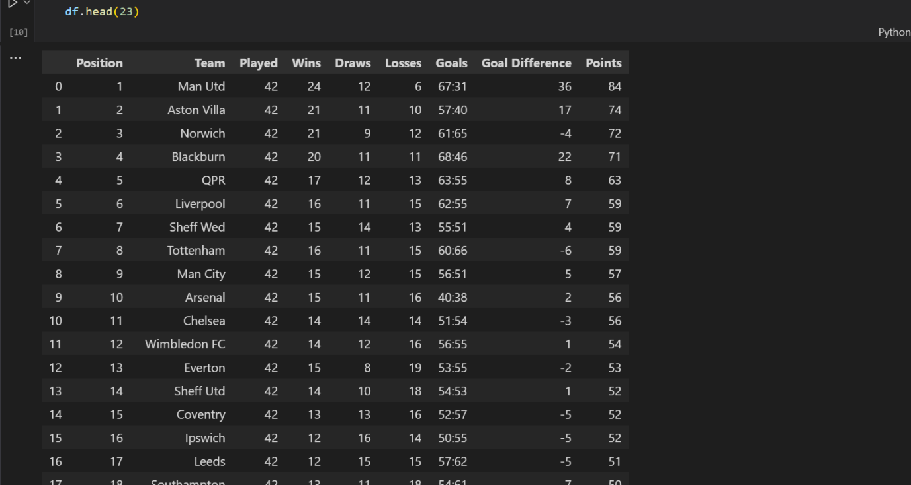

After we provide a dictionary of what team names to replace as the key and what team names to replace with within the df.replace(), we are good to go. After that, we close the driver. All league tables follow the format provided for scraping. We will return to the league tables after seeing how other datasets needed for the project were scraped.

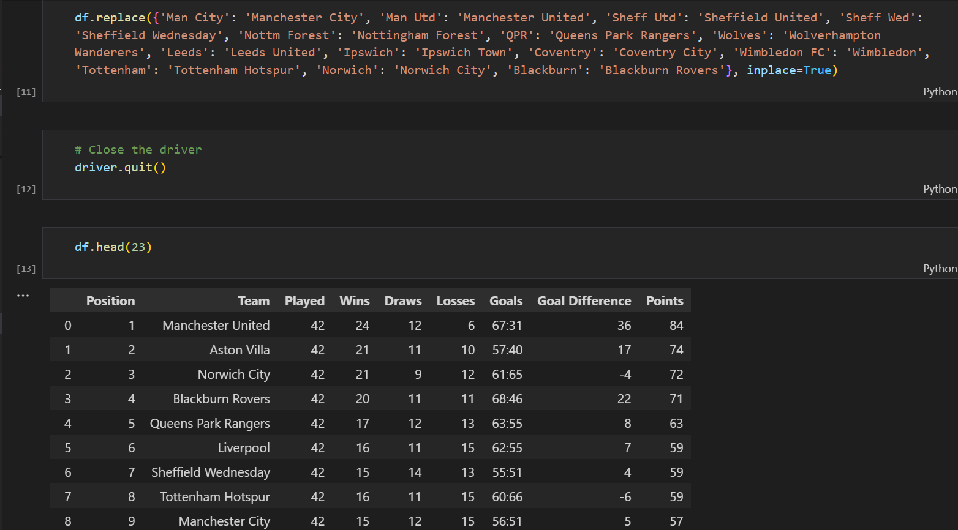

1. **Most Wins in the English Premier League**

This dataset was extracted to help have a general sense of every team who had played in the EPL in the duration of our analysis (1992/1993 – 2023/2024). This dataset was gotten from the official Premier League website. Let’s see how to achieve that.

So again, we import the libraries, initialize the WebDriver, provide the URL and set a time to let the page load.

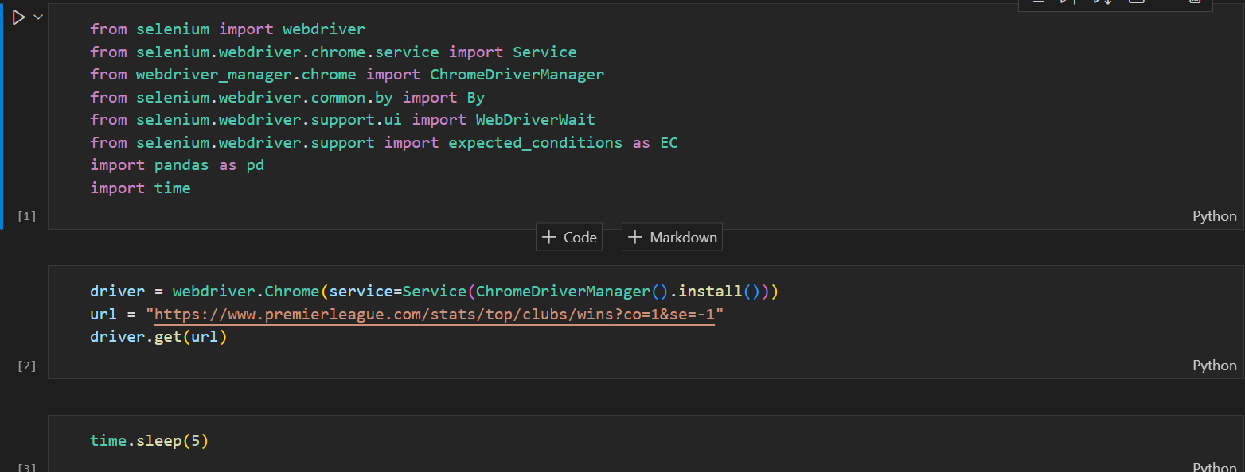

Defined a function to create a team id by extracting characters from the team’s name. Then initialize an empty list for the data to be scrapped.

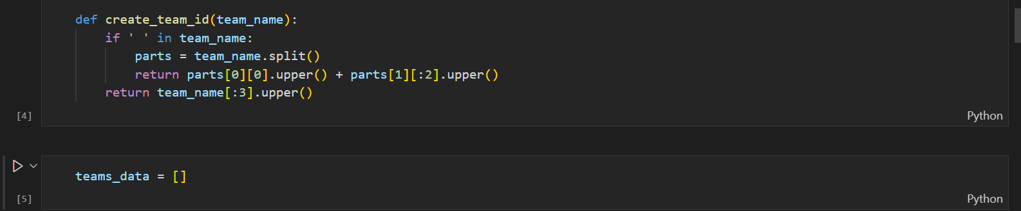

The pages where the data stored had a next page button so some logic was added to detect when the last page had been reached and also to interact with the next page button. This time we use the CSS Selector to locate the data to extract.

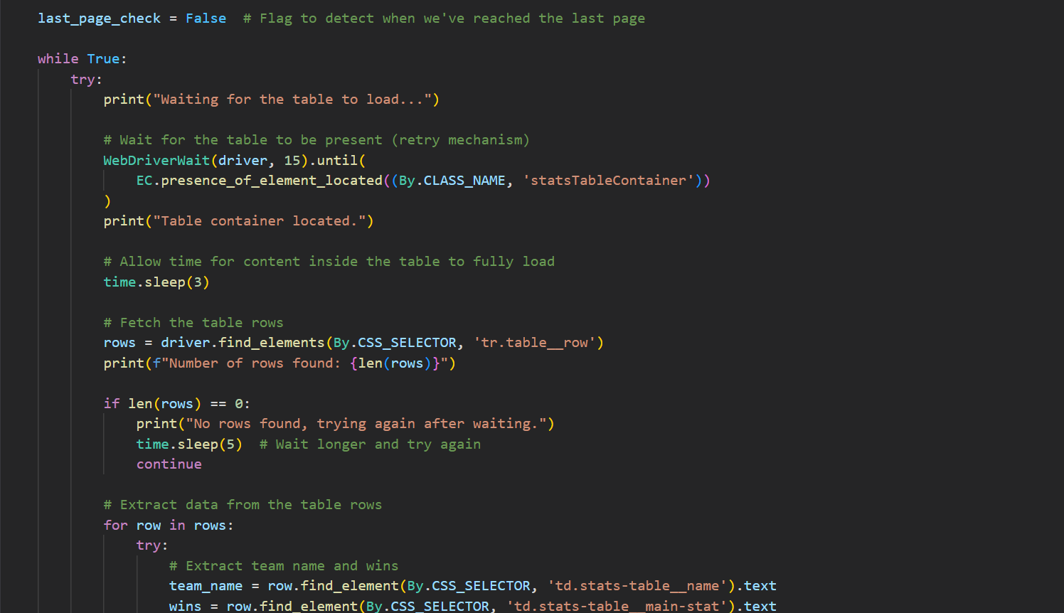

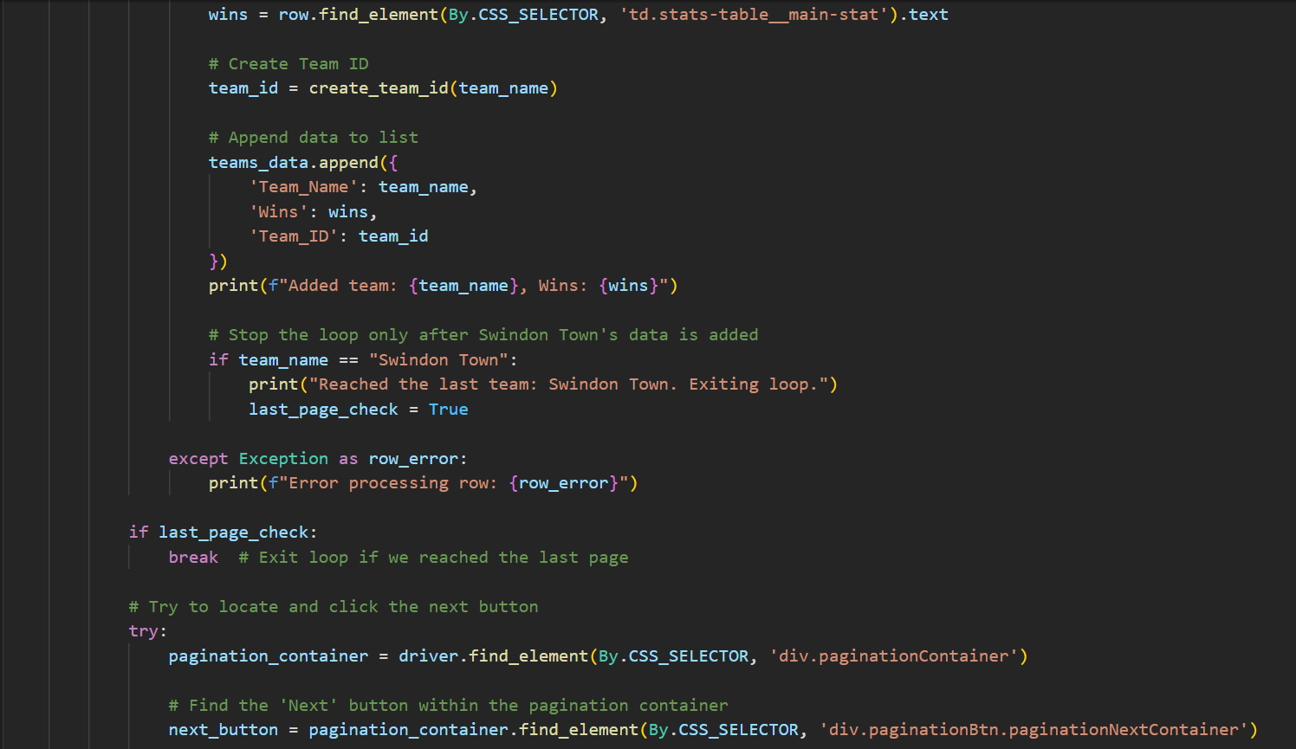

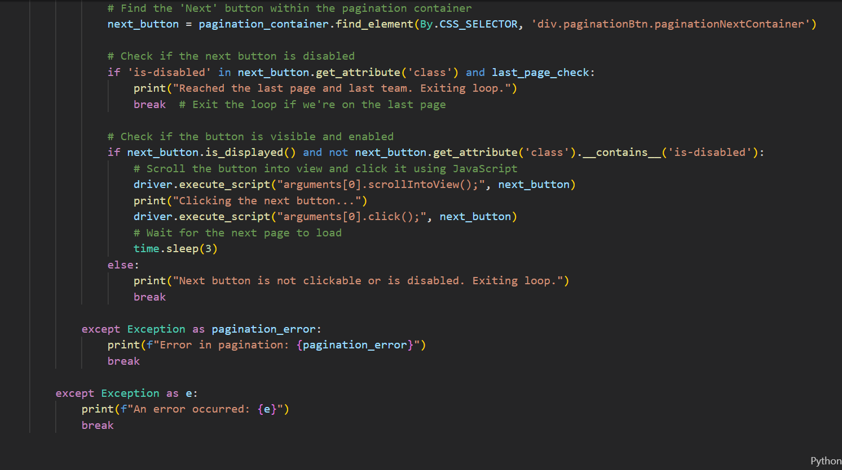

Now we save the results in a data frame.

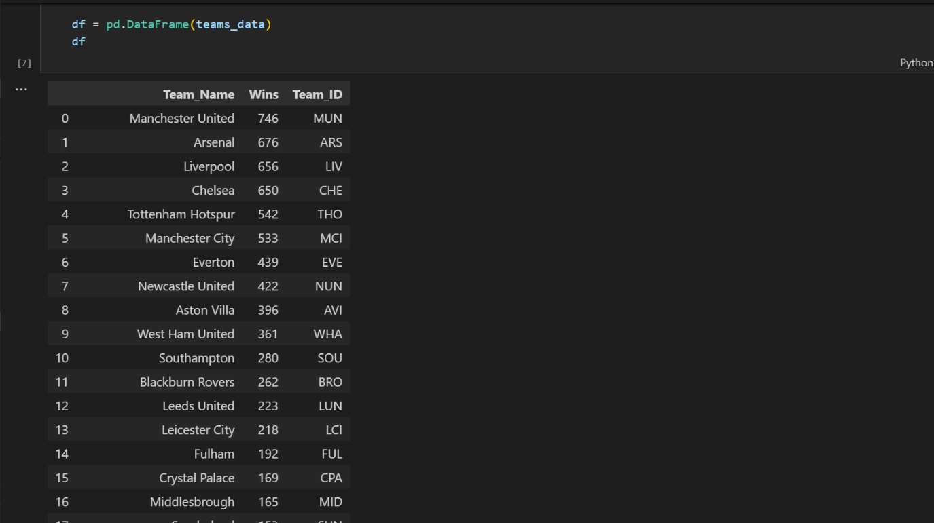

On closer inspection, we can see there are some issues with the given Team ID for some teams. For example, Stoke City and Swansea City have the same Team ID (SCI). That is because in the definition of the create team if function, the instruction was to extract the first character from a team name and the two characters after the space if the team’s name contains two words. Also for Brighton & Hove Albion, the team id came out as B&. We will have to fix that.

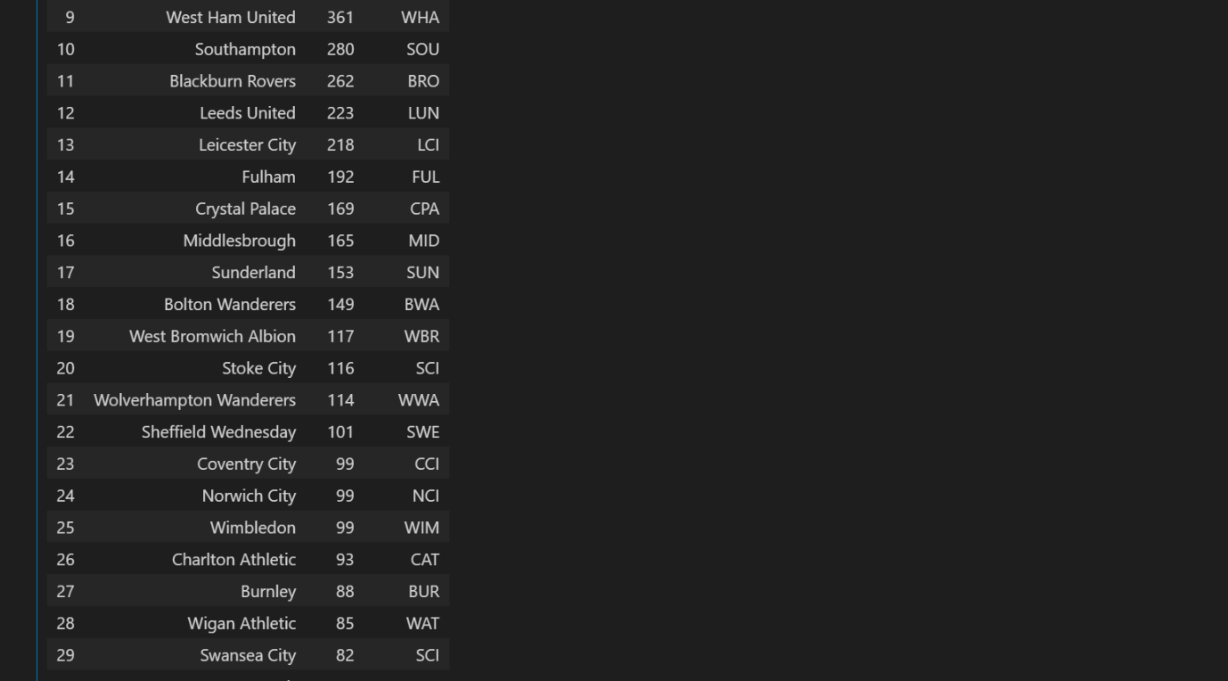

We will achieve this by using df.loc and providing a dictionary of replacements.

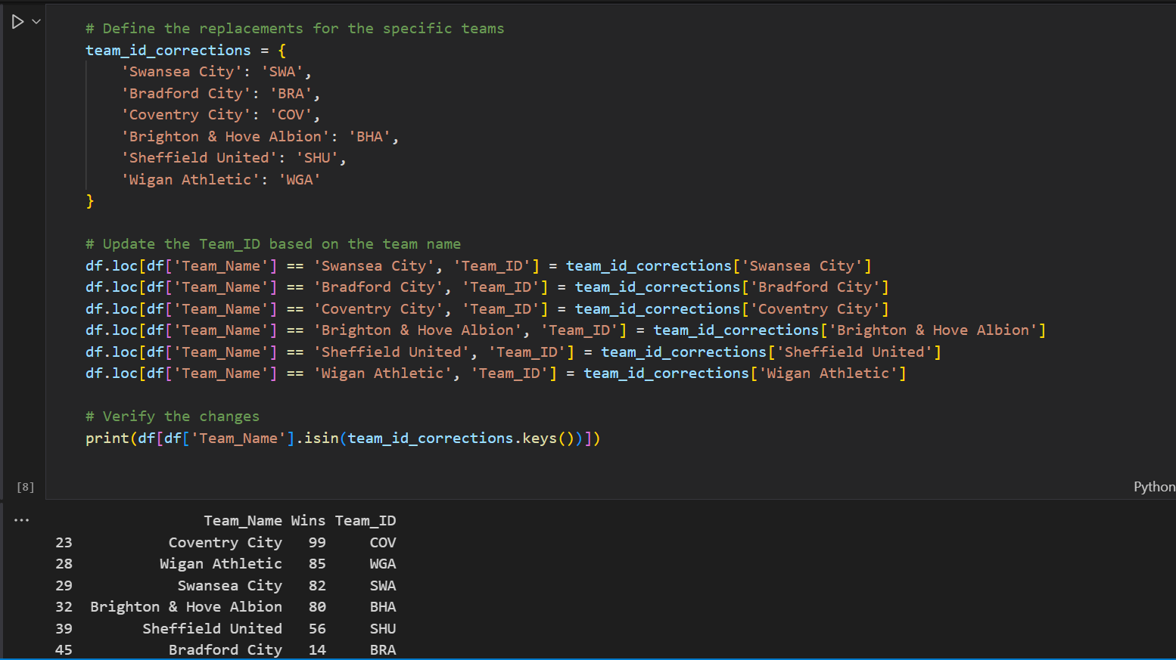

We can see the changes by running df  
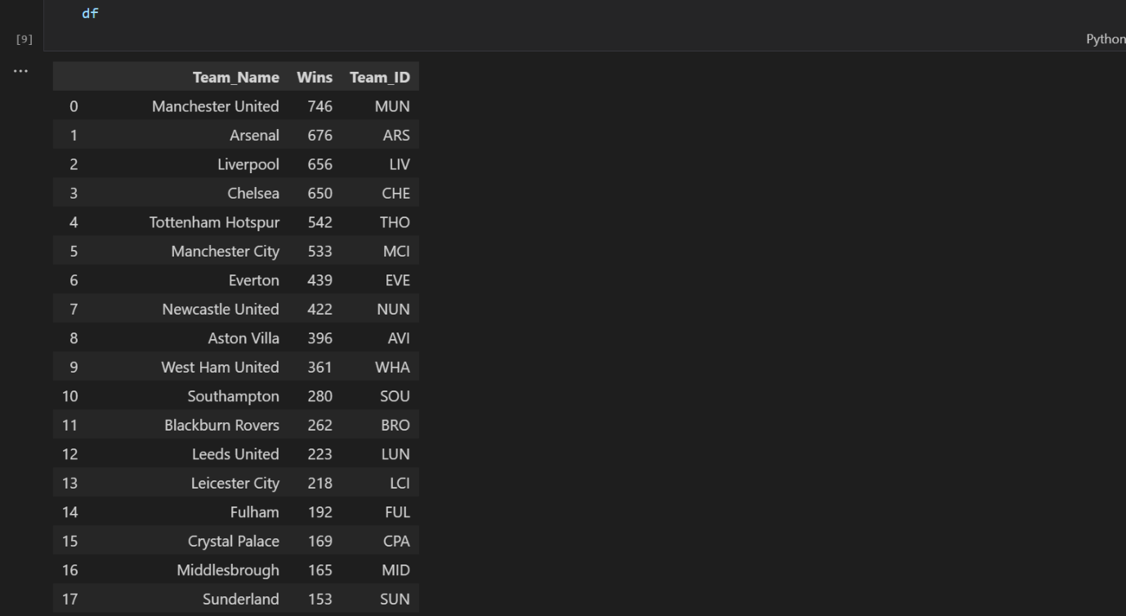

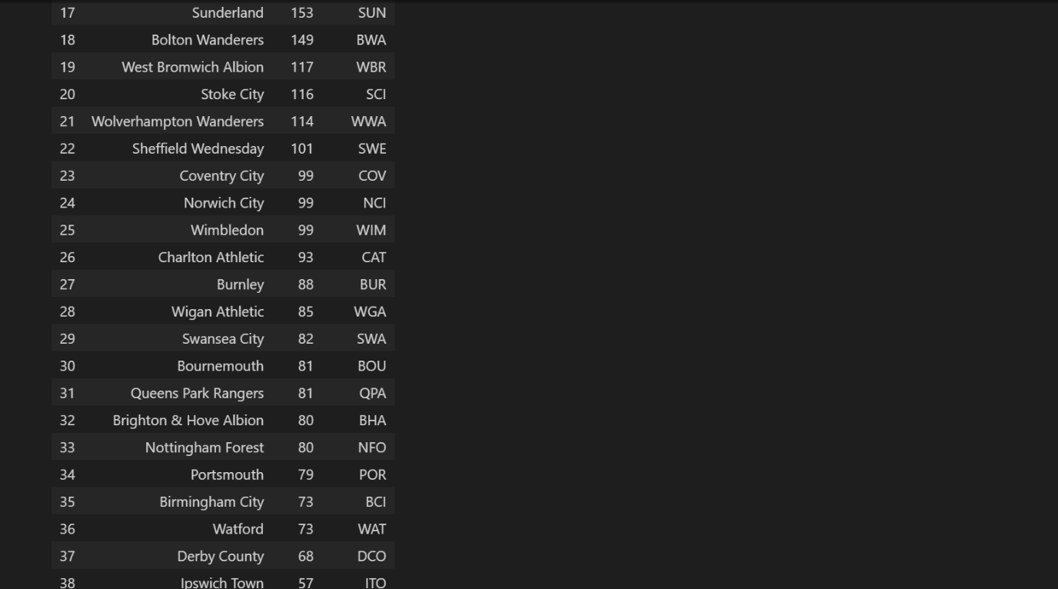



Next thing, we will create a rank column to rank the teams based on their wins

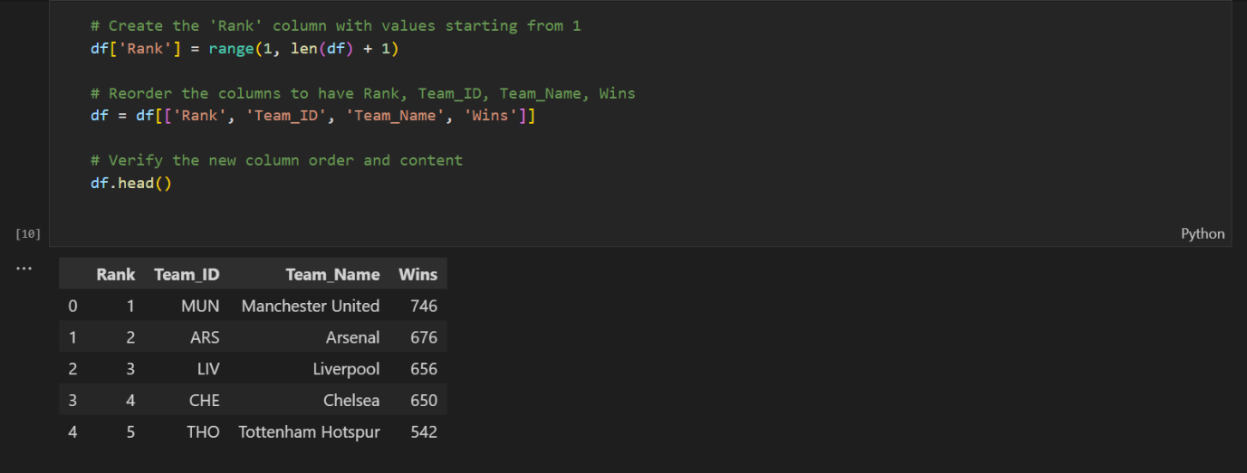

Now we have Team IDs which will come to play later during the analysis. We can export the data frame to a .csv file.



1. **Manager Team Table**

The next dataset to be retrieved is a list of managers and teams managed. We will also be creating a manager id to identify a manager’s time within a team because managers over the course of their career’s have managed multiple teams even rivals (I’m looking at you Jose Mourinho). This dataset was gotten from the official premier league website.

Again, we import the necessary libraries, initialize the WebDriver, set a timer to let the page load

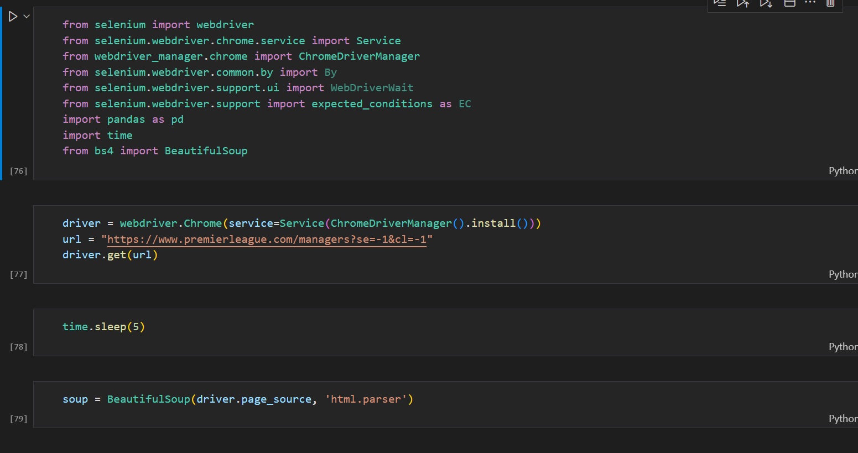

Now we create variables for the tables and the rows specifying what HTML elements we are targeting. We then initialize lists for the manager’s name and the team names. Then we saved the scraped table into a data frame.

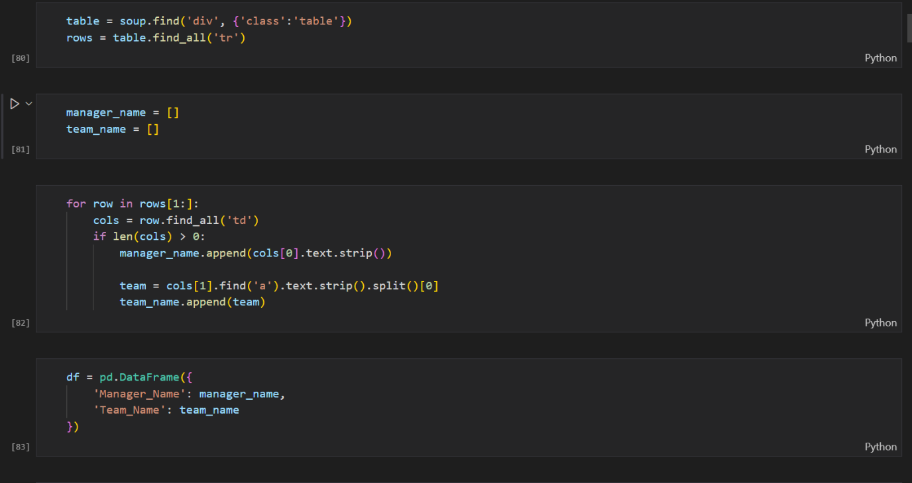

Then we load the previous dataset we scraped



A bit of data cleaning will be needed because of the team names are the short form of the team names. We’ll use a function and some logic to correct that.

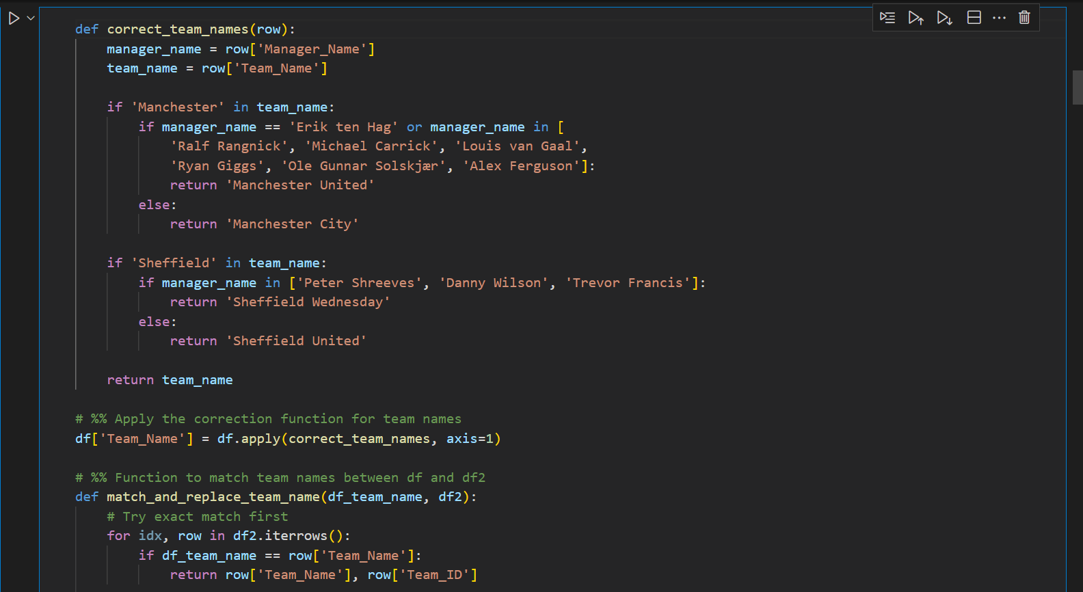

After applying the correction to the team names next thing is defining a function to generate a Manager ID for each tenure a manager was in charge of a team. The vision for the Manager ID is to use characters from the manager’s name, the team he is managing in that tenure and the count of the alphabetical characters in the manager’s name.

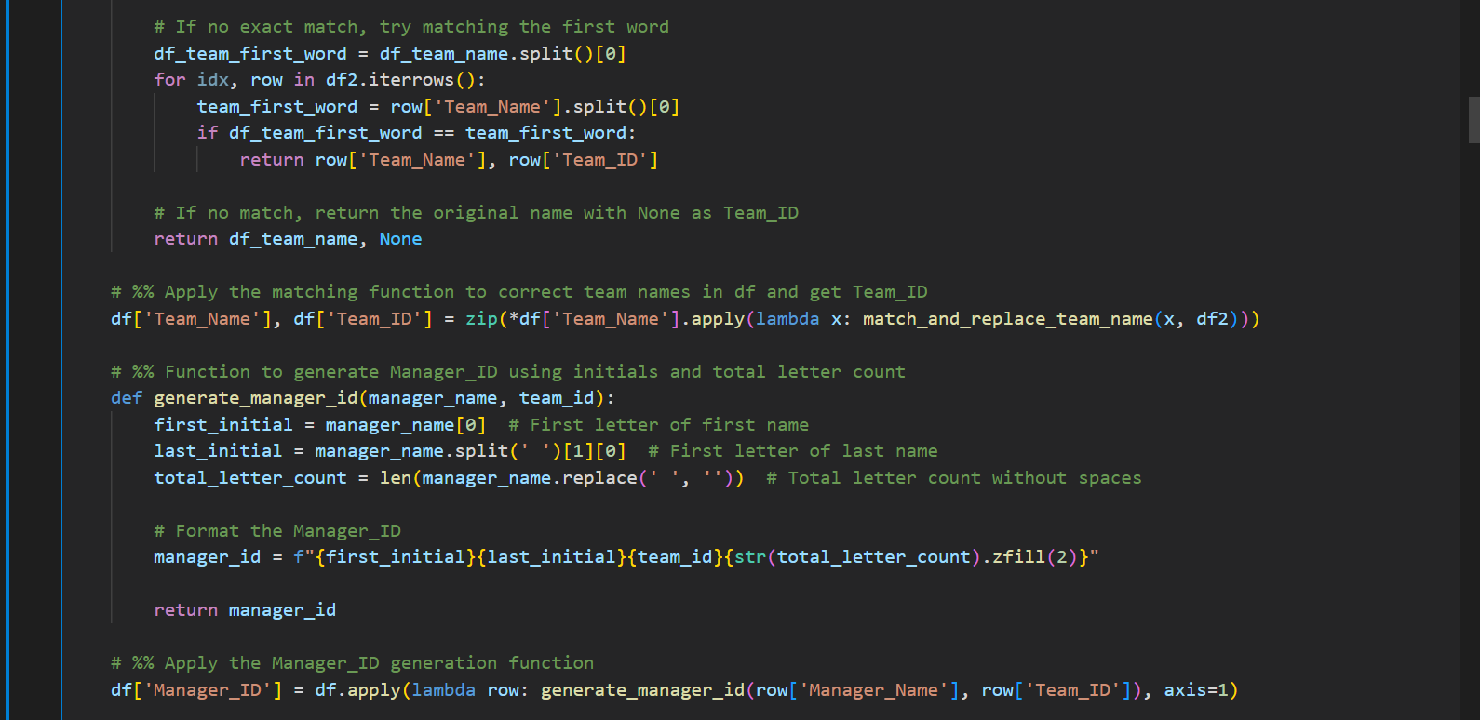

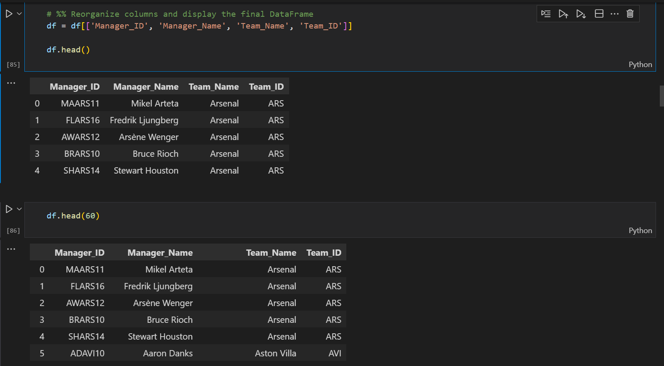

Great, the Manager ID has been created but there’s a problem with this dataset. We can see Unai Emery’s time at Aston Villa has been recorded but his stint at Arsenal is missing. We’ll see this pattern is common upon closer look at the dataset.

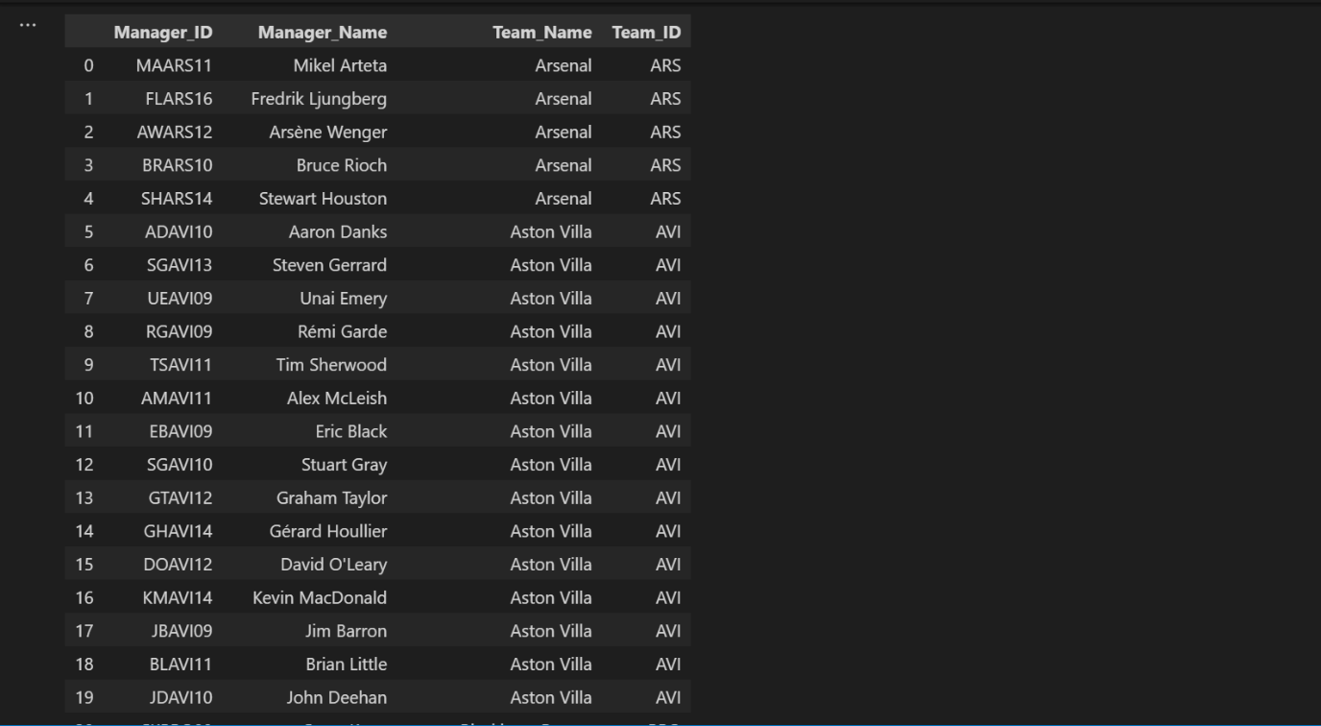

Even the great Jose Mourinho’s stint at Chelsea is missing.

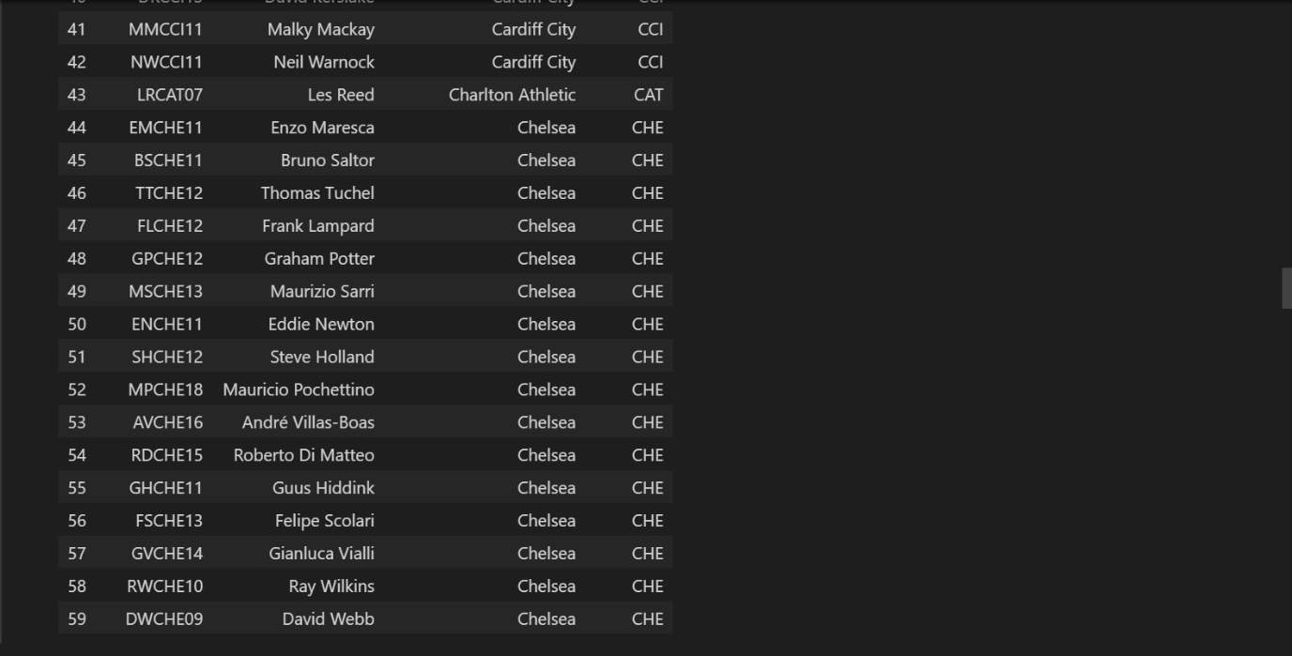

Also looks like we will have a bit of data cleaning later. The second manager’s name is the full name of Bruno Lage but we should use names we are familiar with.

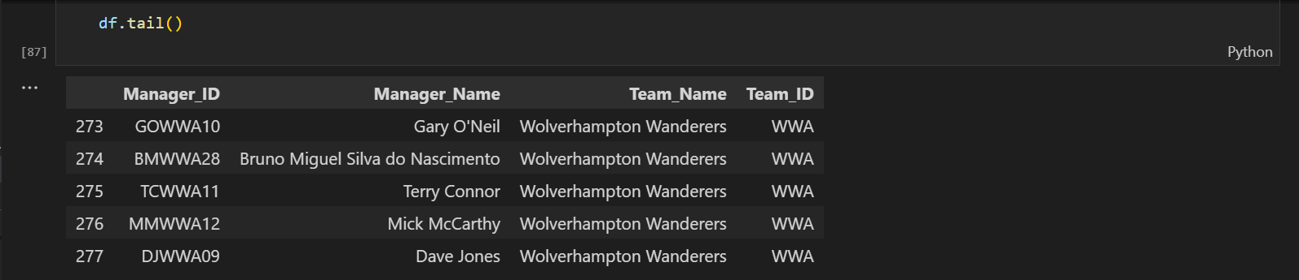

Let’s take a look at Manchester United’s managers included in this dataset

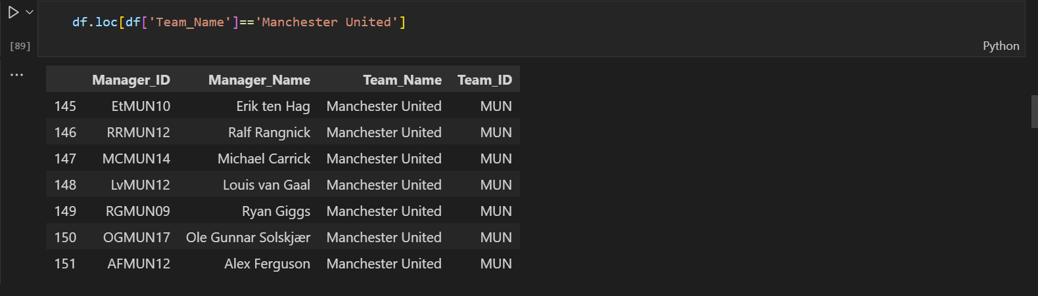

Jose Mourinho and David Moyes’s stints are the club are not recorded. David Moyes, I could understand (most of United fans would agree) but Jose Mourinho helped restore a bit of dignity at the club seems unfair to not include him. Let’s check some other teams.

Wow Barnsley don’t have any manager recorded that can’t be right.

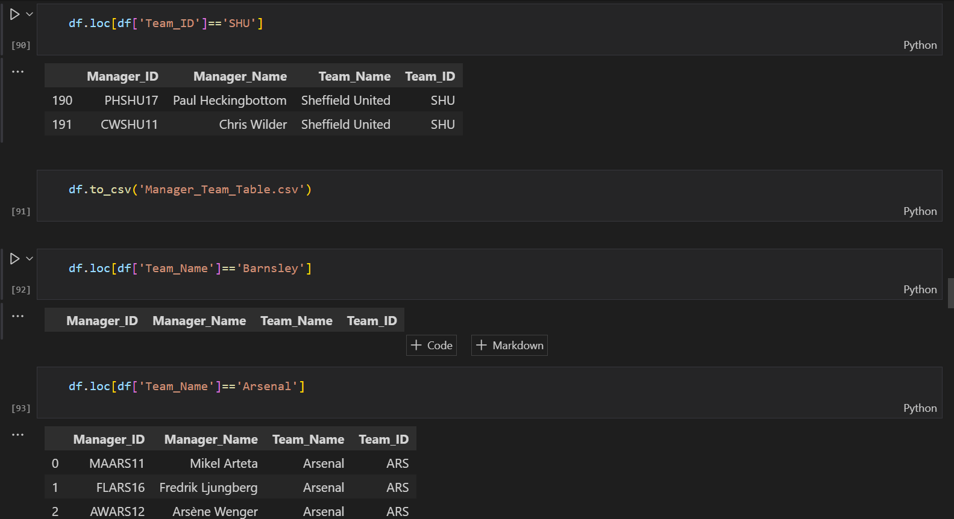

Okay so Jose Mourinho is included in this dataset but only for his stint at Tottenham Hotspur.

I can’t imagine he would be too happy with this. We should clean those names right about now.

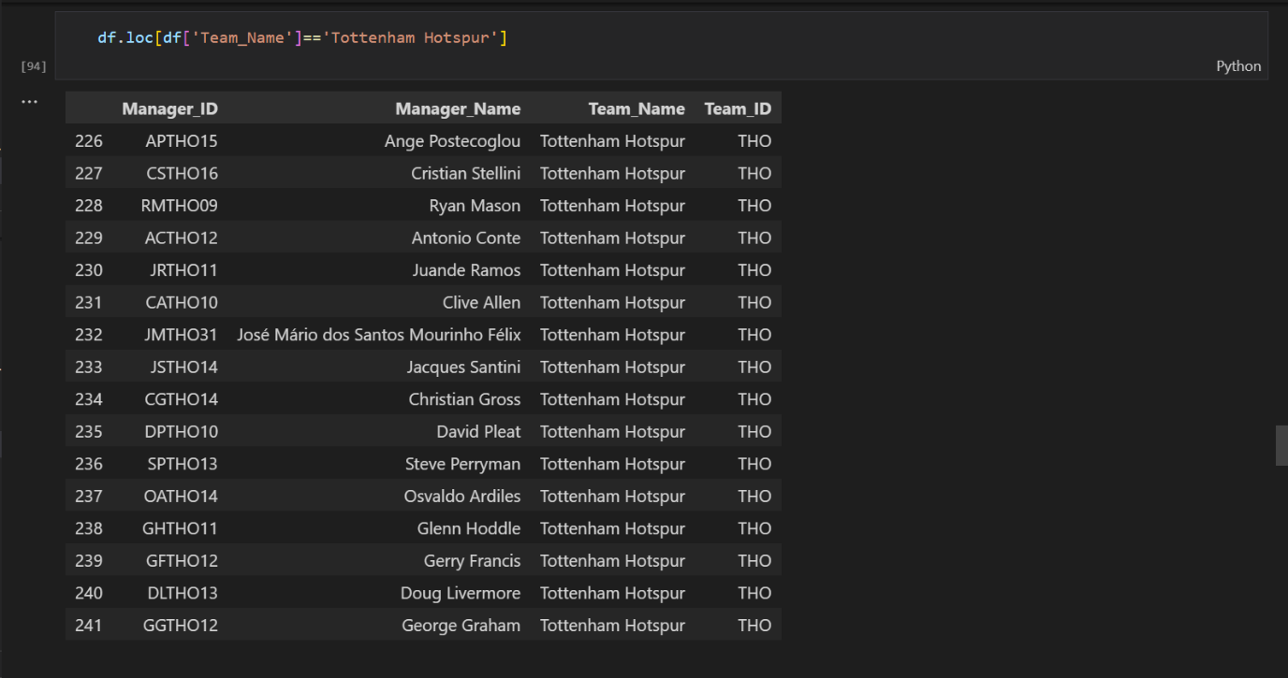

We will clean the names using a dictionary and the df.loc method again. Here’s how to achieve this:

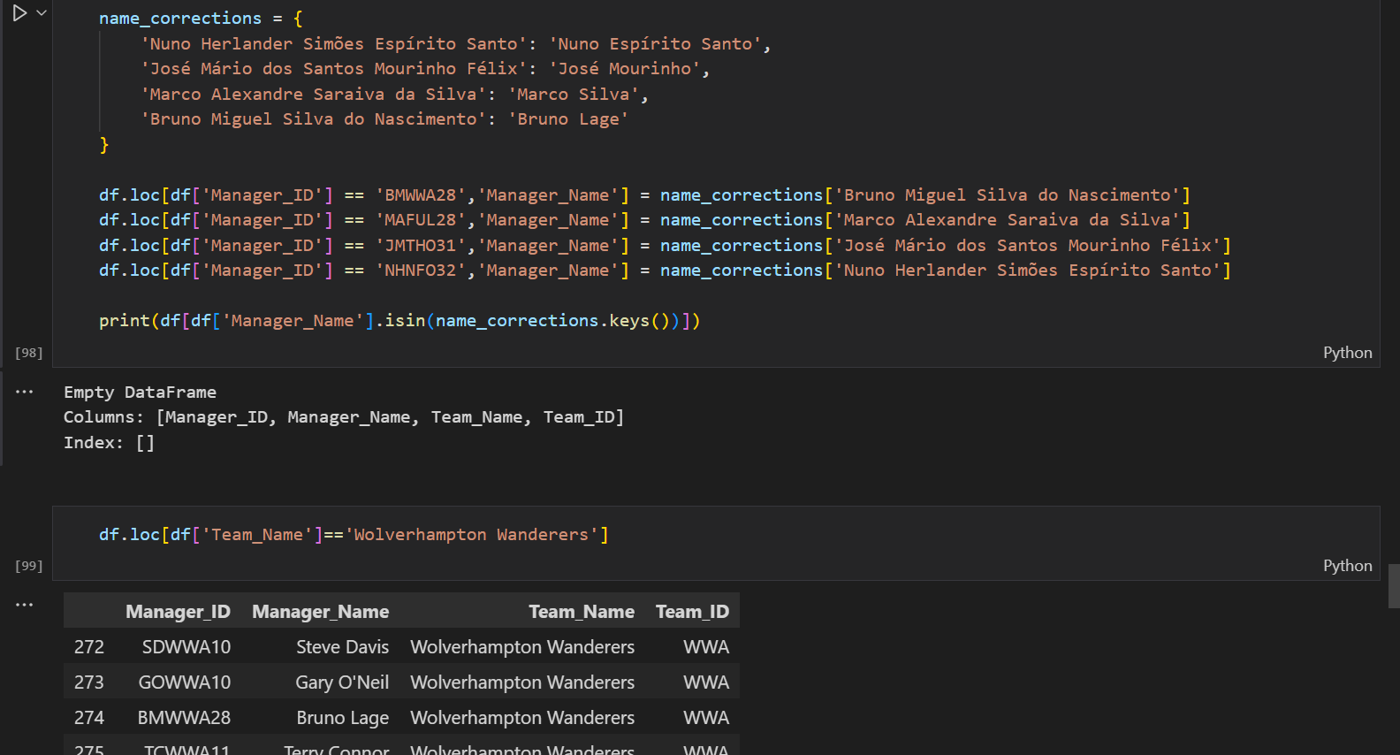

Okay great, seems Bruno Lage most recognized name now appears in the appropriate place. Let’s check the others.

We won’t be using this dataset but its good to at least defined a function to create Manager ID’s. Next will be the Manager History Table which should only contain managers who have managed in the EPL.

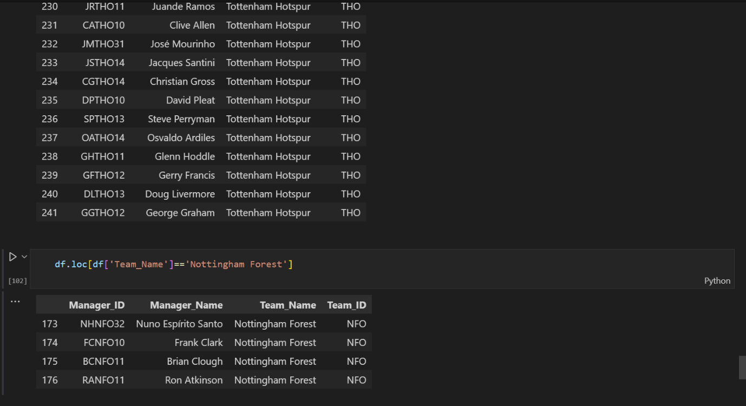

1. **Manager History Table**

This is the main dataset needed that would contain the manager’s name, appointment date, end of tenure, time of post, matches managed, wins, draws, losses, and PPG (points per games). This is broken into two steps; first step was to only get managers that had managed in the EPL from 1992/1993 to 2023/2024. This was how to achieve that:

The dataset was gotten from the Transfermarkt website.

First, we import the libraries, initialize the WebDriver and initialize an empty list to store the scraped data.

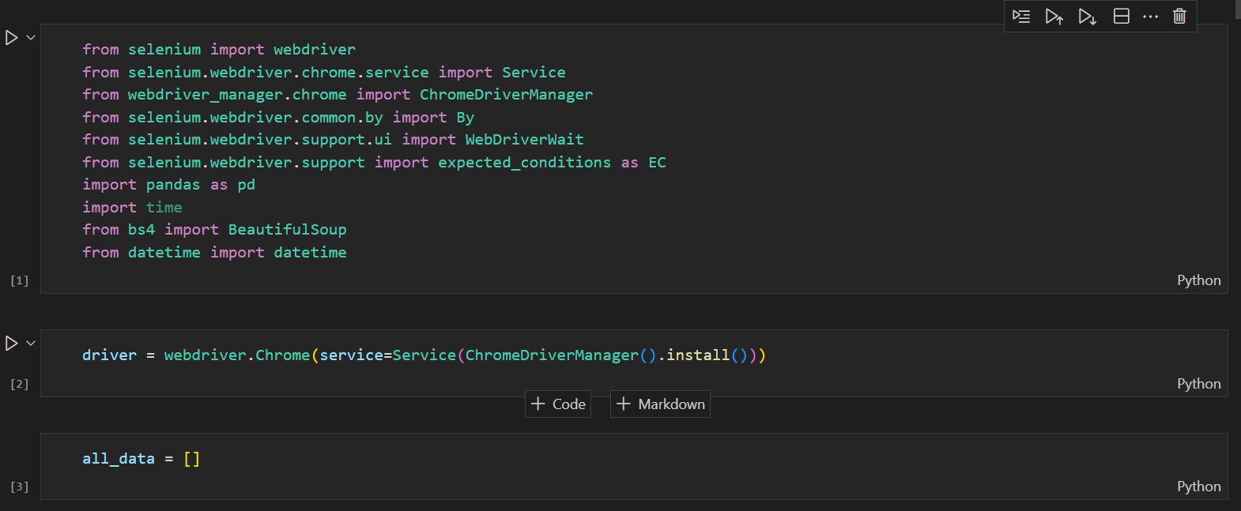

The staff history of Transfermarkt are stored differently for each team. We would also need the team history of each team to get what seasons they played in the EPL. Going to different pages every time would be a lot of work so I defined a function to handle this. This works because Transfermarkt uses a unique number to identify a team. We will see how this comes into play later.

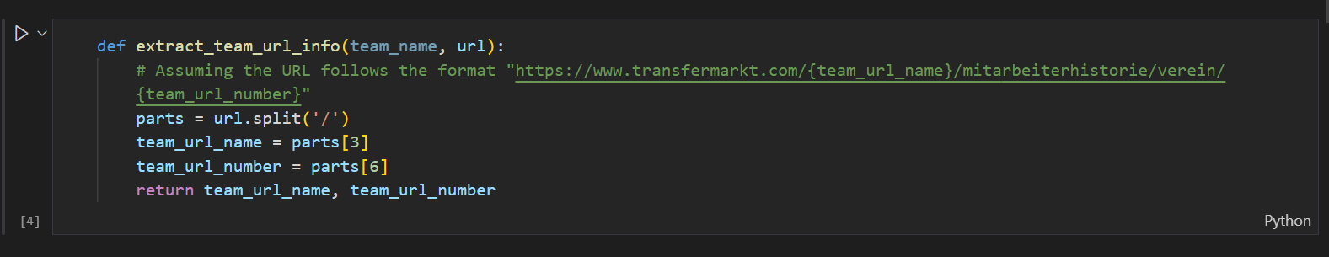

Since the URLs for different teams had the same format, this works fine. We will also create variables for the start date (the day the 1992/1993 season commenced) and the cutoff date (the day the 2023/2024 season ended).



We then create a dictionary of team names and their corresponding URLs

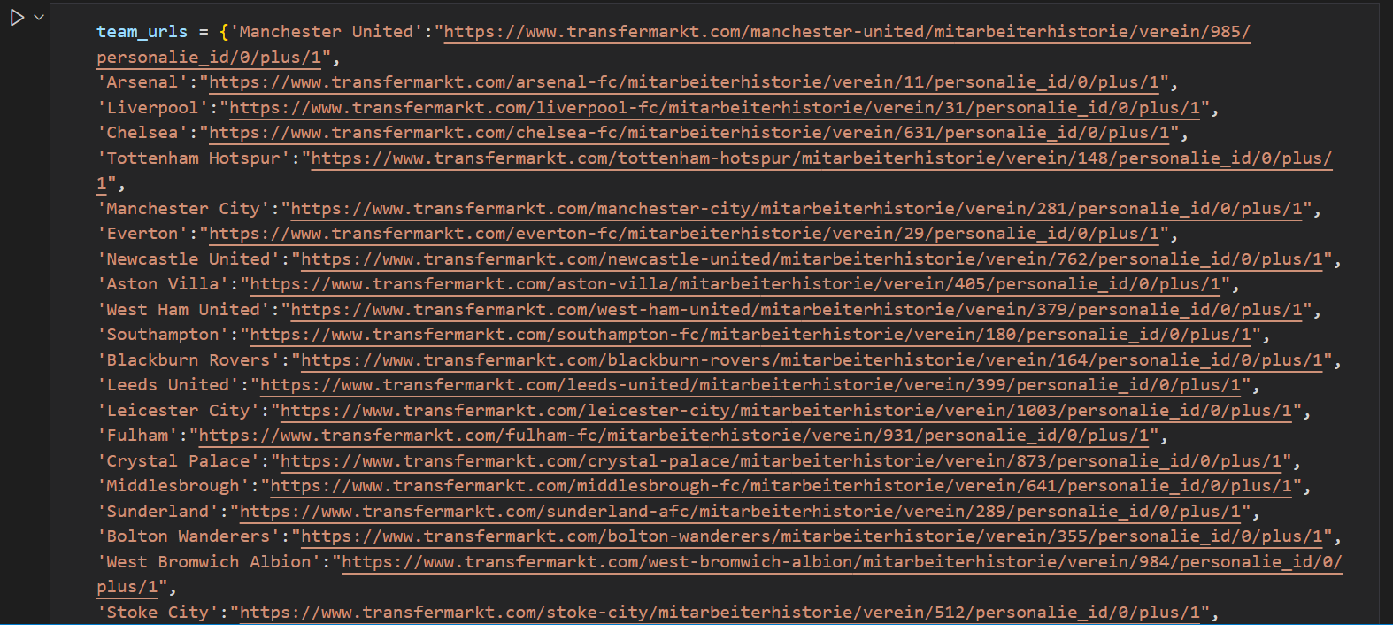

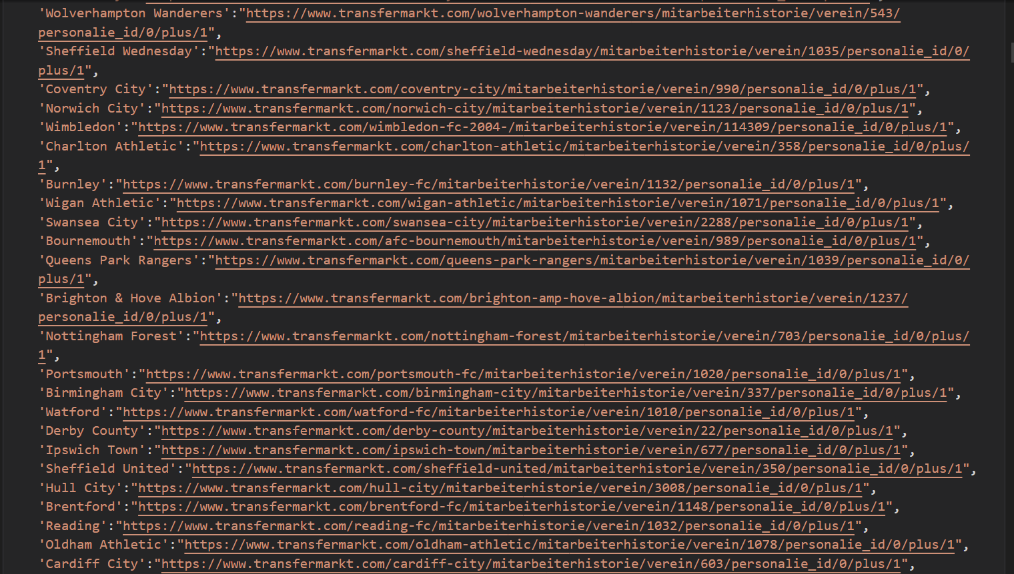

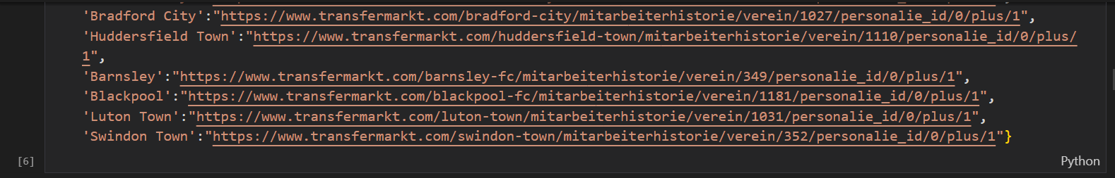

Then we define a function to properly parse dates

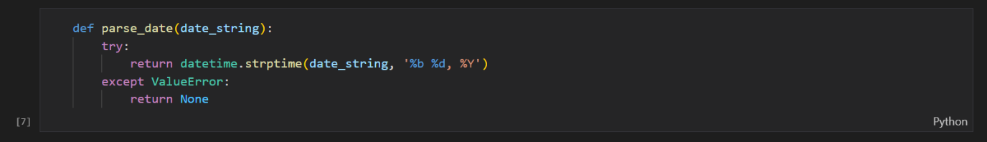

Then another function to scrape the team history table using the team URL name and team URL number to get the seasons the team was in the premier league

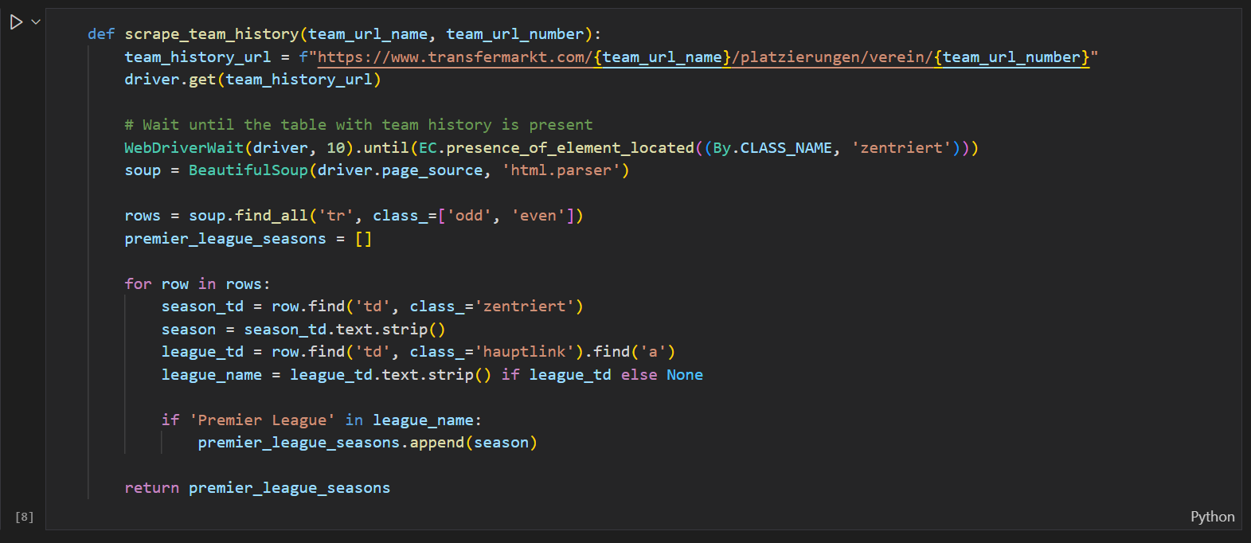

Then another function to scrape the staff history

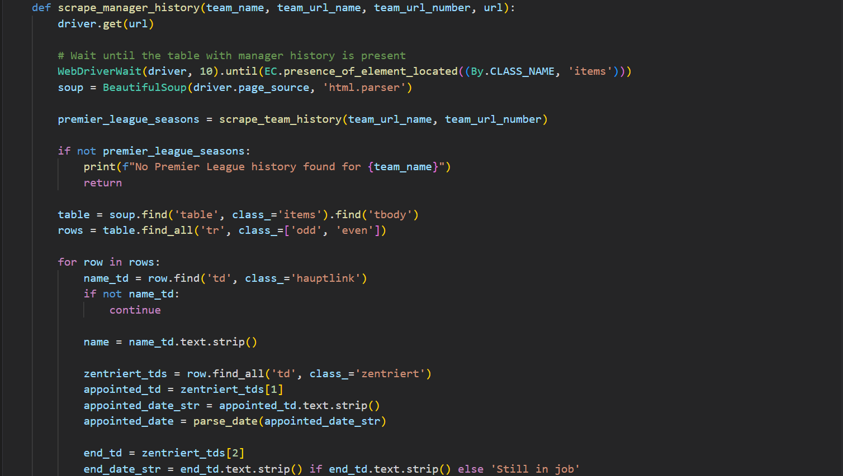

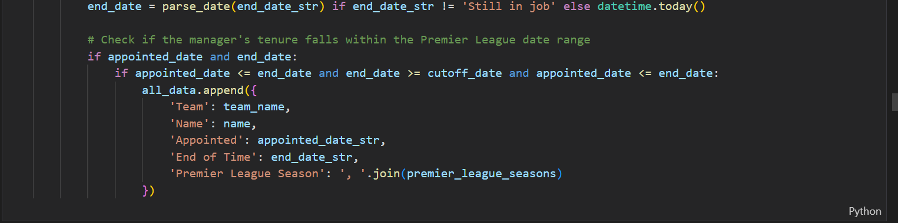

Then we put the functions to work to scrape the data we need.



Then we store the scraped in a data frame. Let’s the results. What we are expecting are the team name, the manager name, the manager’s appointed date, the manager’s end of time in charge and the premier league seasons the team has been in the English Premier League.

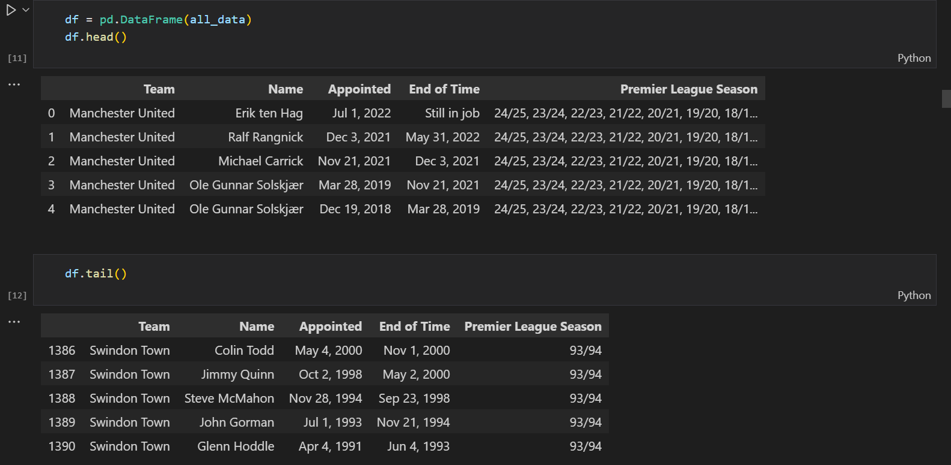

So, my reason of including these seasons is to confirm if the manager actually managed the team during their time in the league. For example, for Swindon Town: Colin Todd, Jimmy Quinn, Steve McMahon and Glen Hoddle are not needed for our analysis since Swindon were only in the league for the 1993/1994 season.

Next is to filter out the managers we won’t need for our analysis. We will need to define some functions for this. The 2019/2020 season is special because of the pandemic other than that all the other seasons follow the same timeline. So here we will create date ranges for each season and check if the manager’s appointed and end of time falls within these ranges.

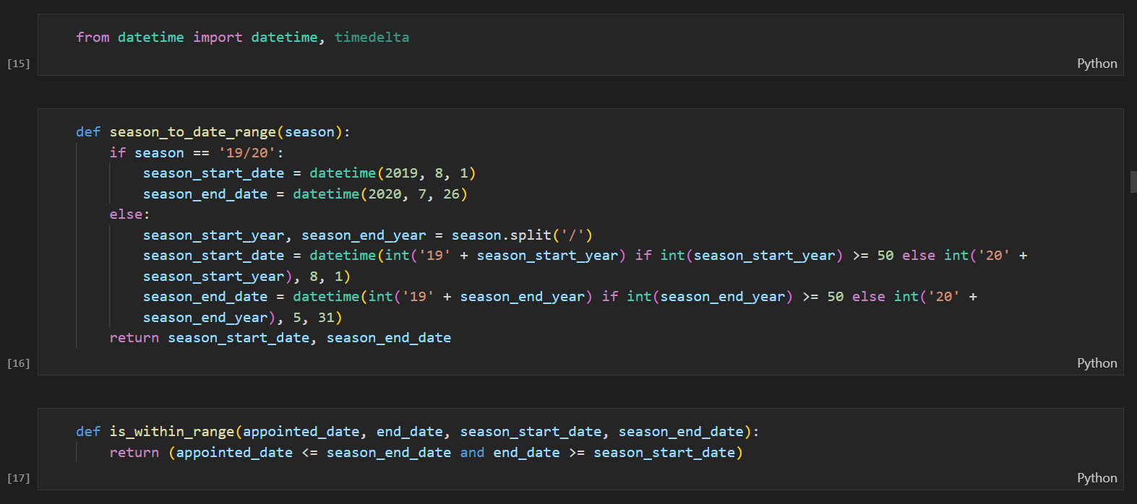

Then we define a function to filter the managers based on these ranges.

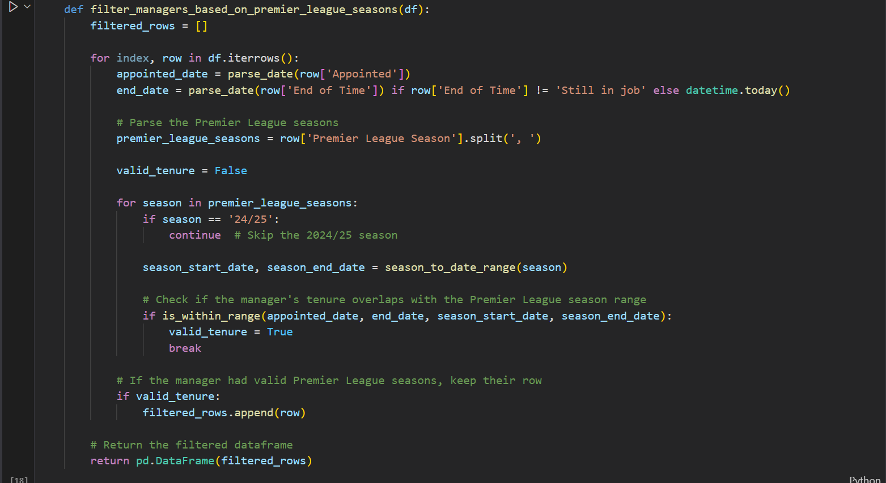

Now let’s see the results

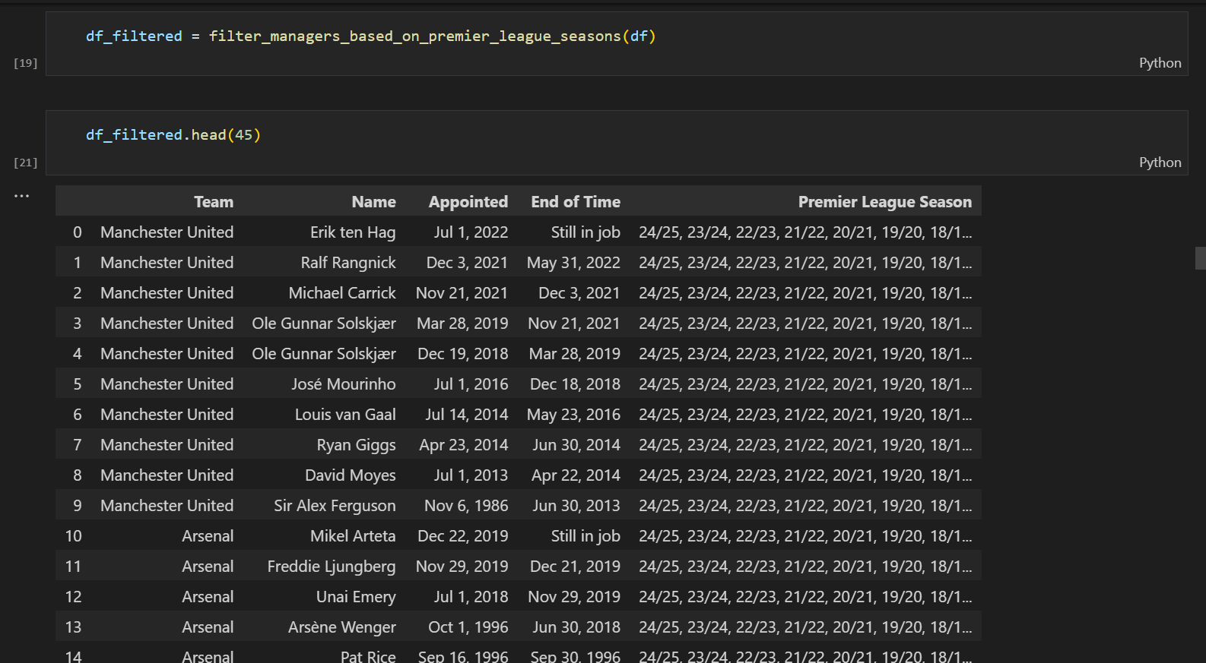

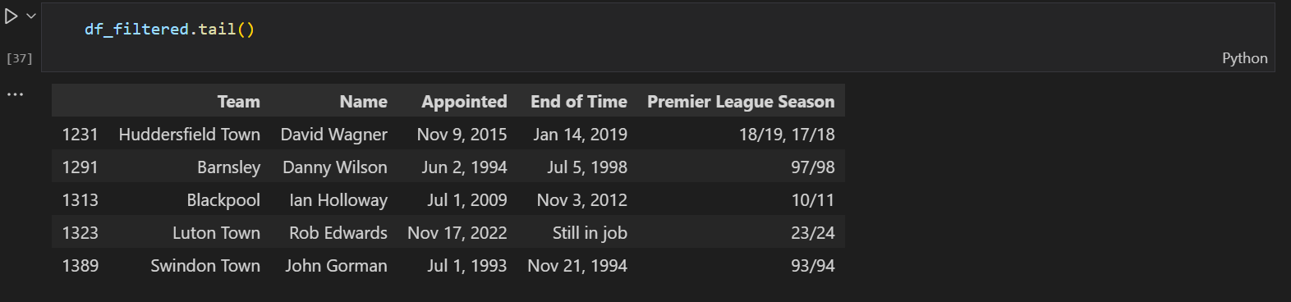

Yes, now we only have one entry for Swindon Town. Let’s check for Ipswich Town.

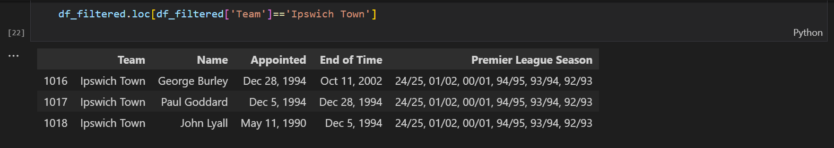

Yes, that checks out. Great now let’s export this and get to the real Manager History table.

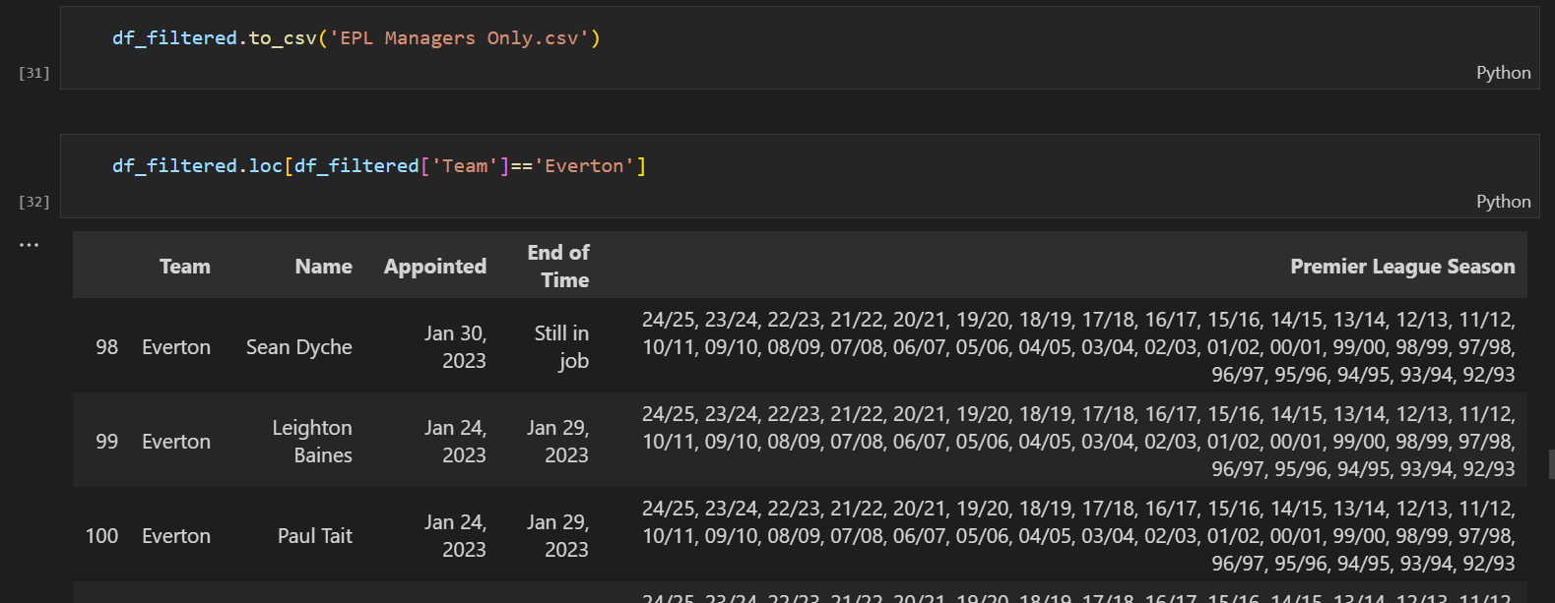

The following steps are largely identical to the ones previously enumerated. Let’s have a look. First, we import the necessary libraries.

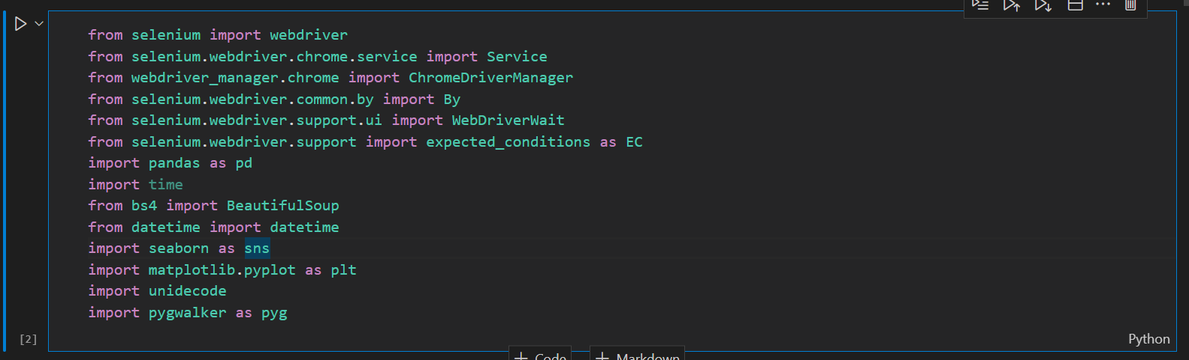

We then create a dictionary of team names and their corresponding URLs







Next, we initialize an empty list to store the data, define a parse date function like earlier and initialize the WebDriver

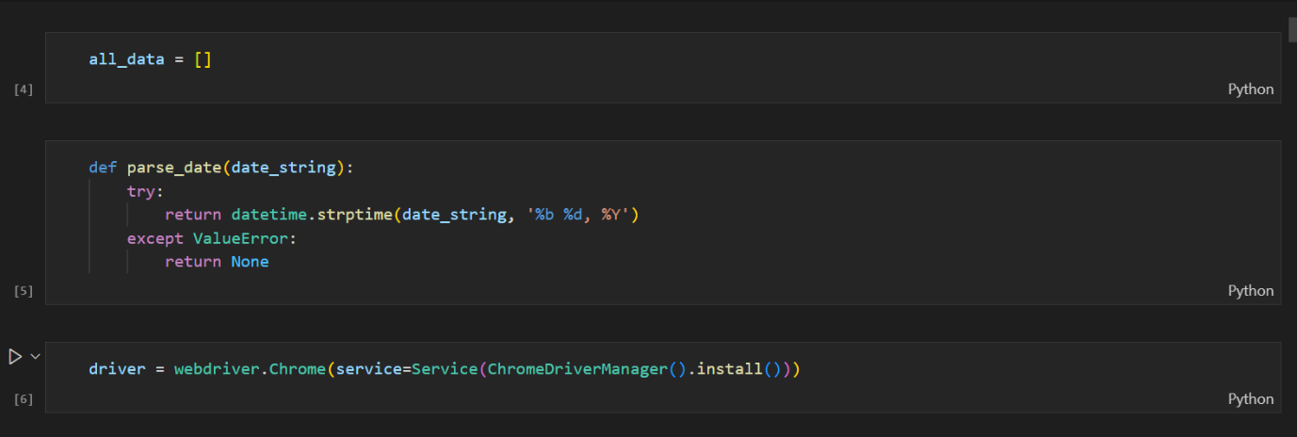

Next, we define a function to scrape the manager’s name, appointment date, end of tenure, time of post, matches managed, wins, draws, losses, and PPG (points per games), so it would be different from previously defined functions.

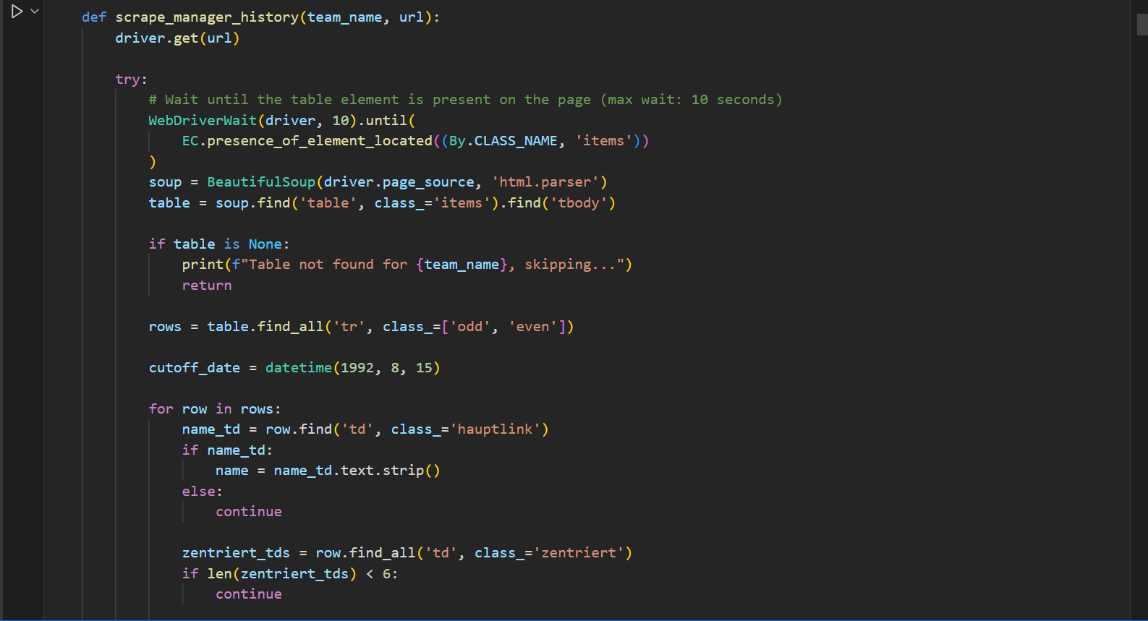

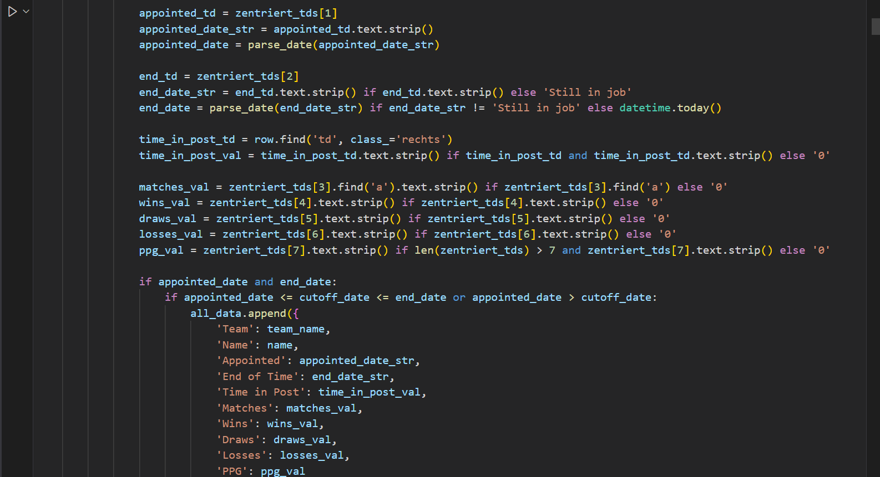



Then we let the function do its job and save the scraped data into a data frame

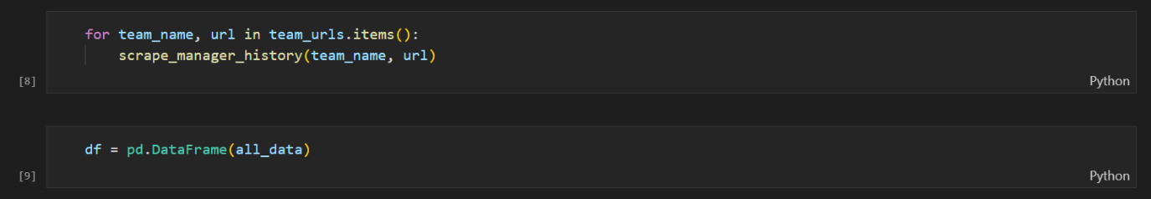

Let’s see the results:

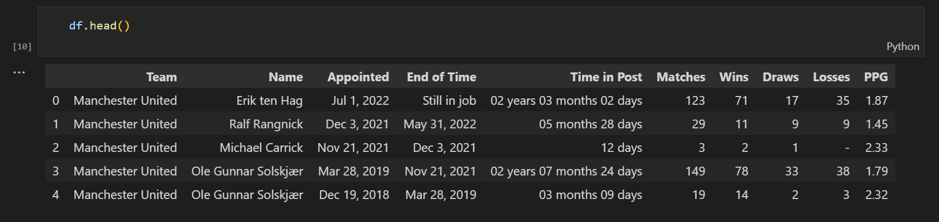

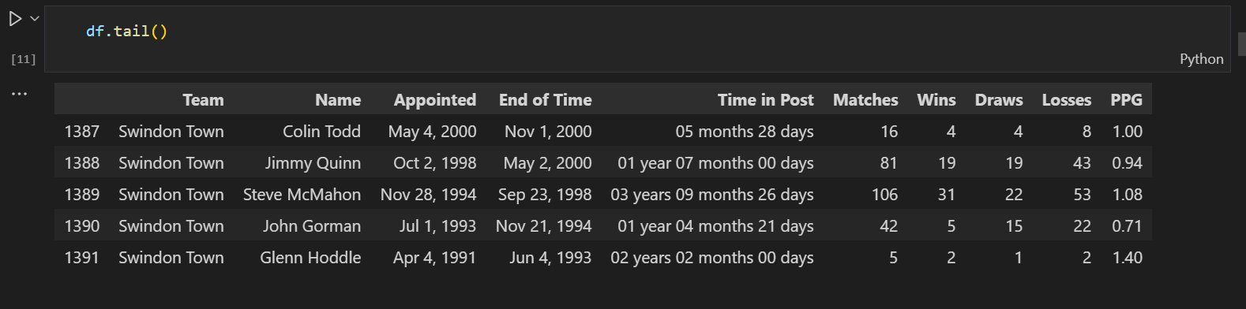

We’ll still have to filter some managers out. Now let’s see if all the teams included in the League Power Rank table are also found in this dataset:

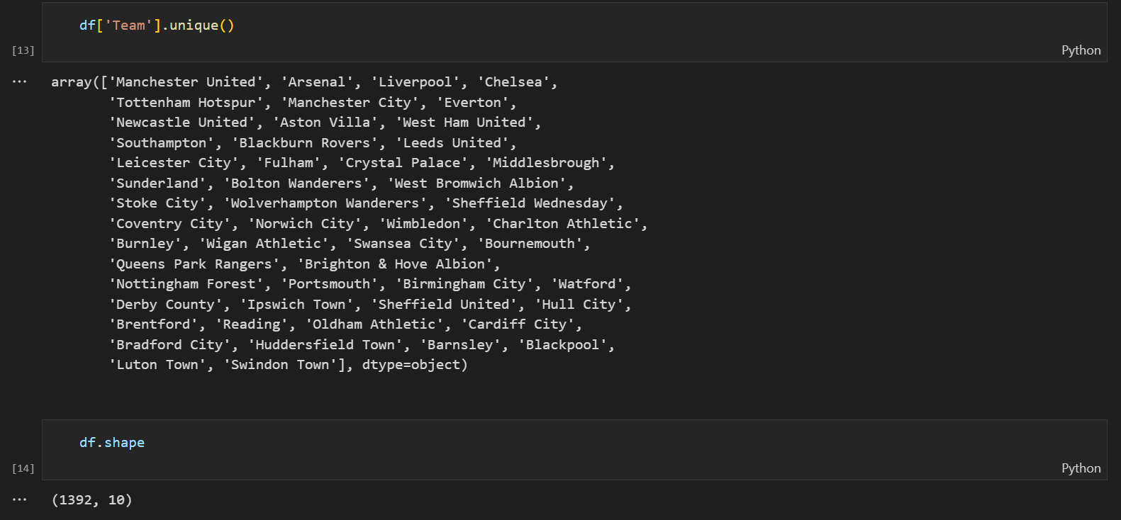

And we have 1392 rows and 10 columns within this dataset.

Now let’s filter out the managers we don’t need for our analysis.

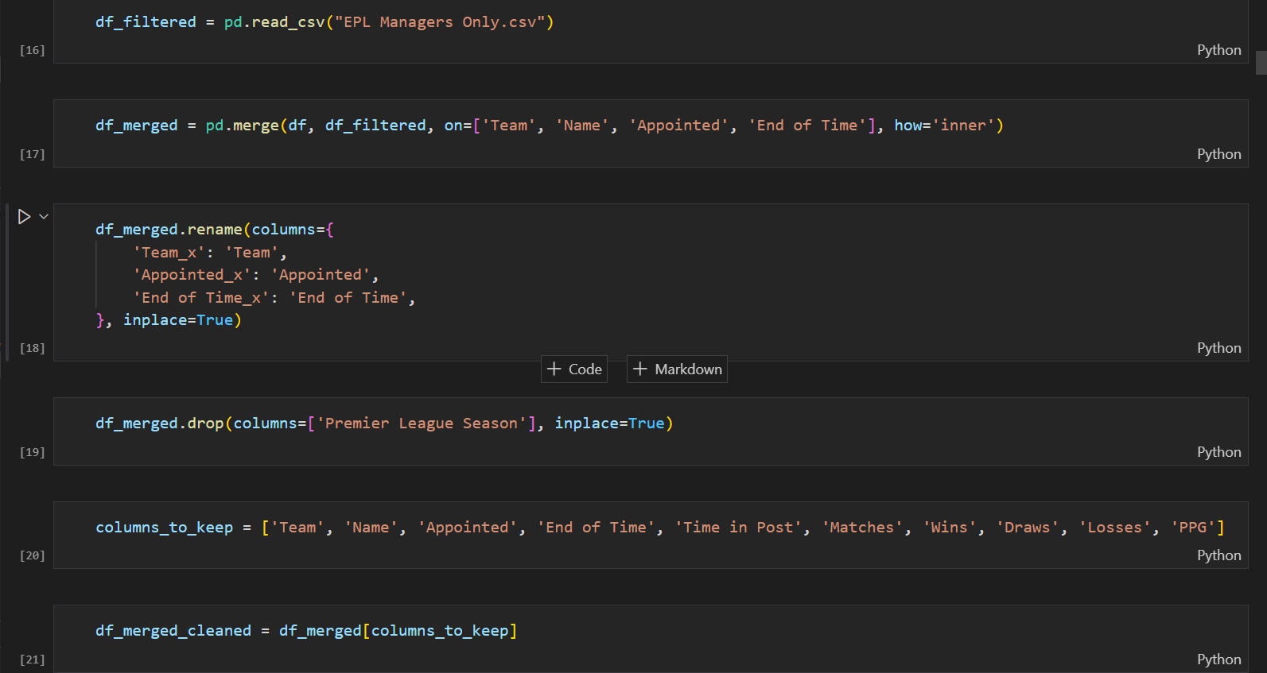

Now let’s see if we get the desired results. We’ll look in closer at Wimbledon to spot differences.

These are all the managers for Wimbledon in our original data frame:

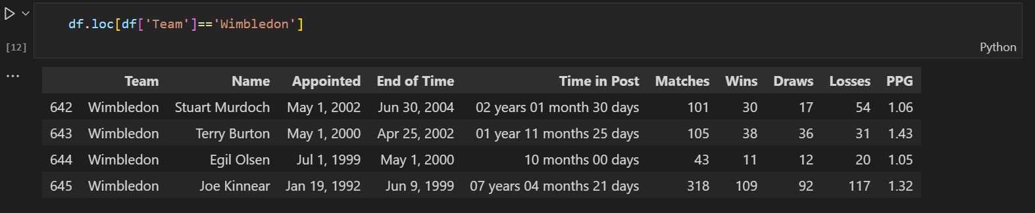

Now these are the managers in the filtered data frame:

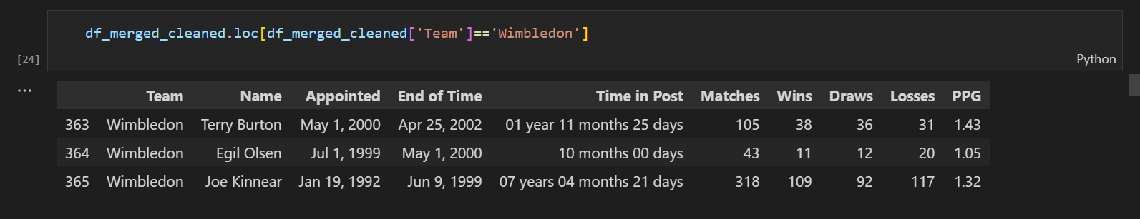

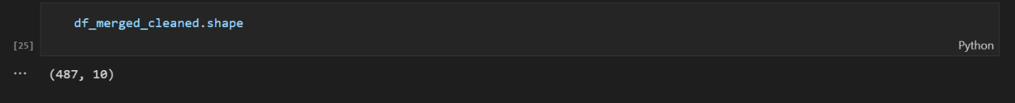

Notice we now have 487 rows and 10 columns.

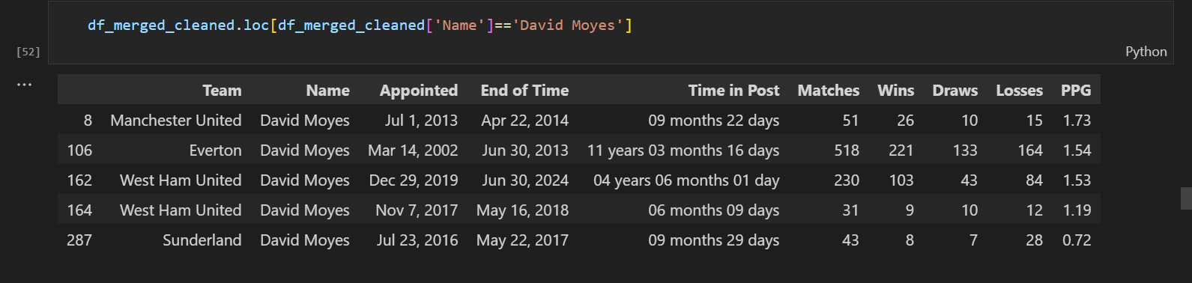

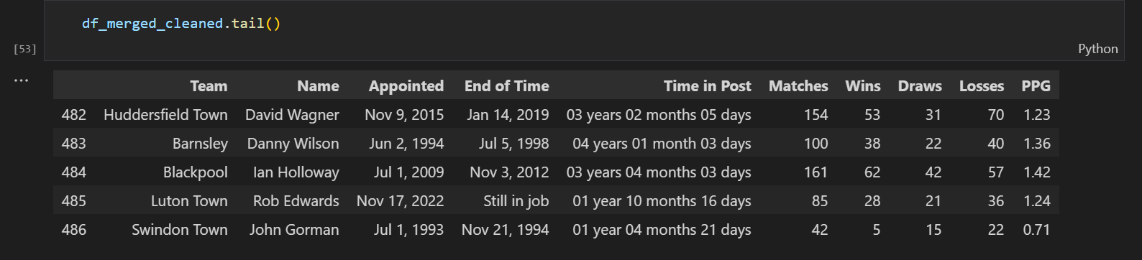

Next, we’ll load the League Power Rankings into this notebook to assign team ids to all respective teams.

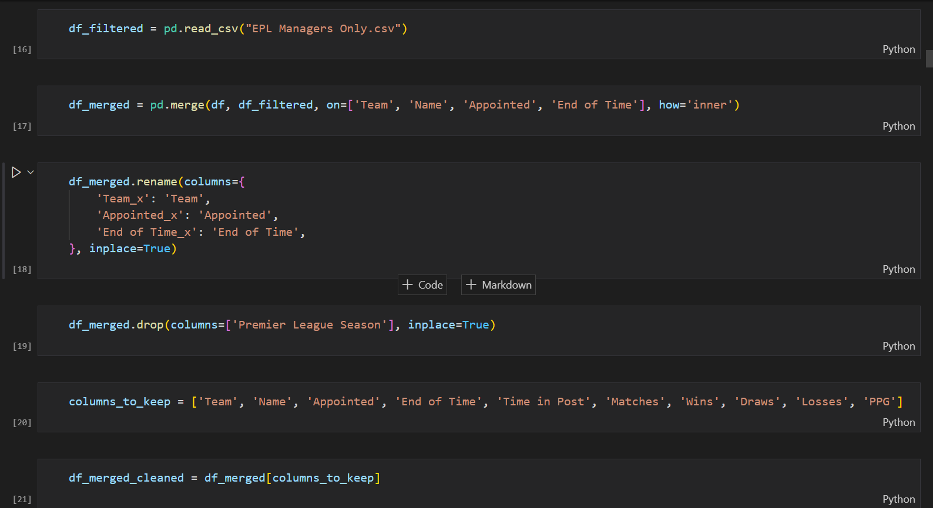

Let’s see what we have now

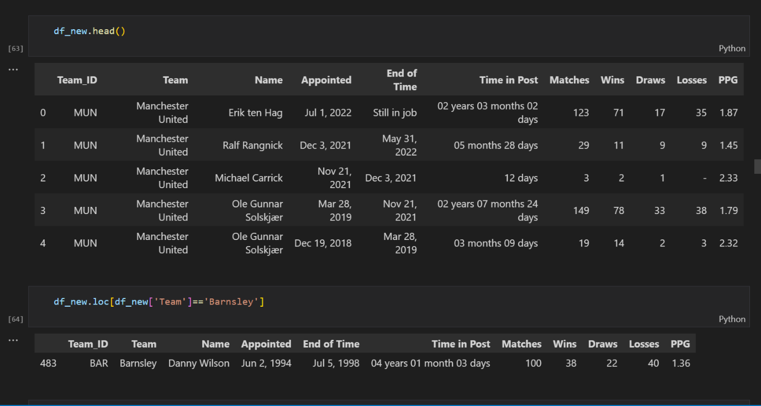

We will now define a function to create a Manager ID like we did earlier

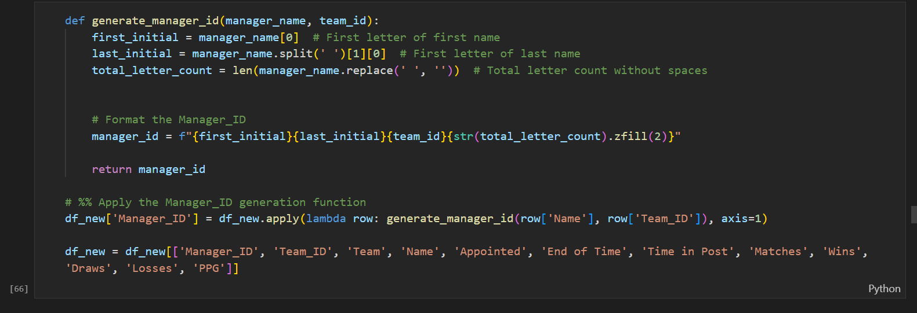

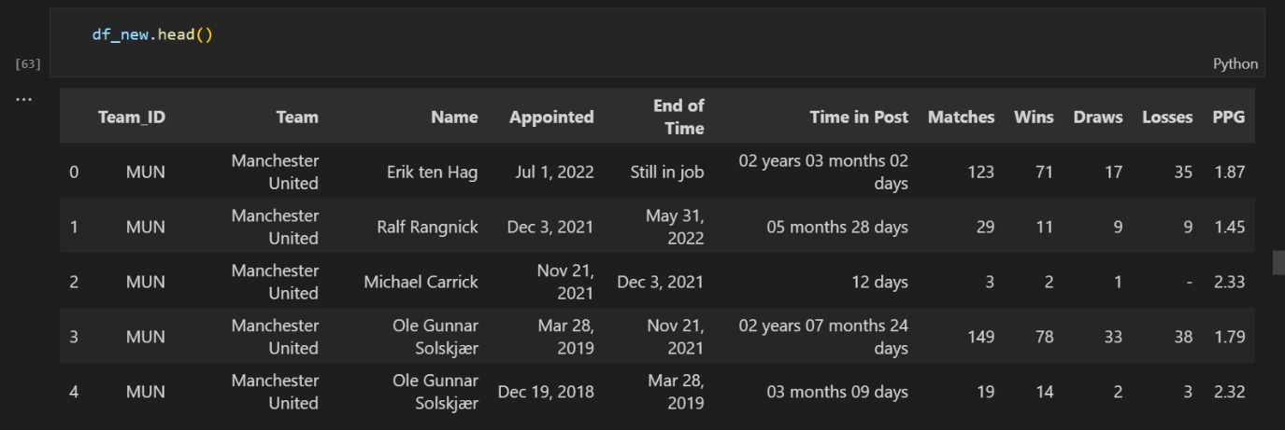

We’ll look at two managers to see these changes

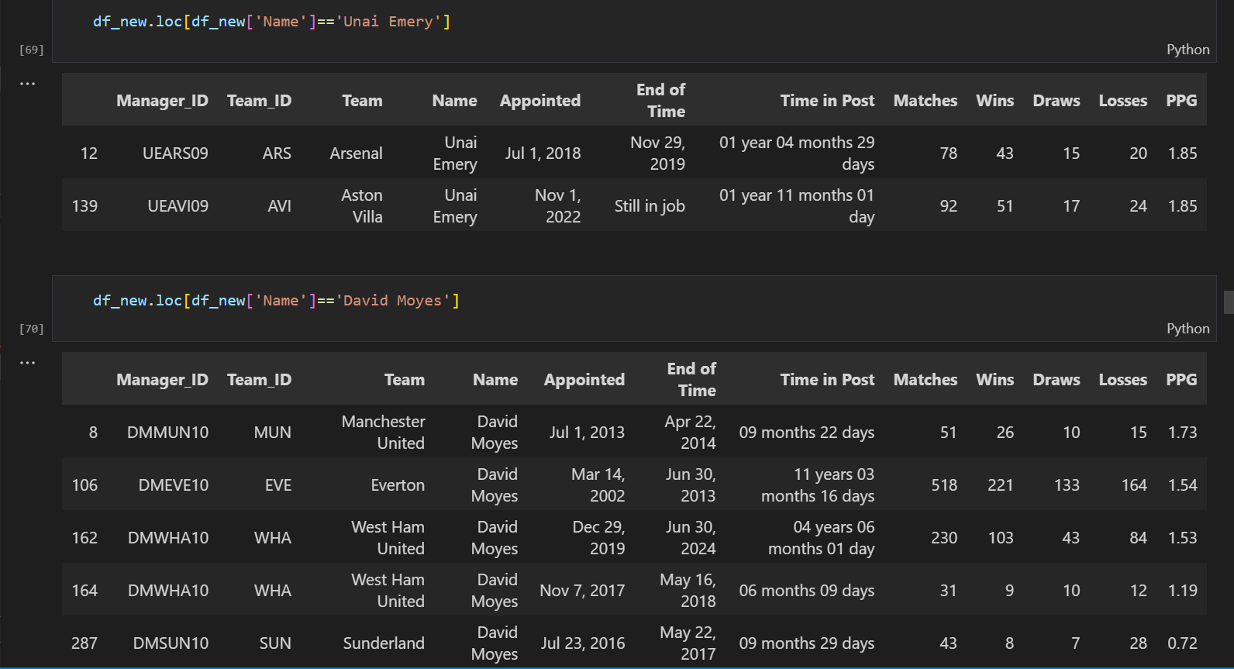

Okay great! Now let’s rename some columns so we don’t get confused down the line.



Great, now we have all the relevant data to find some answers like which manager has managed the most games, who has the highest PPG etc. To do this, we’ll have to ensure the data types within some columns are the appropriate data types.

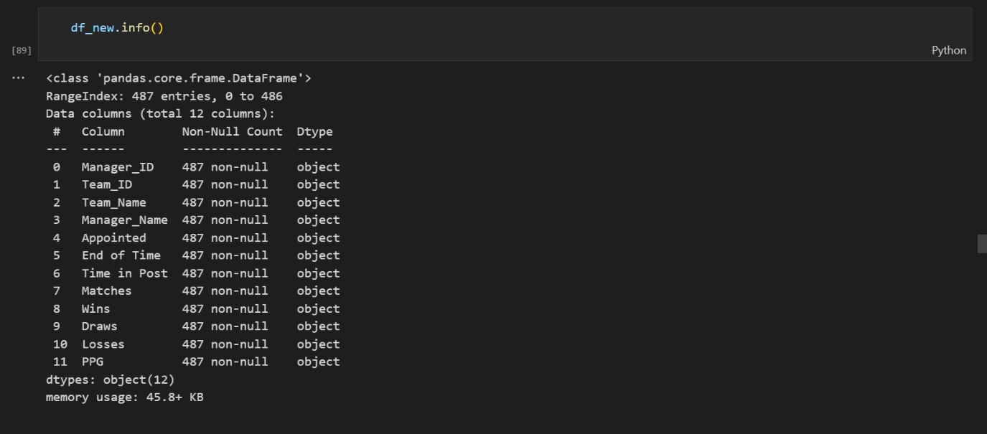

As we can see, all the data within is dataset are objects. We have to change some to numerical data types.

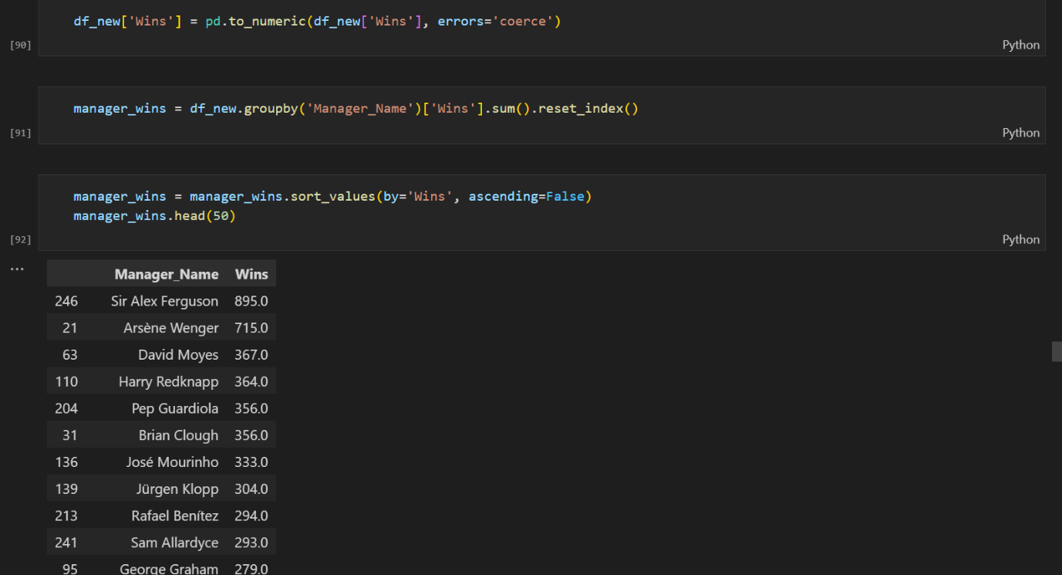

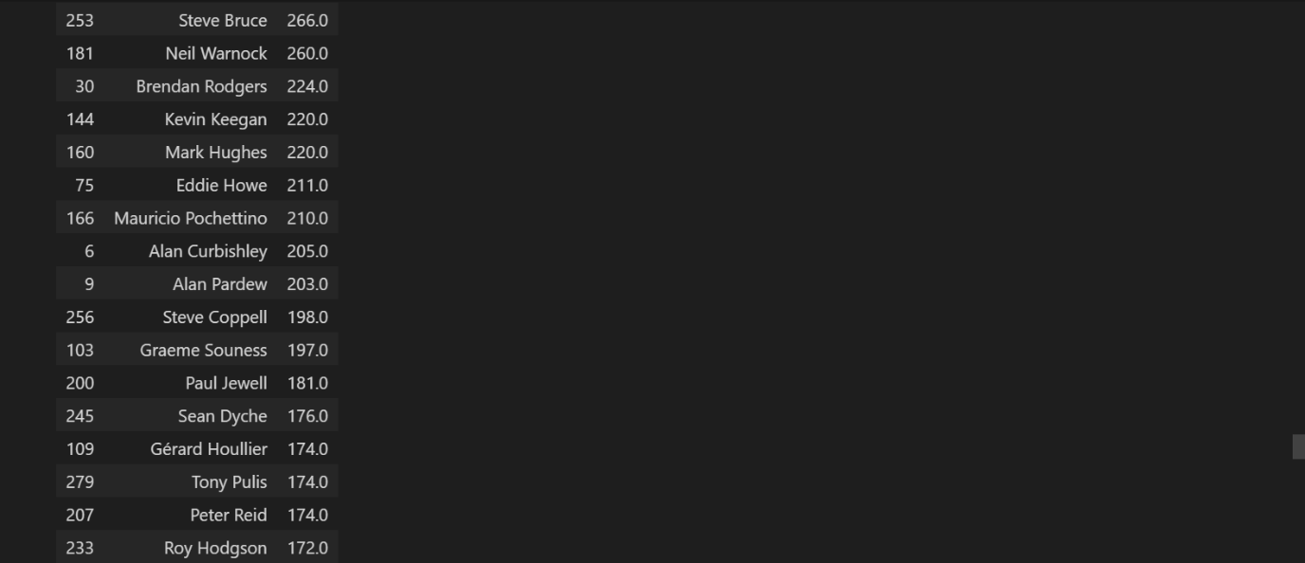

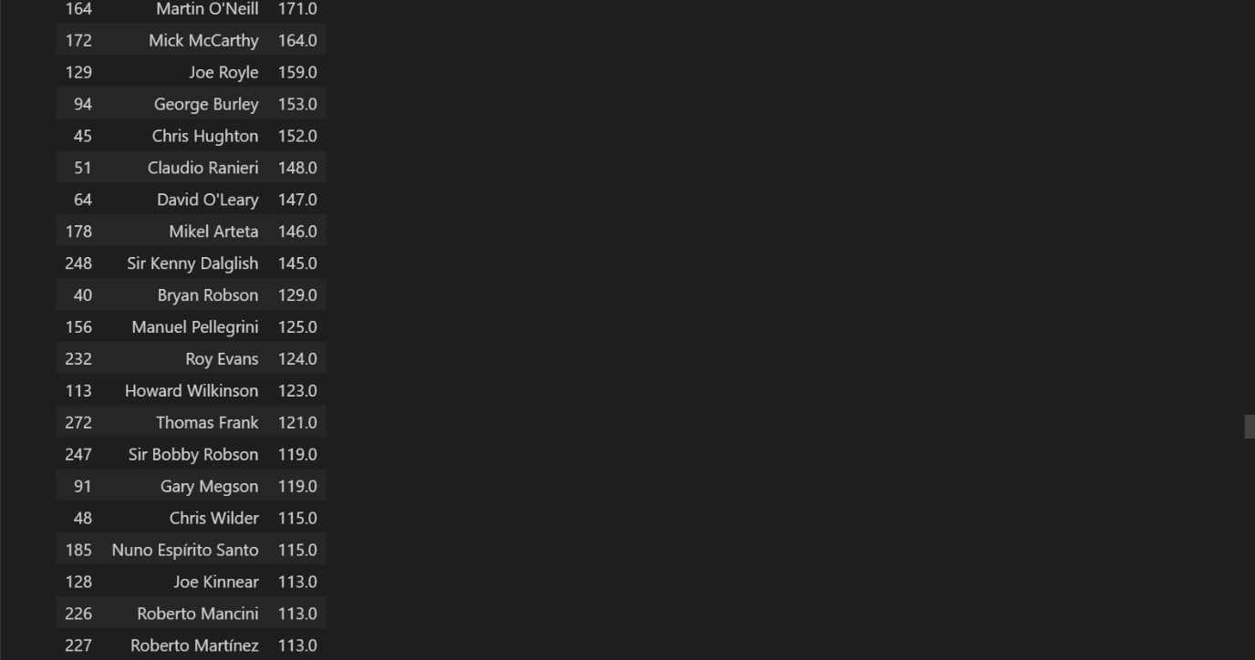



Sir Alex Ferguson has the most wins of any Premier League manager with 895 wins followed by Arsene Wenger with 715 wins then David Moyes with 367 wins. One thing to note is Pep Guardiola is in the top 5 even though he has managed way less games than other managers in the Top 5, that is very impressive. Let’s keep an eye on him in this analysis.

Let’s convert the rest of the columns to their appropriate data types and also handle null values.

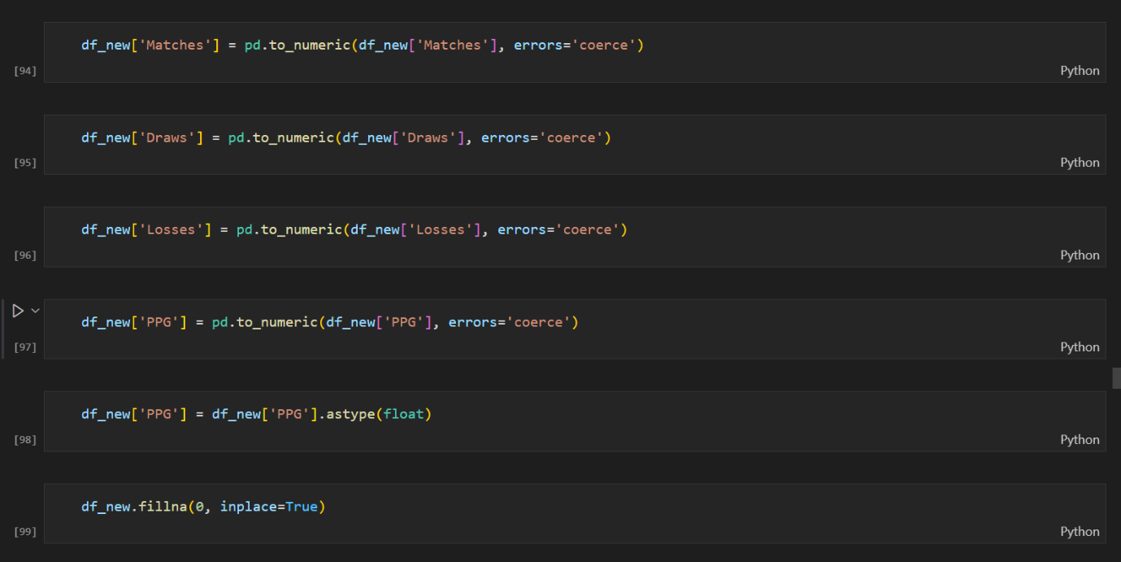

Now let’s find managers with the most draws

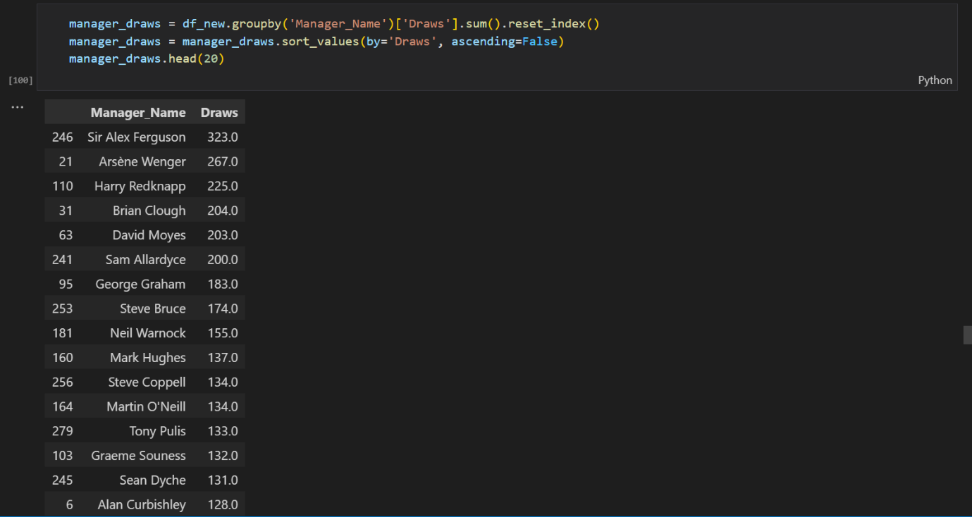

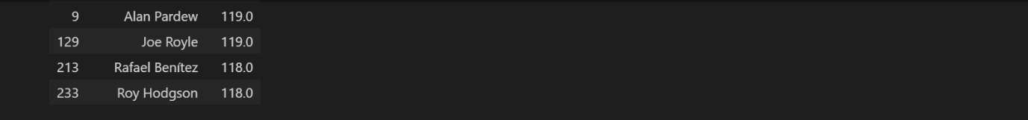

Now let’s try to find the average matches managed by managers in this dataset and managers with the most losses. We’ll exclude managers who didn’t get to manage a game.

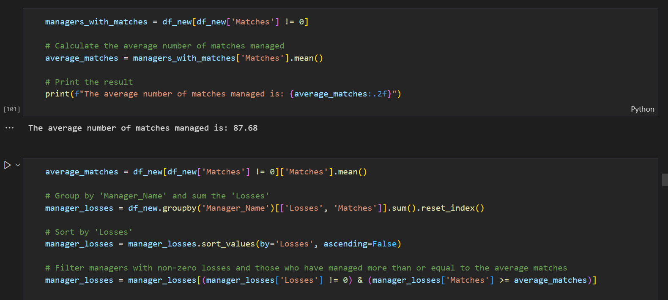

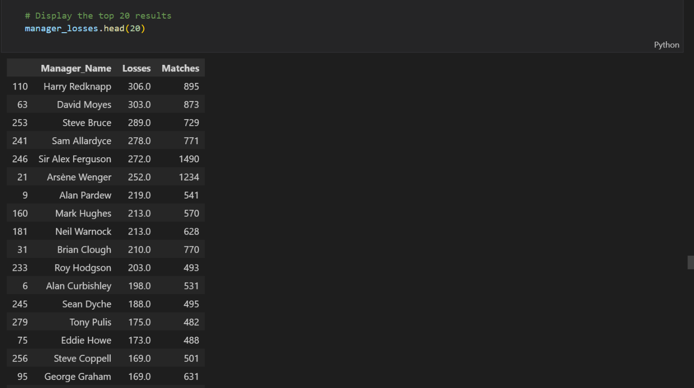



Now let’s find the managers with the most matches managed.

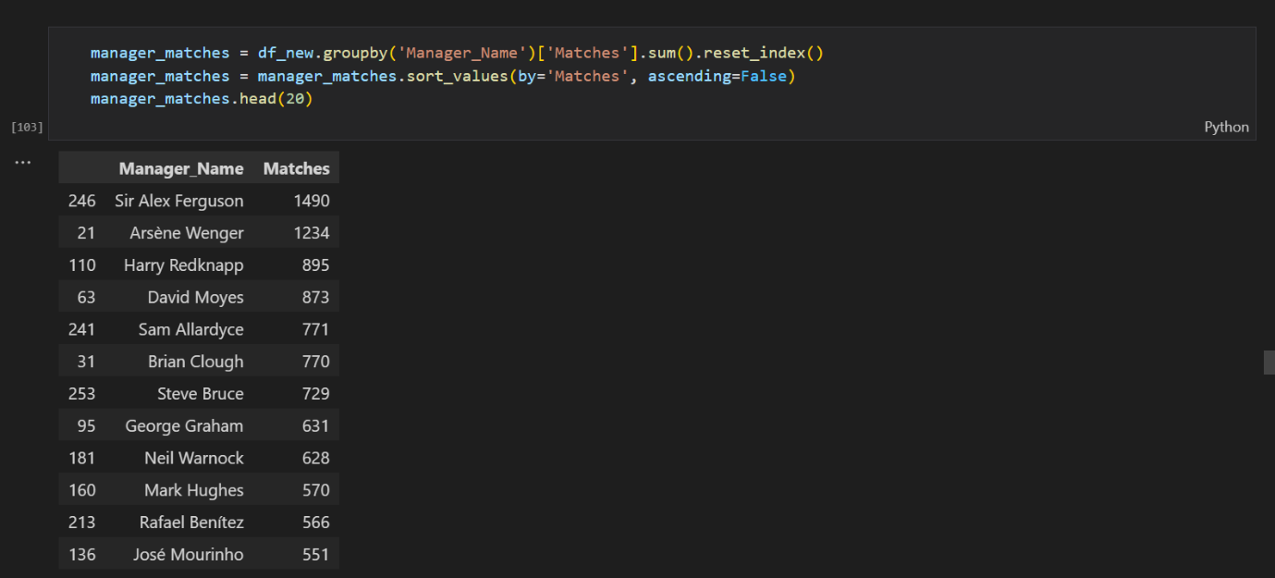

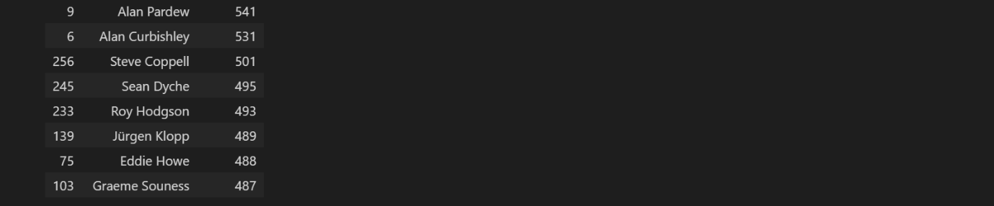

Now let’s see the managers with the highest PPG (Points per Game)

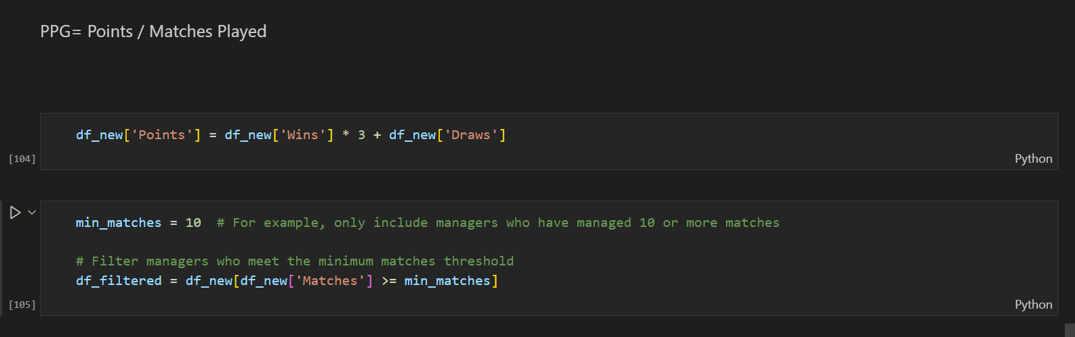

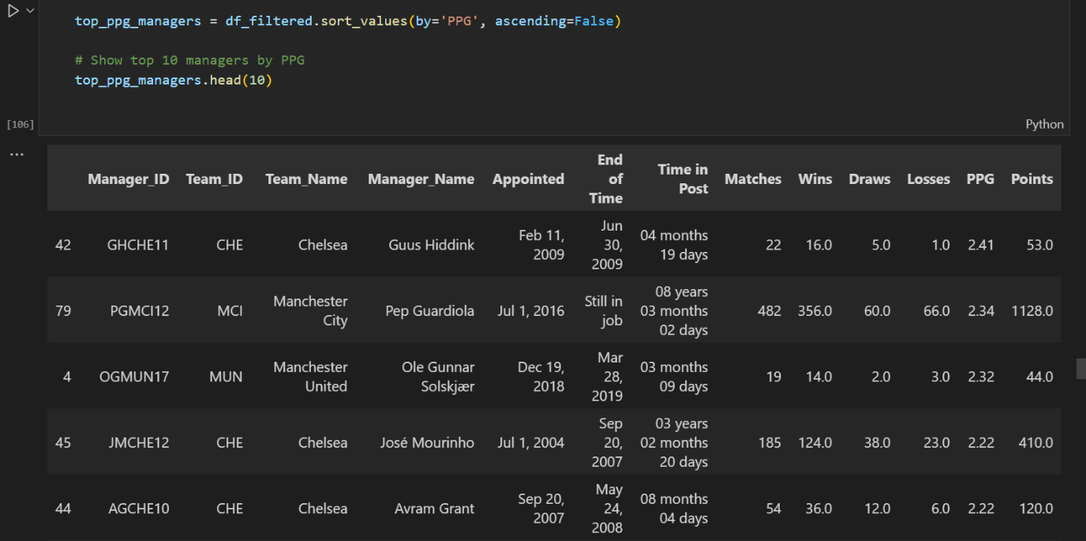

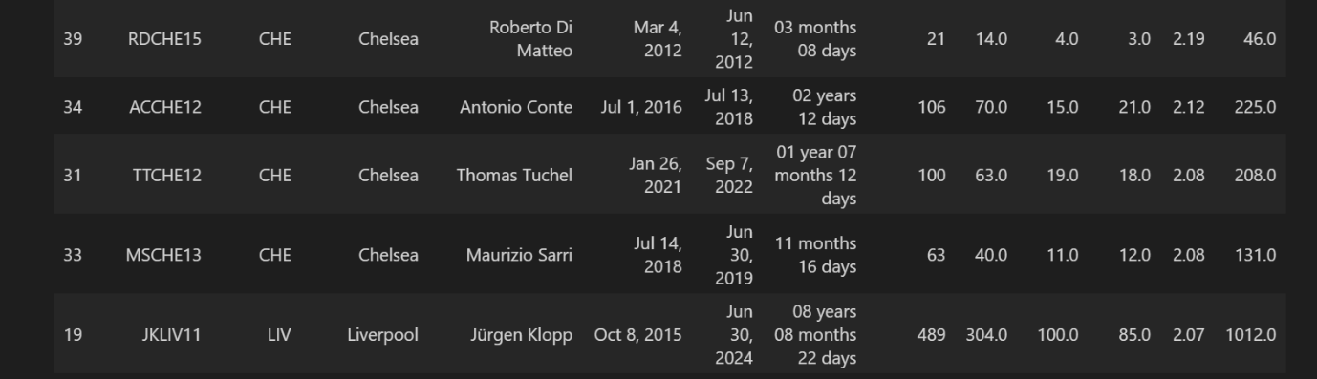

We see Guus Hiddink has the most points per game though he only managed 22 games. Pep Guardiola even though he has managed 200 games plus has a PPG of 2.34, that is very impressive. Jose Mourinho in his stint at Chelsea also had a high PPG of 2.22. There is no Sir Alex Ferguson in this list.

Now let’s plot this information on a bar chart

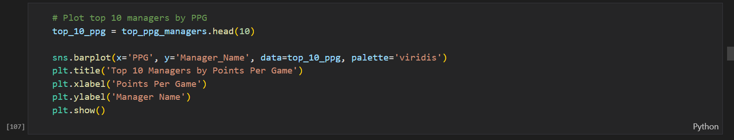

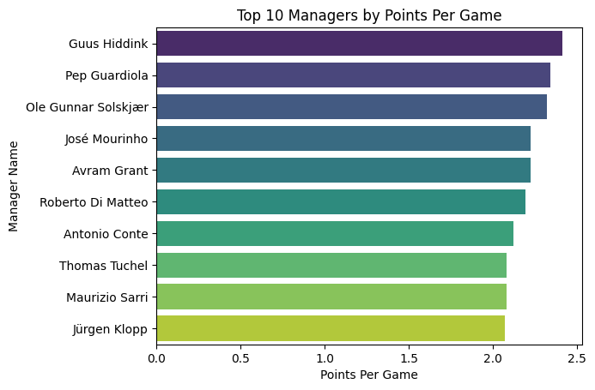

Now let’s see which managers accumulated the most points. We will only look at managers who have managed 400 plus games

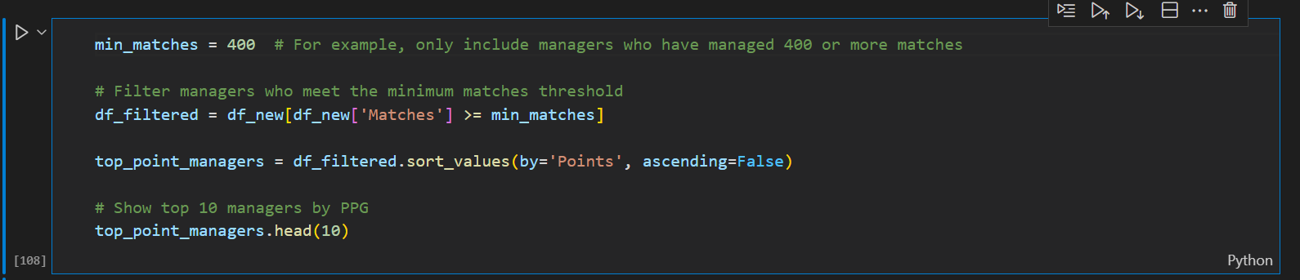

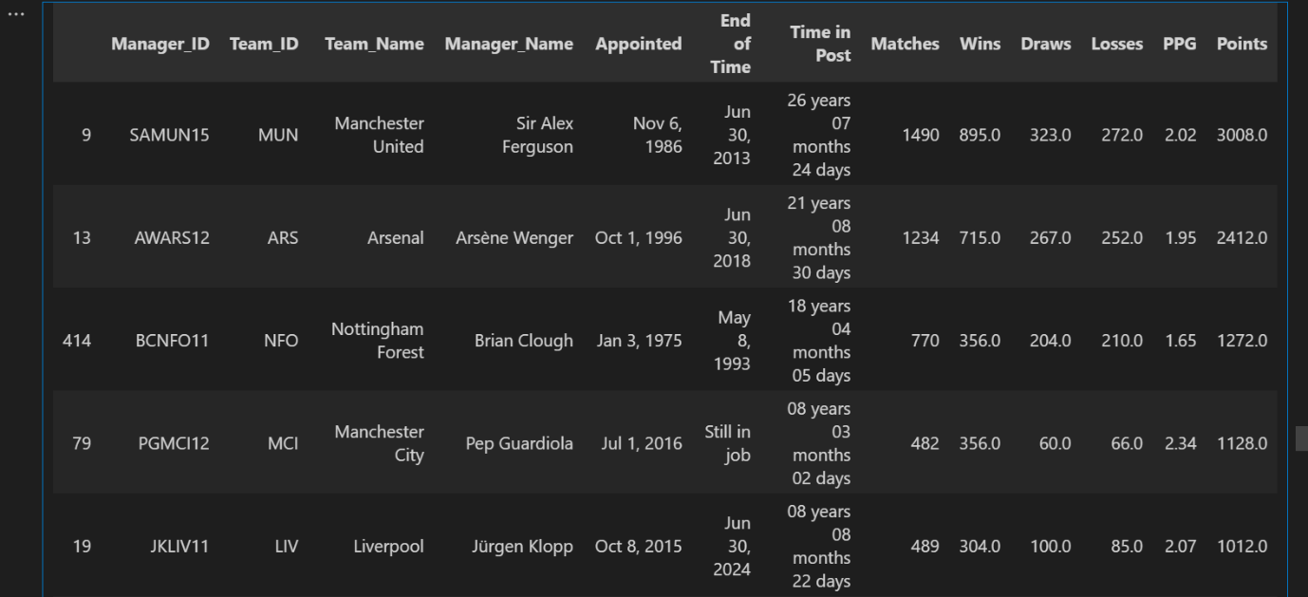

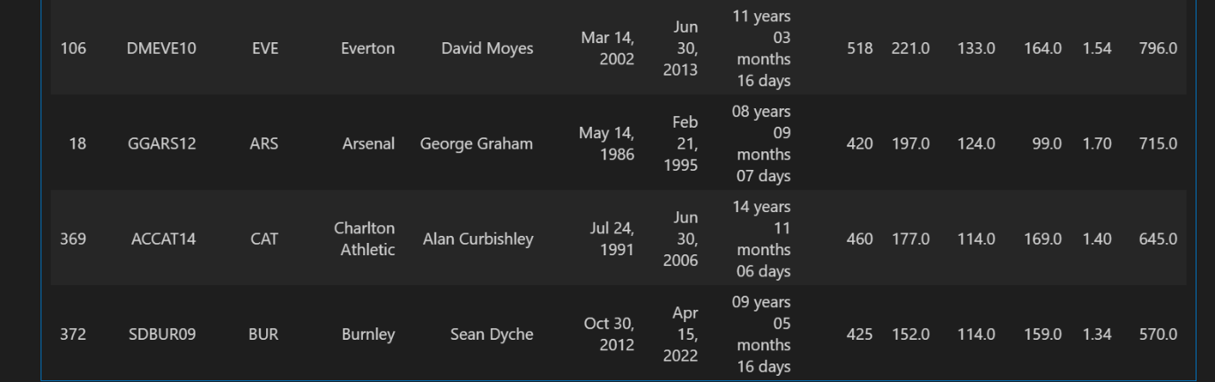

Sir Alex Ferguson has accumulated the most points with 500 more points than the next manager Arsene Wenger. Pep Guardiola also shows up in the Top 5 alongside Jurgen Klopp.

Now let’s plot this information on a bar chart.

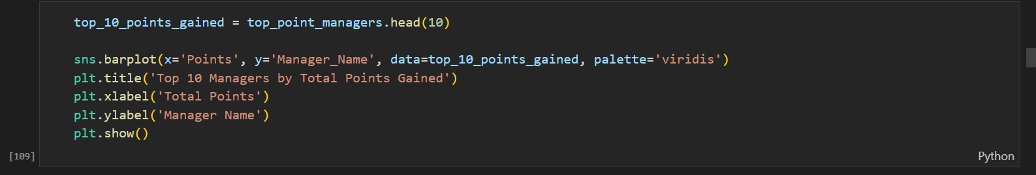

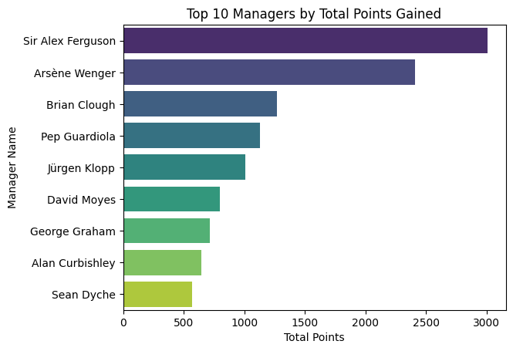

Now let’s calculate the highest win ratio across the managers in this dataset.

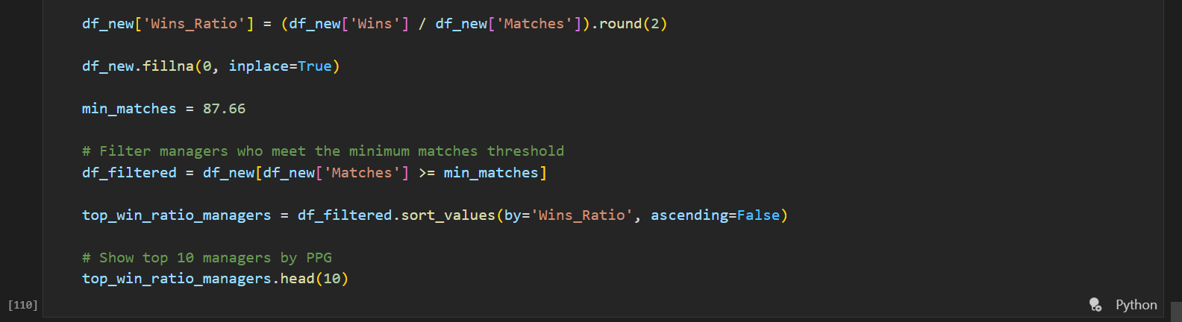

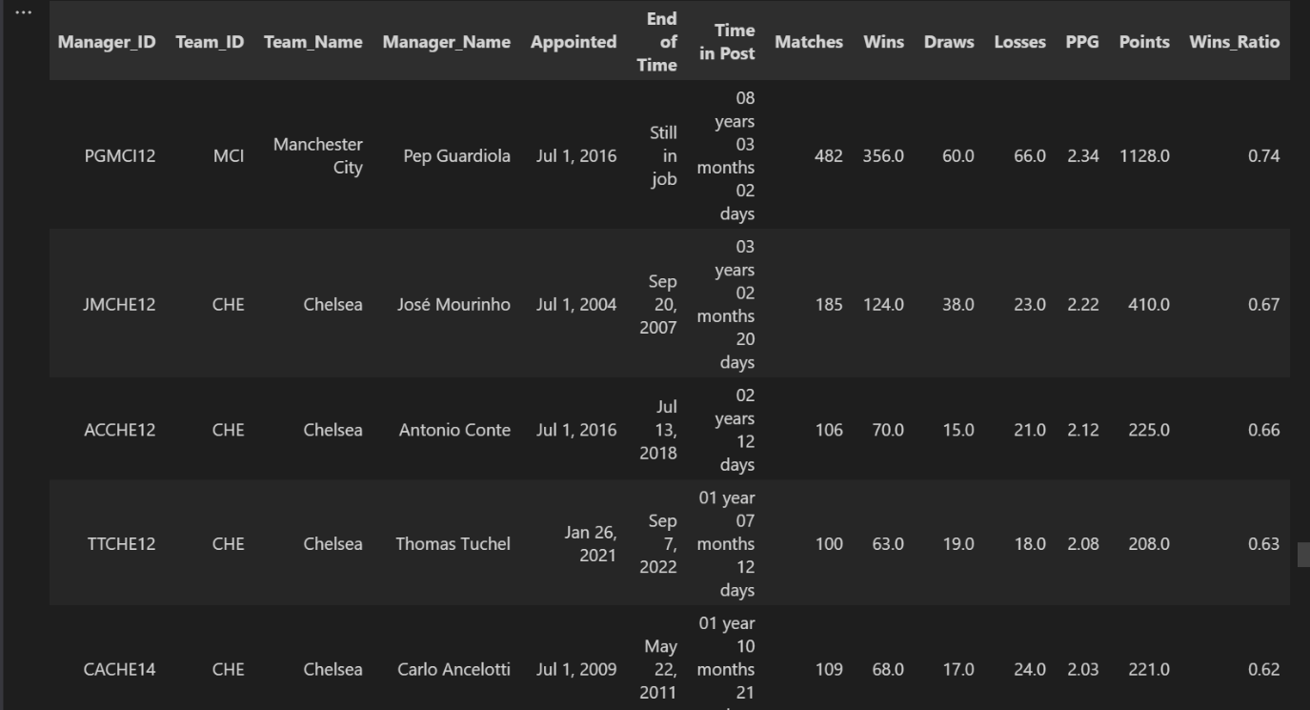

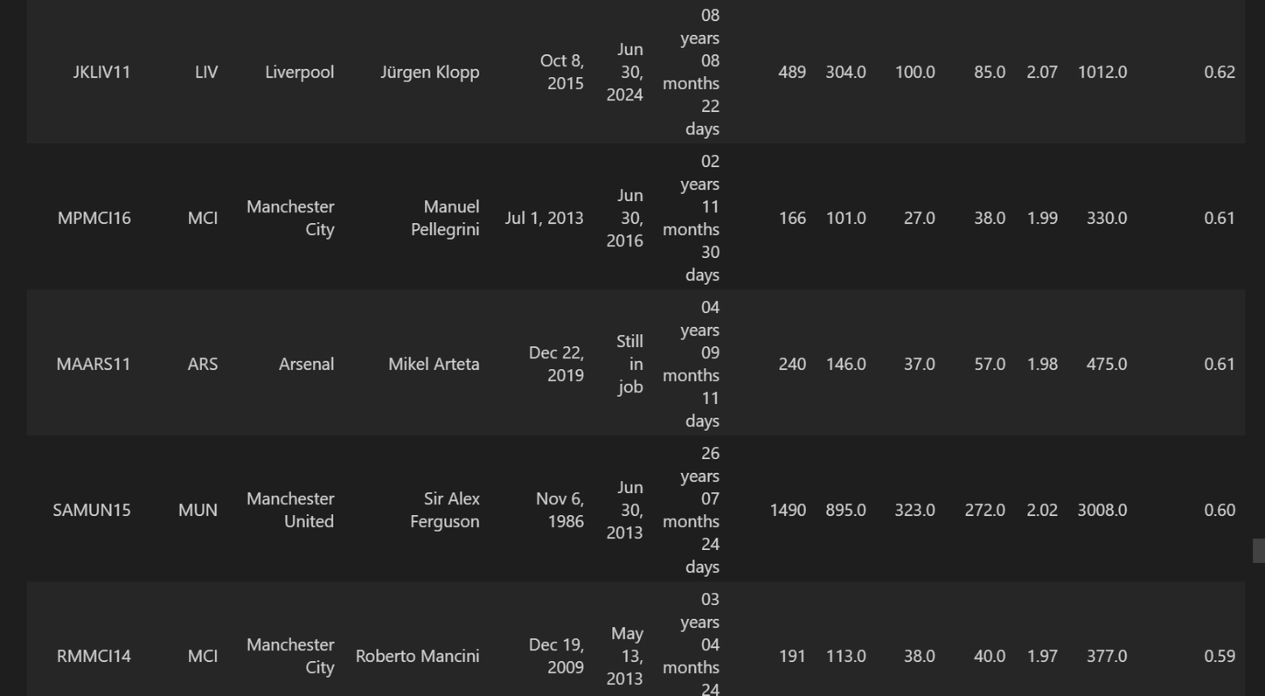



Pep Guardiola has the highest win ratio with 0.74 followed by Jose Mourinho’s stint at Chelsea. Mikel Arteta is also doing a good job at Arsenal with a win ratio of 0.61. Sir Alex Ferguson shows up as 9th on this list though a win ratio of 0.60 in 1490 games means he has won more matches in Premier League than Guardiola has managed.

Next, we will clean some of these names with special characters because they originate from foreign countries. We will use the unidecode library for this.

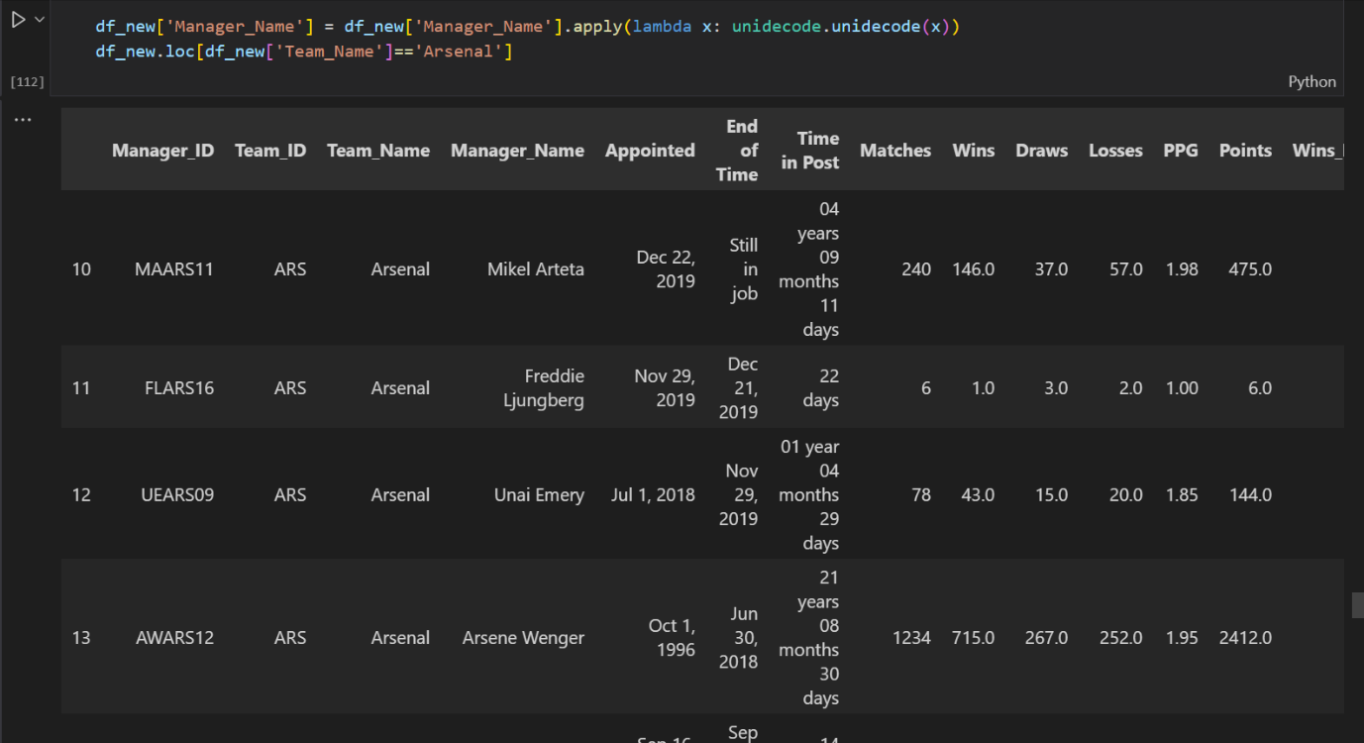

Next, we will convert the datatypes of the appointed and end of time to datetime datatypes. With this we are done with the scraping of the manager history table, we will return to it after we obtain the matches dataset.



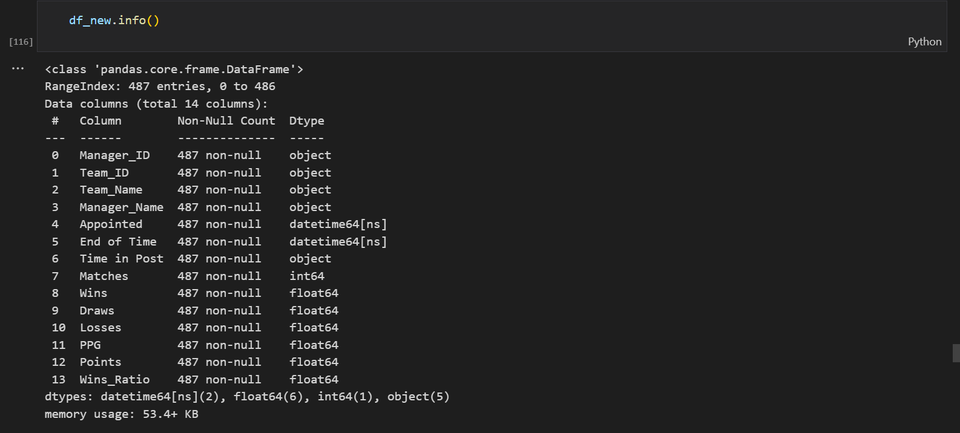

1. **Matches Table**

The goal of this part of the project is to obtain the match data of all the games played from the 1992/1993 season to the 2023/2024 season. The variables include Match Day, Date, Home Team, Home Team Score, Away Team and Away Team Score. I’d also like to create a match id column to uniquely identify matches and a season to discern what season the match was played. This information is obtained from Transfermarkt. Okay let’s dive into it.

We begin by importing all necessary libraries and defining a function to standardize time formats.

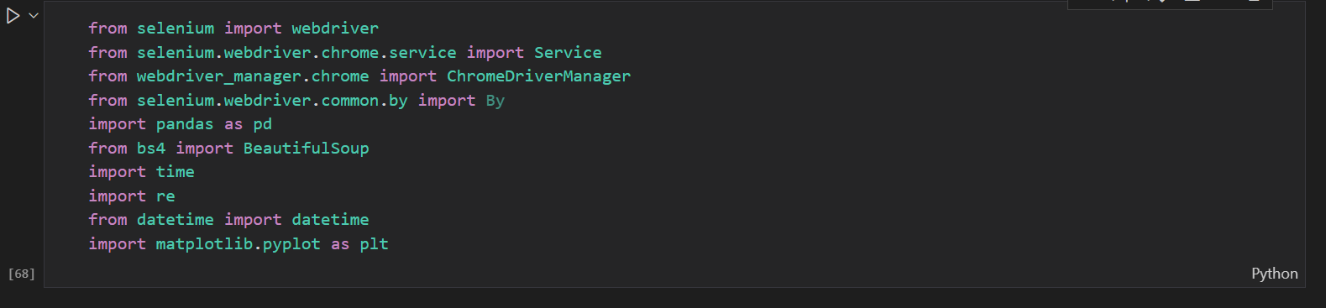

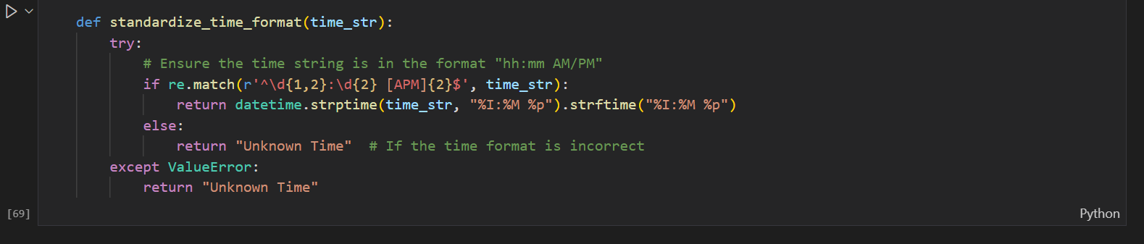

Next, we define a function to parse date and time because on Transfermarkt in 2000s the format of the date changed and we need a way to handle that.

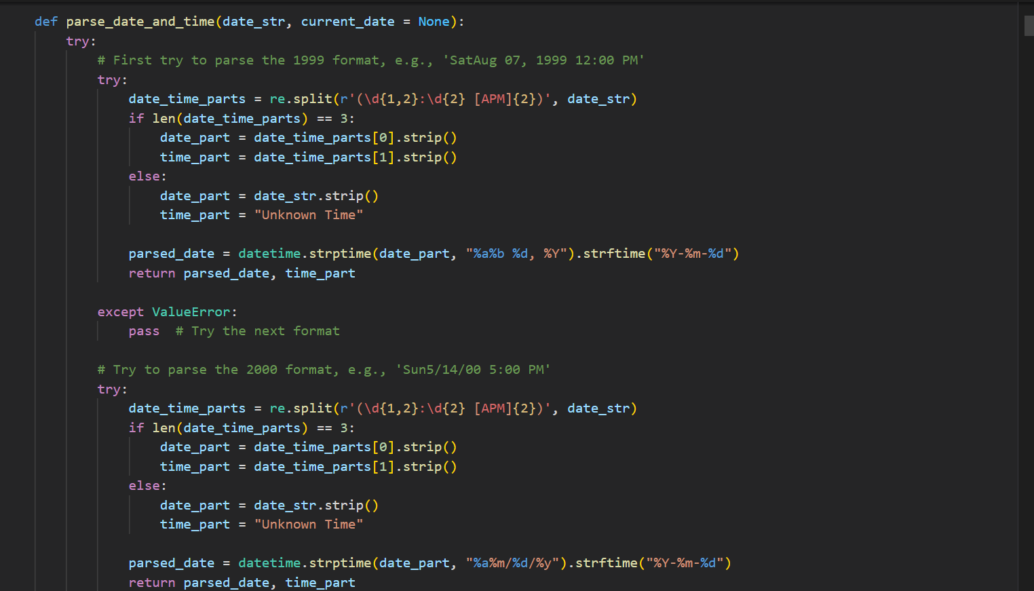

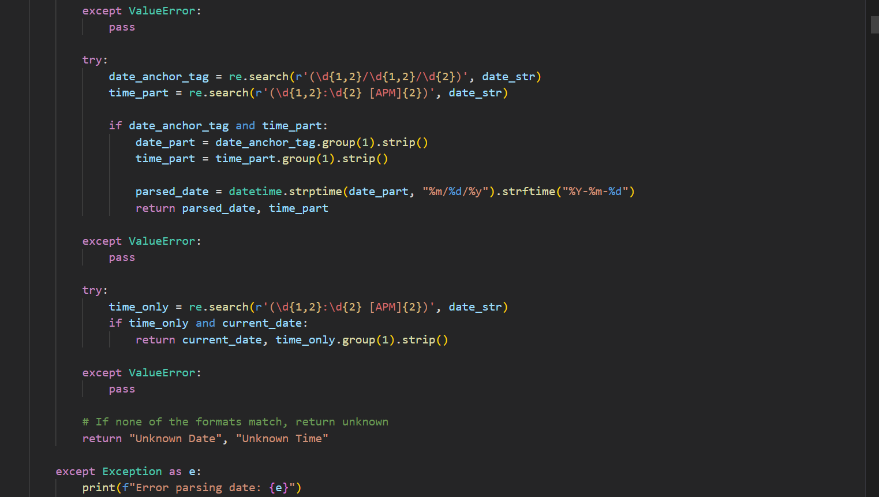

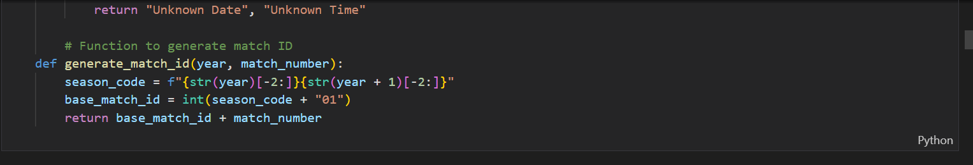

Next, we initialize the WebDriver and define variables for the start year and end year in focus. Those will be the year the first season and last season. We will also create an empty list to store the data.

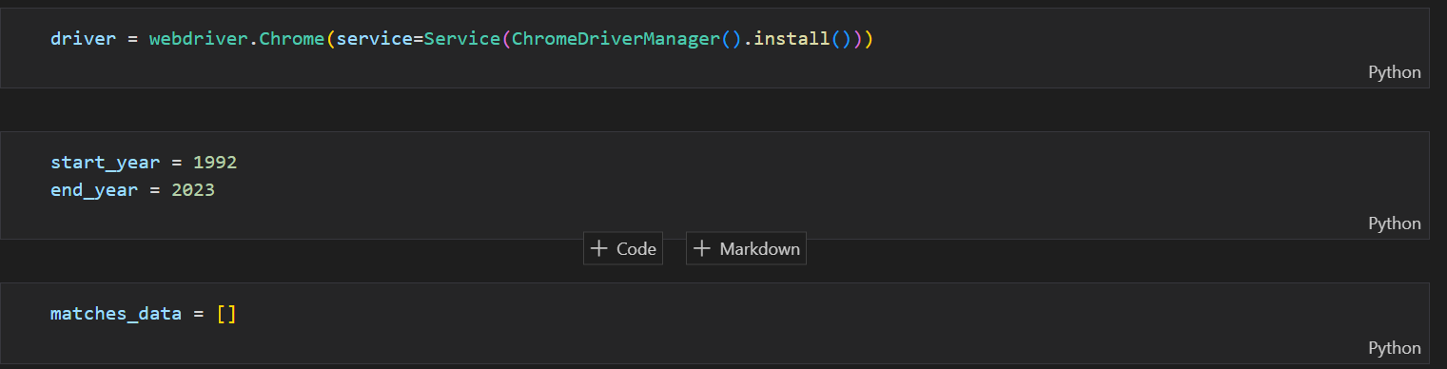

Now we begin the scraping process by using the start and end year as arguments. The URL being used is a template that all match data for every season follow. So by providing a range of years like we did, we will be able to scrape the match data for every season necessary.

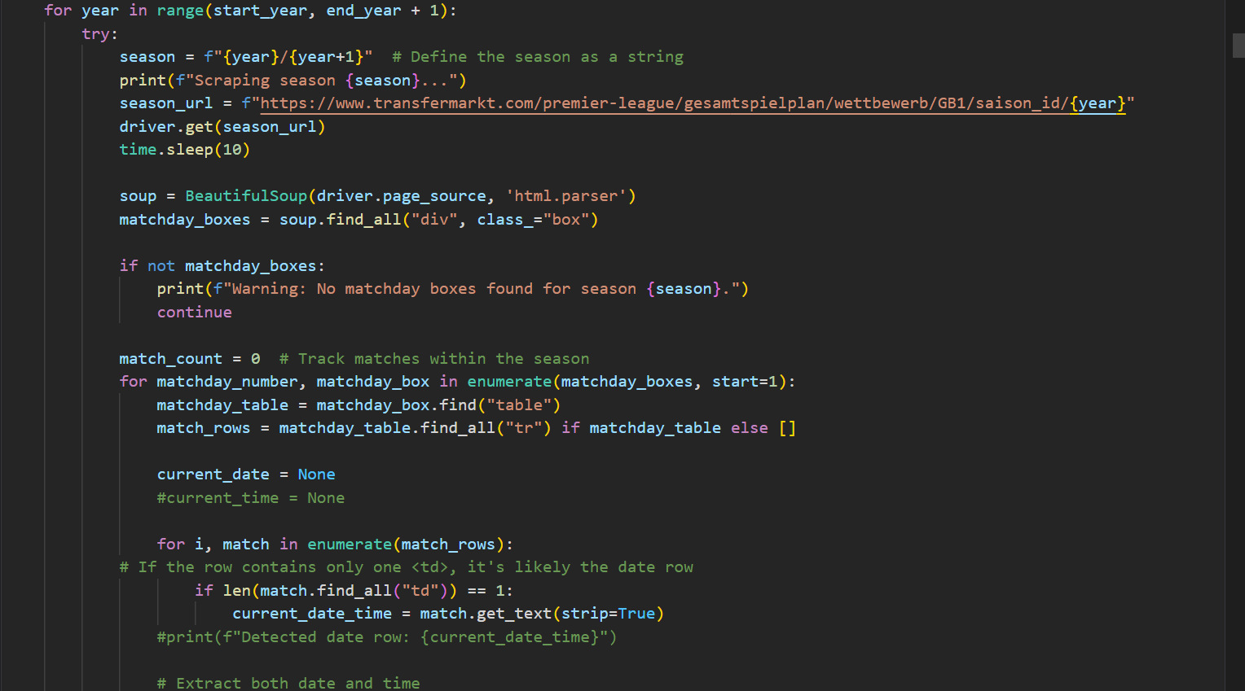

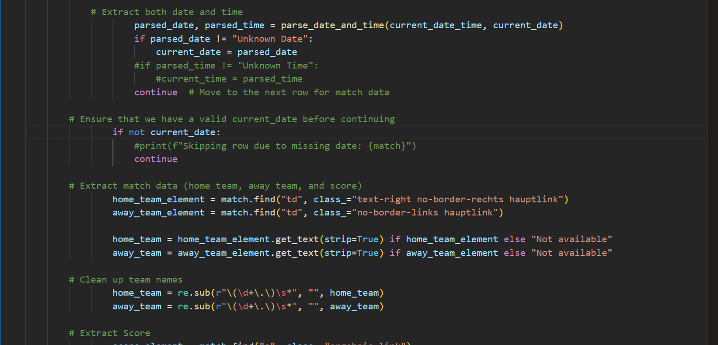

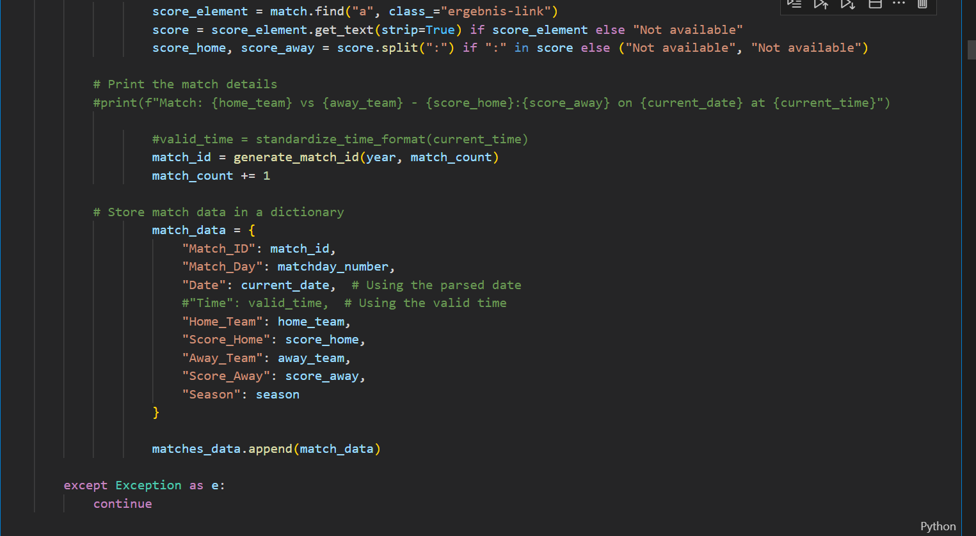

Next, we save the scraped data into a data frame. I also handle an issue with match day so it correctly reflects what match day the match was played.

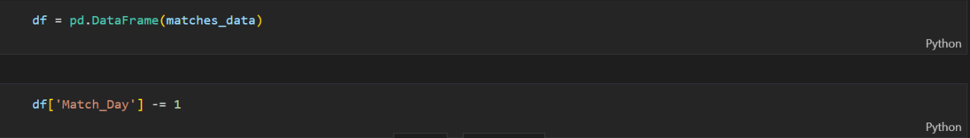

Let’s see the results

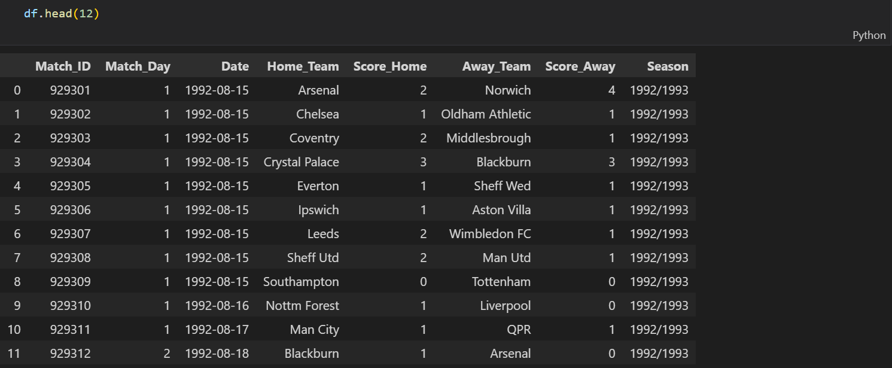

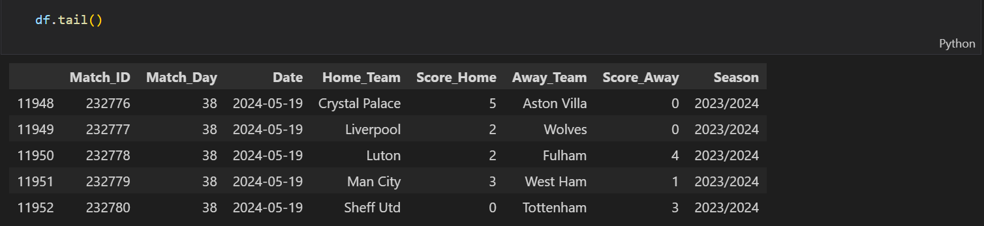

Great, its looking good so far. And now when we check if any Unknown Date is recorded in our data frame, we shouldn’t find any.

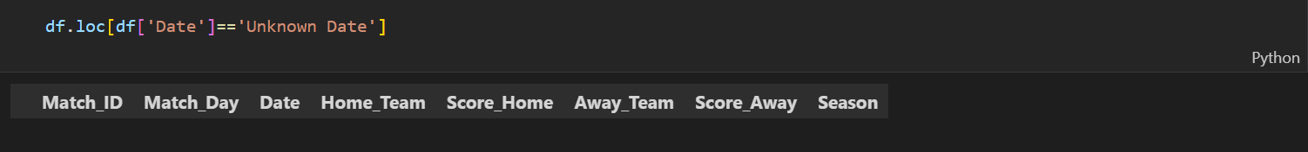

Now, let’s read the manager history table we previously obtained into this notebook. The end goal now is to properly assign the correct managers to all these matches.



Before we assign managers to these matches, let’s assign the Team IDs to all the teams but first, we will have to do some data cleaning. The names in the matches table are the short form while those in the manager history table are the standard form. To ensure consistency across all datasets, we will use the standard form.



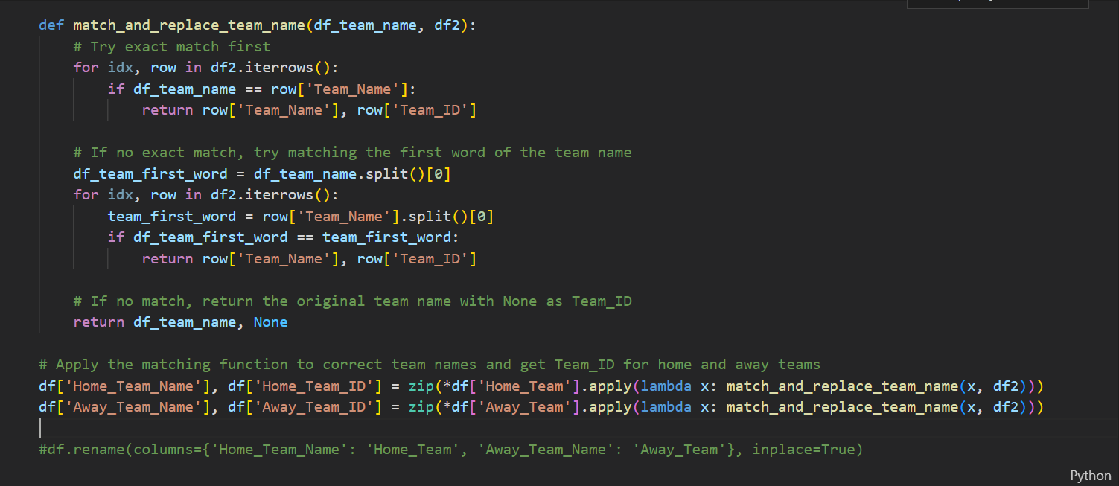

Now let’s see the results

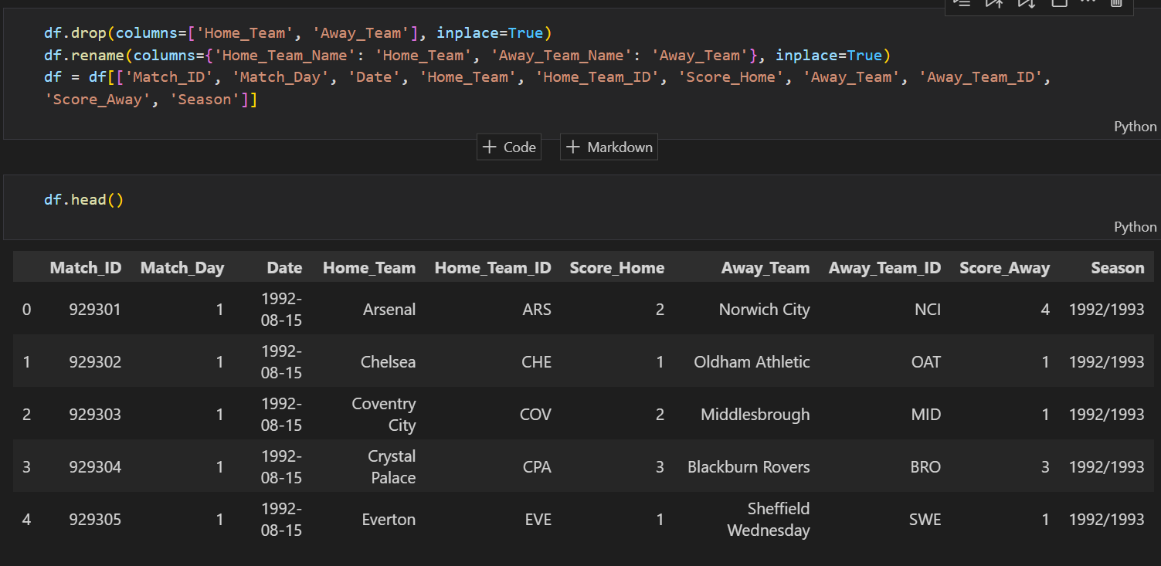

Great! Now let’s assign the managers to these matches. We will define a function for this

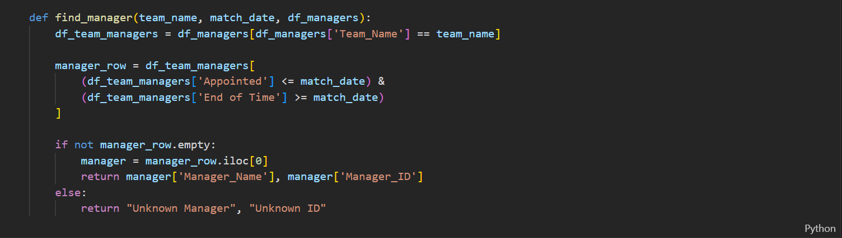

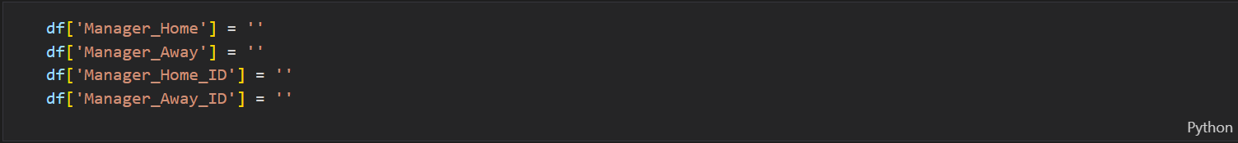

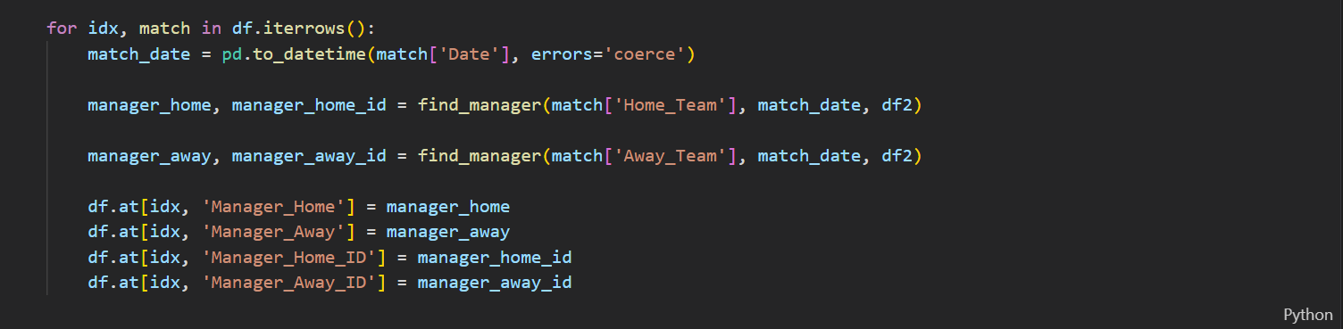

Let’s check the results.

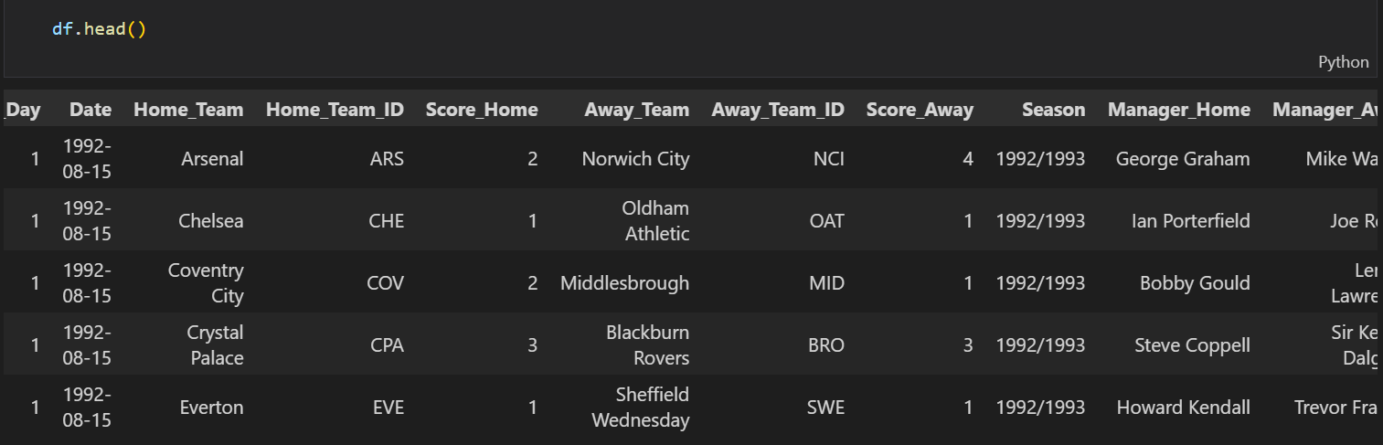

Great we now see managers have been assigned to the matches. Let’s check the Manager History table if this is the correct manager.

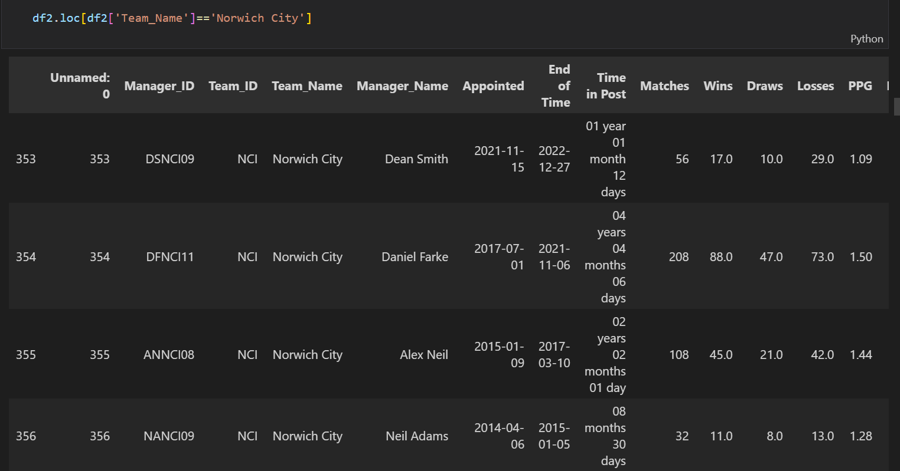

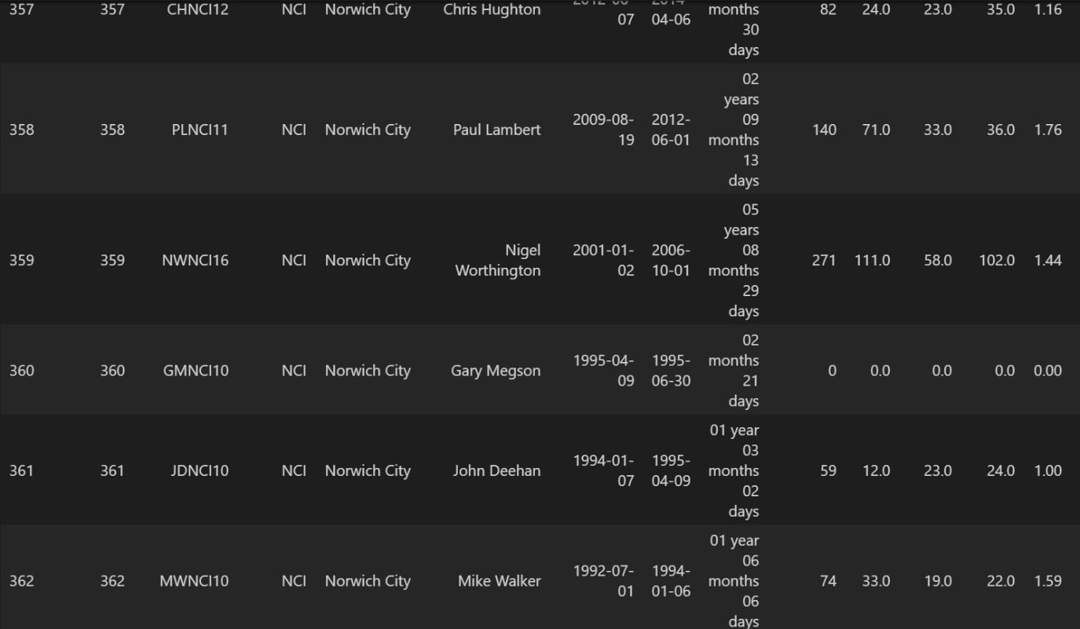

The first match in the 1992/1993 season was between Arsenal v Norwich City on the 15th of August 1992. And Mike Walker was Norwich City’s manager from the 1st of July 1992 to the 6th of January 1994 so yes, he was the manager in charge of Norwich City for that game.

Let’s fix some things and rearrange the order of the columns before checking if we have any match rows with the value ‘Unknown Manager’.

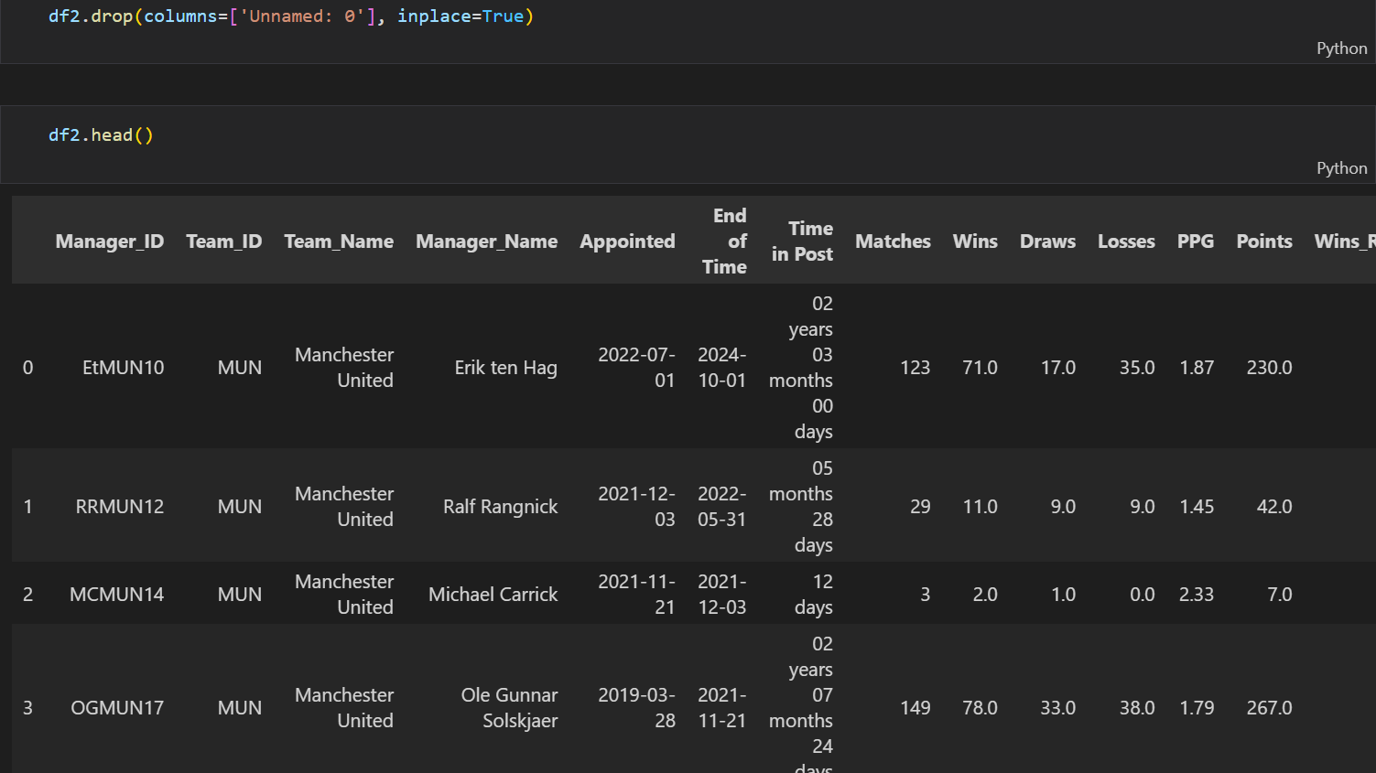

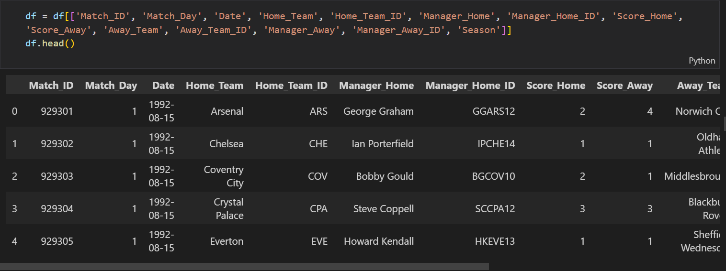

Now let’s check if we have any Unknown Manager’s within the matches dataset and understand why that was so. We’ll check both the Manager Home and Away columns.

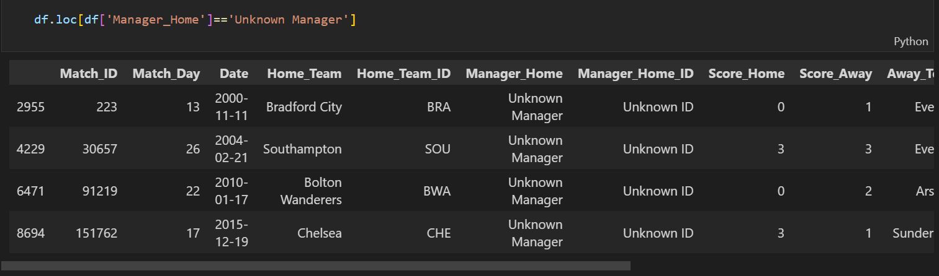

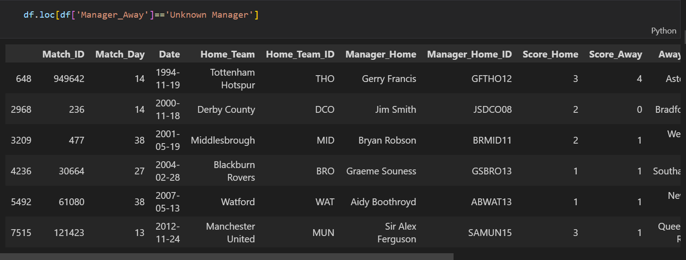

Okay we have 9 rows in total with this issue. Let’s check the Manager History dataset specifically for the Bradford City team to understand why.

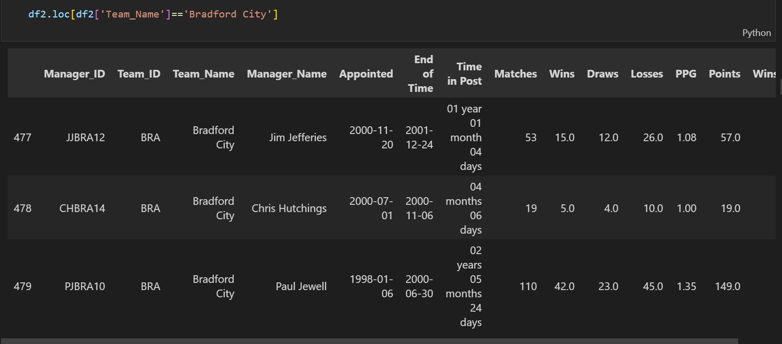

Okay Jim Jefferies is the last manager recorded for Bradford City and he was appointed on the 20th of November 2000. The match involving Bradford City with the Unknown Manager value at the Manager Home column took place on the 11th of November 2000. That’s 9 days before Jefferies was even appointed, what about his predecessor? Chris Hutchings was appointed on the 1st of July 2000 and left the role on the 6th of November 2000. That’s 5 days before the match in question. Did Bradford City lead their players’ out with no plan and told to just enjoy the game, I highly doubt that. Let’s check TransferMarkt for the match in question.

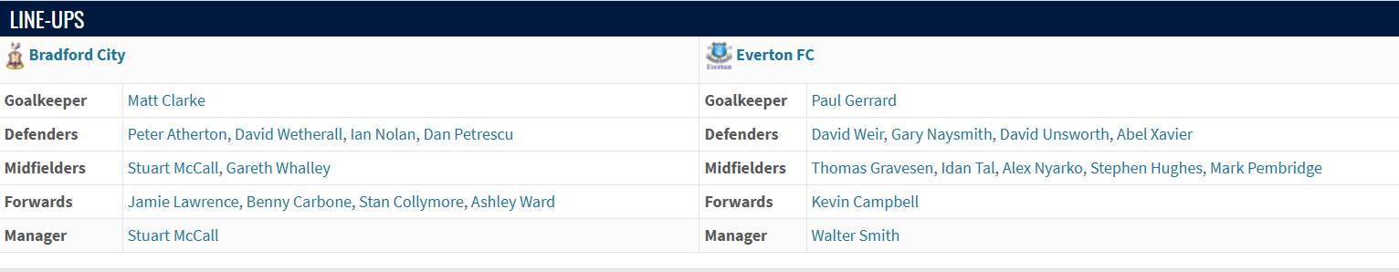



We see Stuart McCall is the name of the manager for the match in question and it’s not our fault we didn’t show up in the records. So now we’ll repeat this research for other matches with the Unknown Manager value. We can define a function to help us input the missing manager names into the appropriate rows.

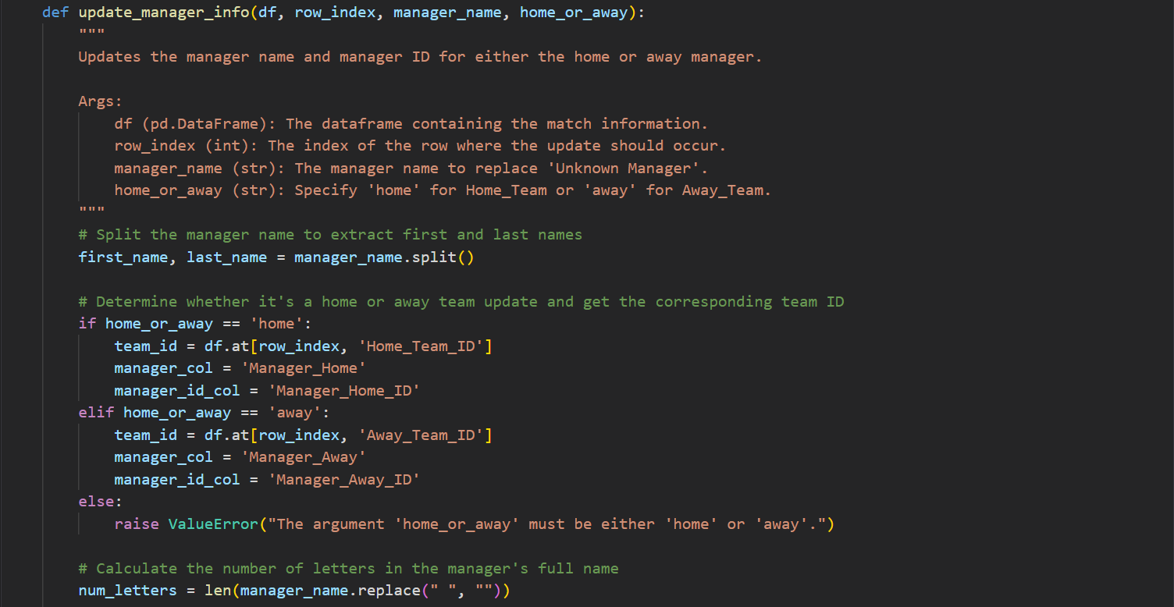

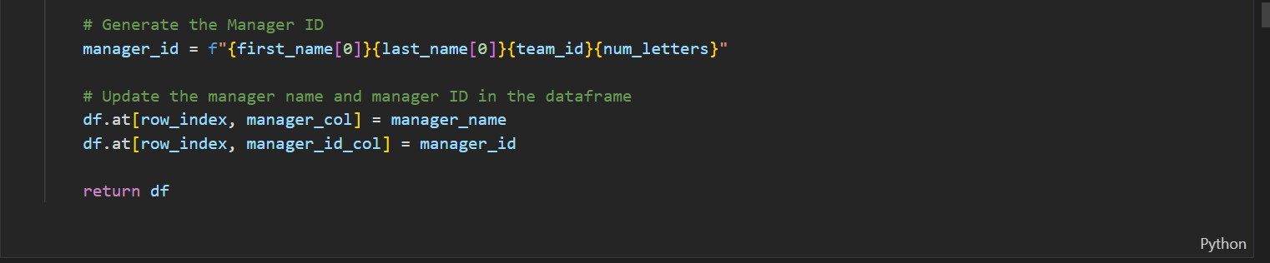

Let’s put the function to use now.

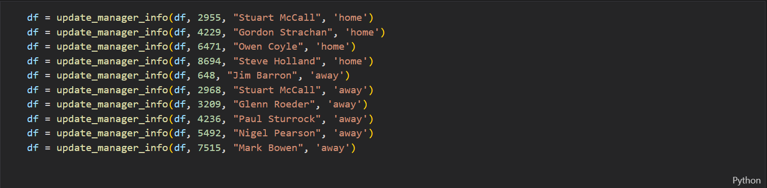

We see it exerted it changes we wanted

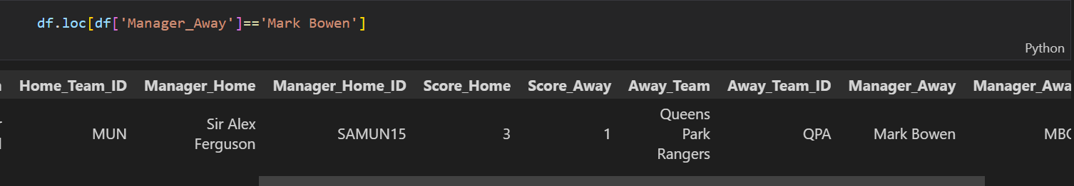

Great! Now we have successfully assigned a manager to each team in a match row. Next thing we’ll do is perform some exploratory data analysis. Let’s find out a manager’s win per season and plot that information. We’ll define a function for this.

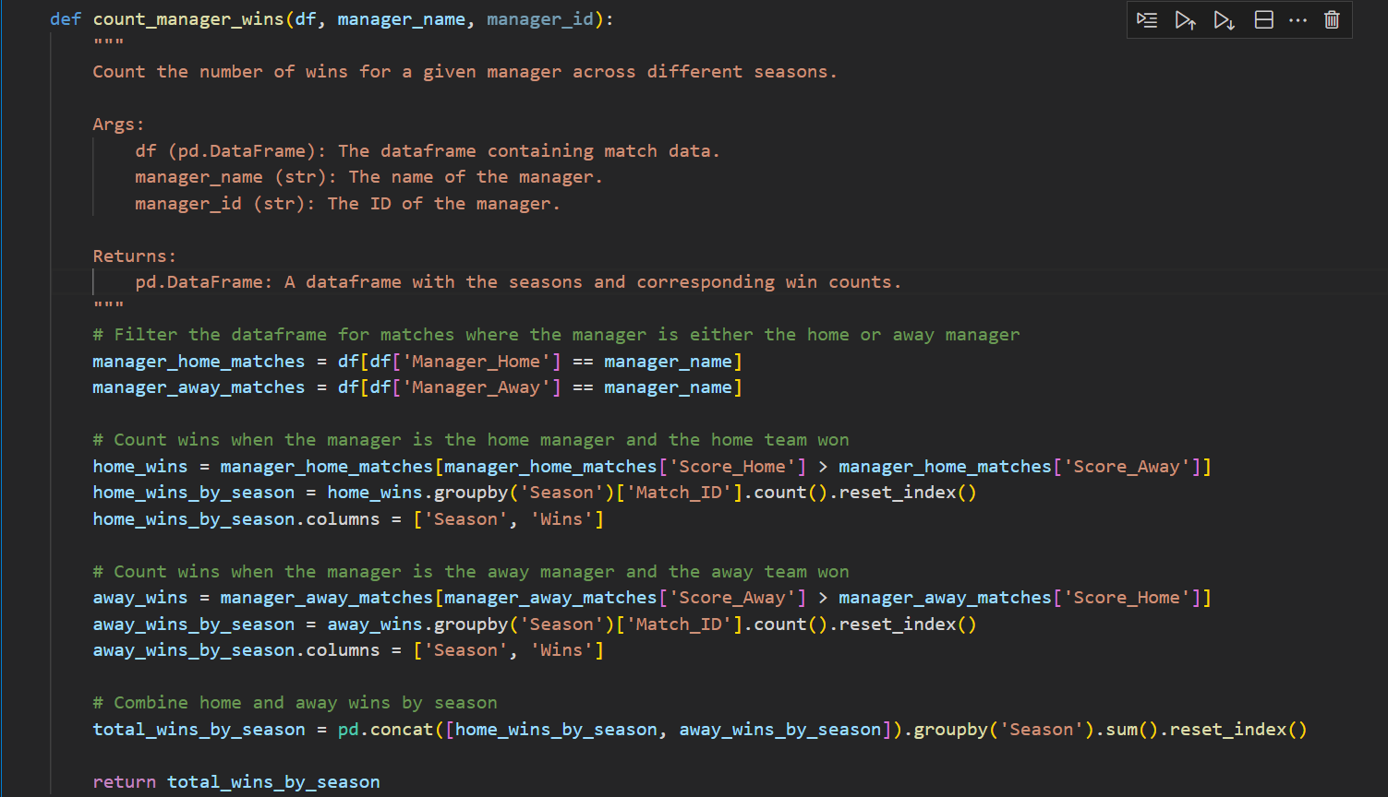

Let’s put the function to use and see Sir Alex Ferguson’s wins per season.

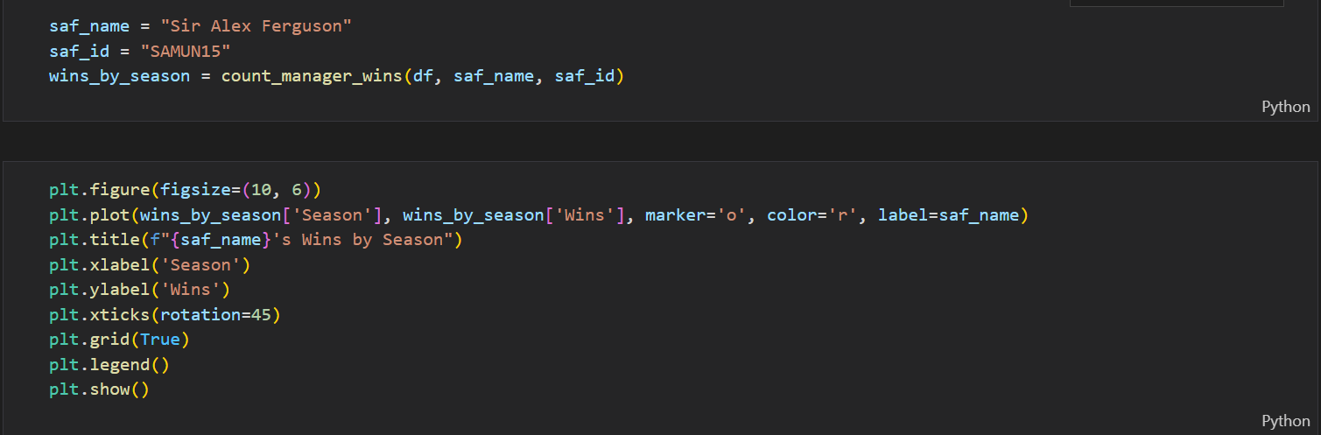

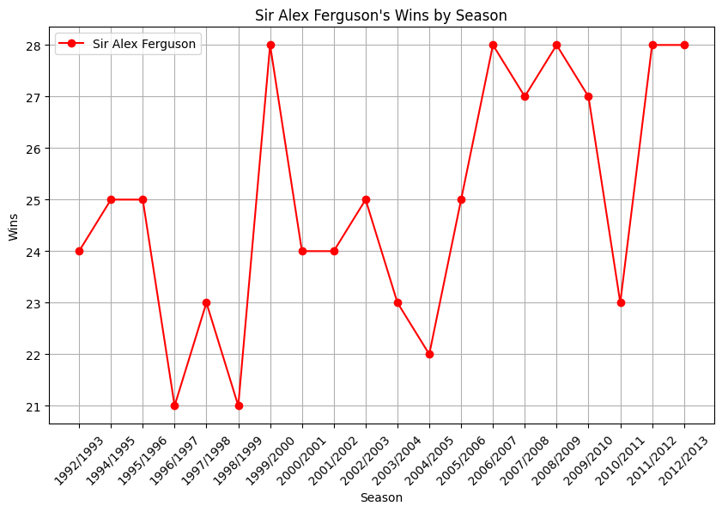

We can see the highest number of wins achieved in a season by Sir Alex was 28 and he achieved this feat on 5 different occasions. Let’s do the same for Pep Guardiola.

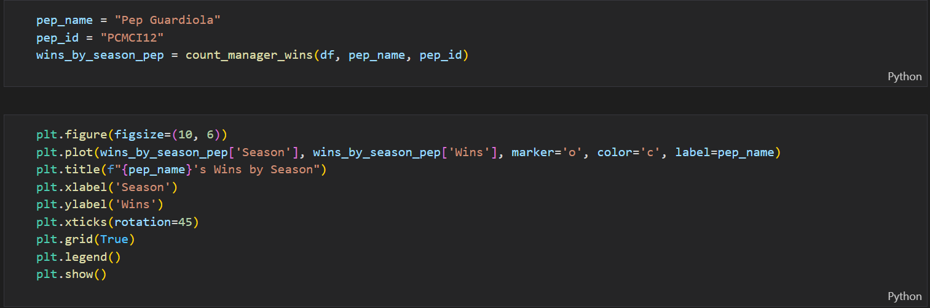

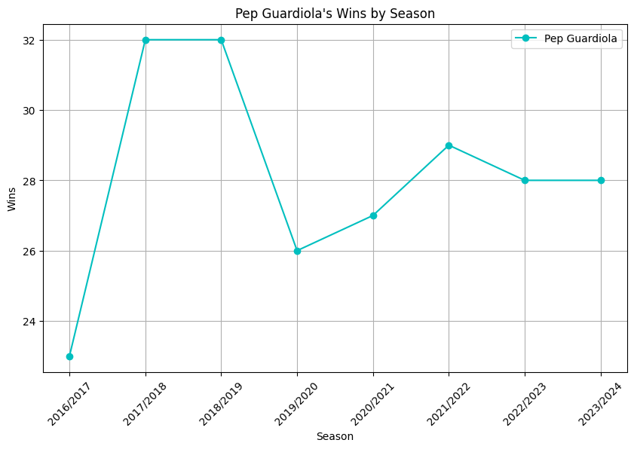

Pep’s highest win in a season is 32 and he achieved this 2 times. Definitely trumps Sir Alex in this metric. Now let’s compare two managers on the same plot. We’ll do Mikel Arteta, the leader of the new school Arsenal vs Arsene Wenger, the leader of the Invincibles.

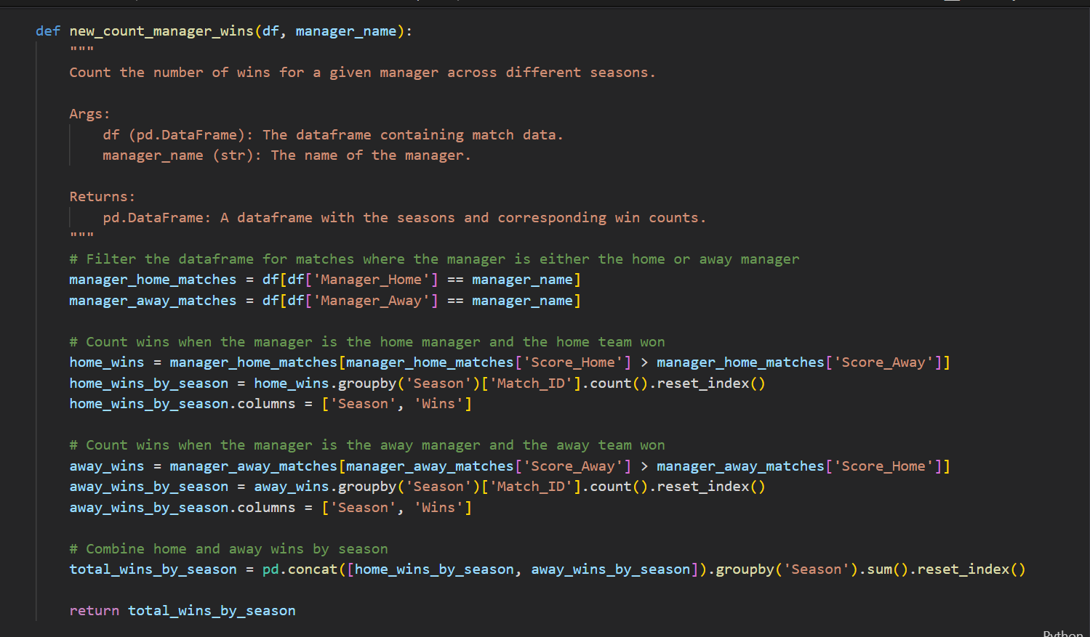

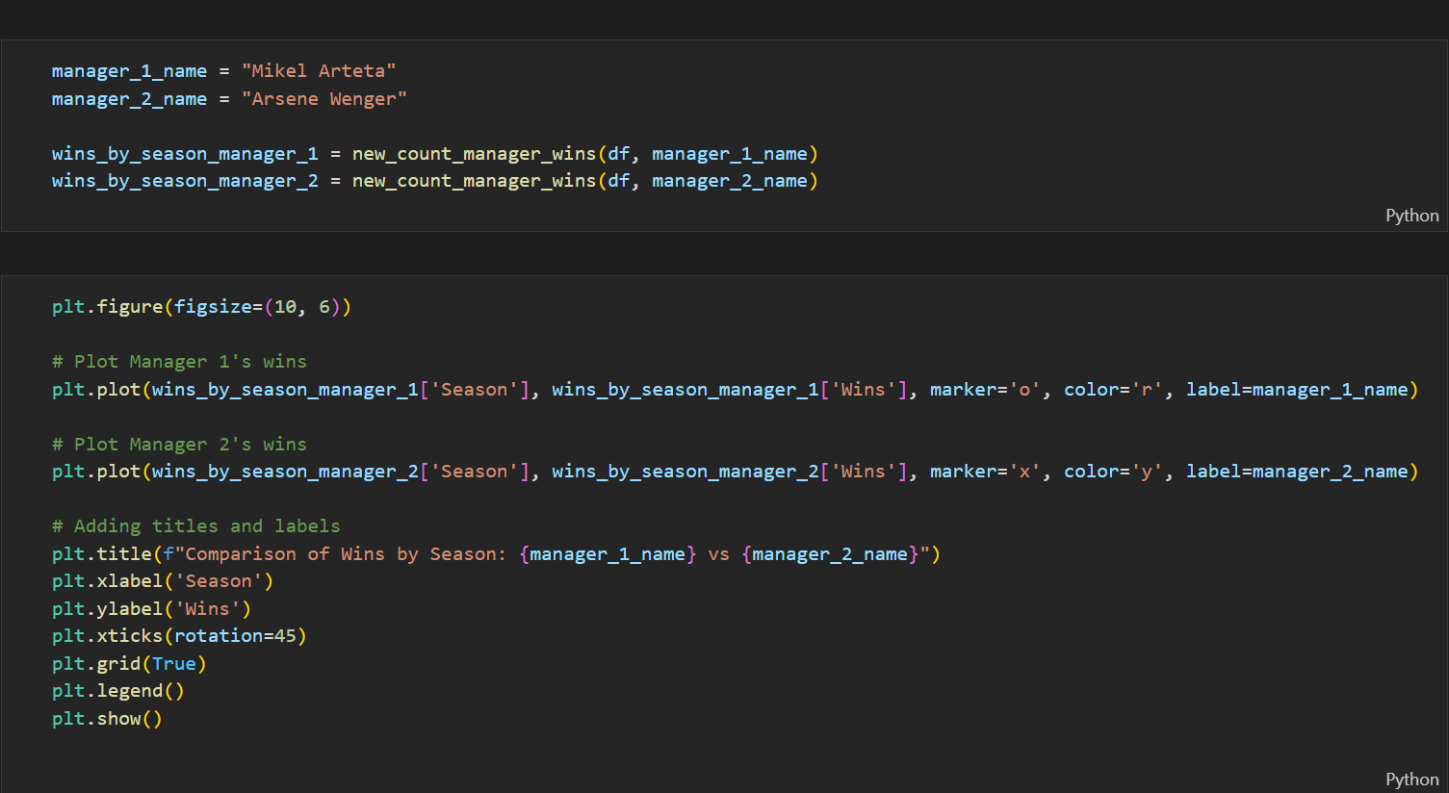

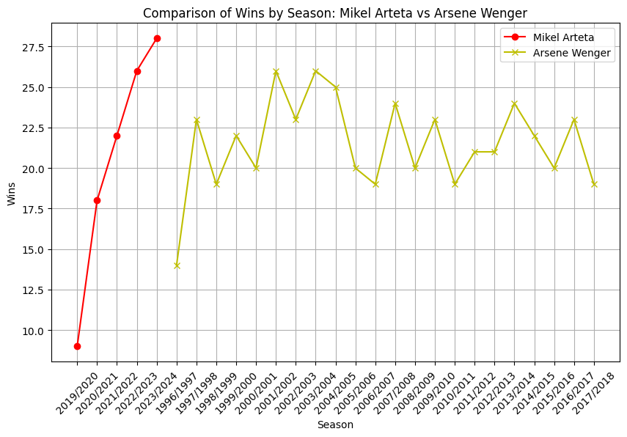

Wow! So, we can see Mikel Arteta has already surpassed his predecessor in terms of highest wins in a season. That bodes well for Mikel maybe he can reintroduce the feeling of winning to the Arsenal camp. Let’s export this data frame to a .csv file to be used in other datasets.

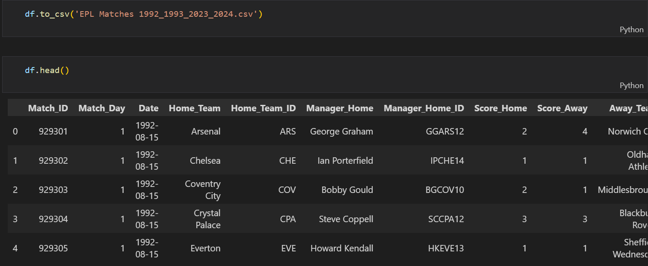

We are reaching the end of this project. I’d like to do two more things:

* Map each season a manager managed on the manager history table
* Map each manager to their respective teams on the league tables.

Let’s get to it!

1. **Extras**

Now let’s return to the manager history dataset and load the matches dataset from its .csv file.



We will define a function to map the respective seasons to each manager. So only the seasons the manager managed will be in each row the manager’s name shows up in.

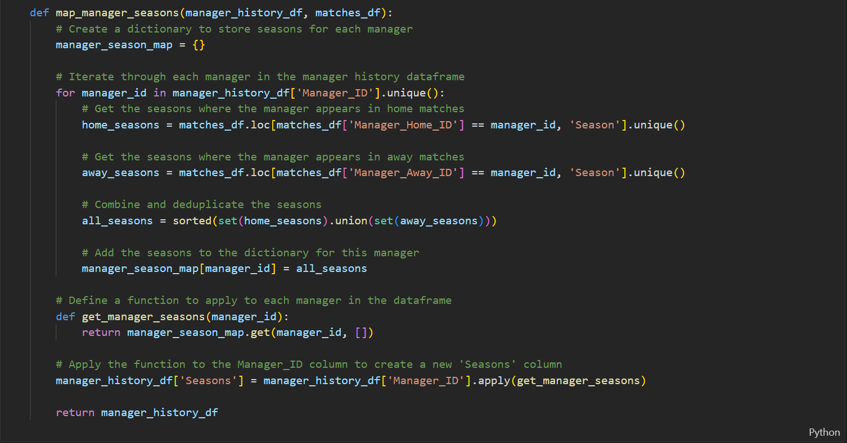

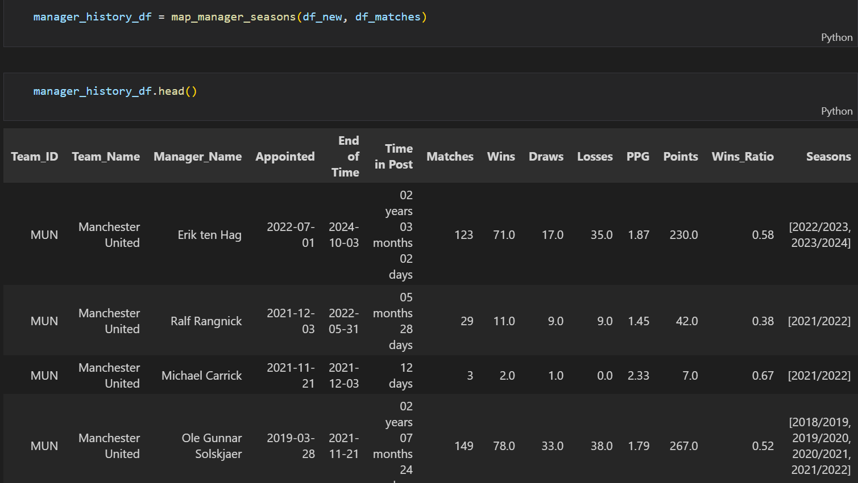

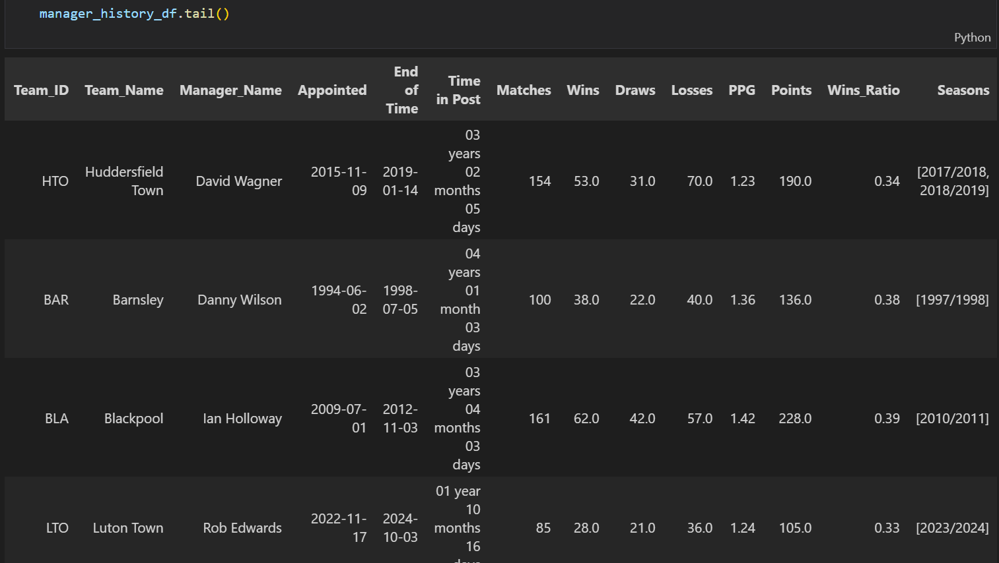

Great! Now we can export the manager history dataset to its final .csv file.



Now let’s update the league tables. We will first import the matches dataset into a data frame.



Now we will define a function to handle the mapping of the managers to their respective teams.

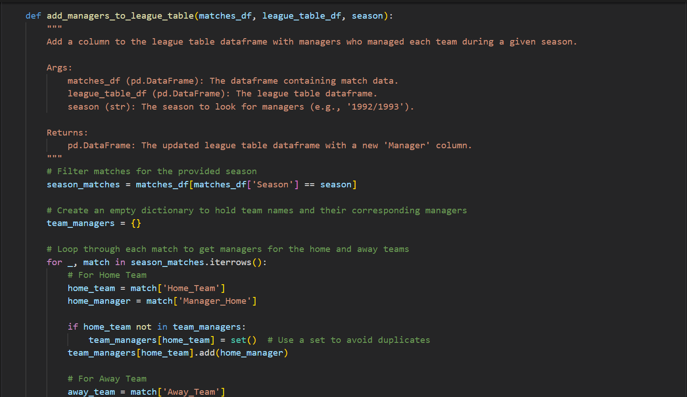

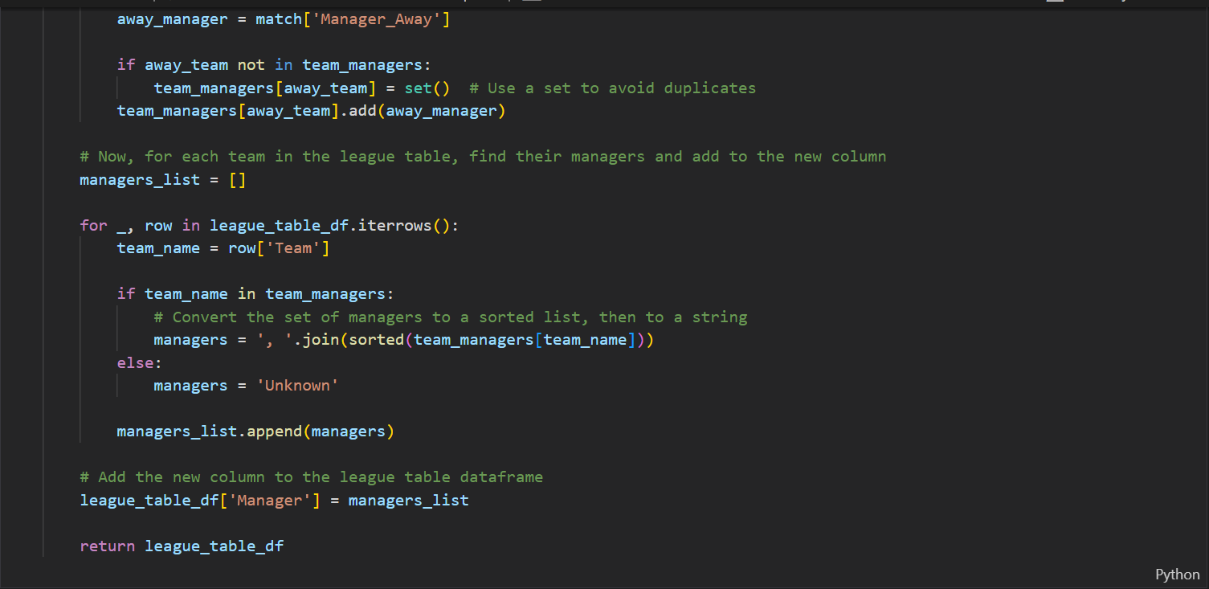

Then we apply the function and see the results.

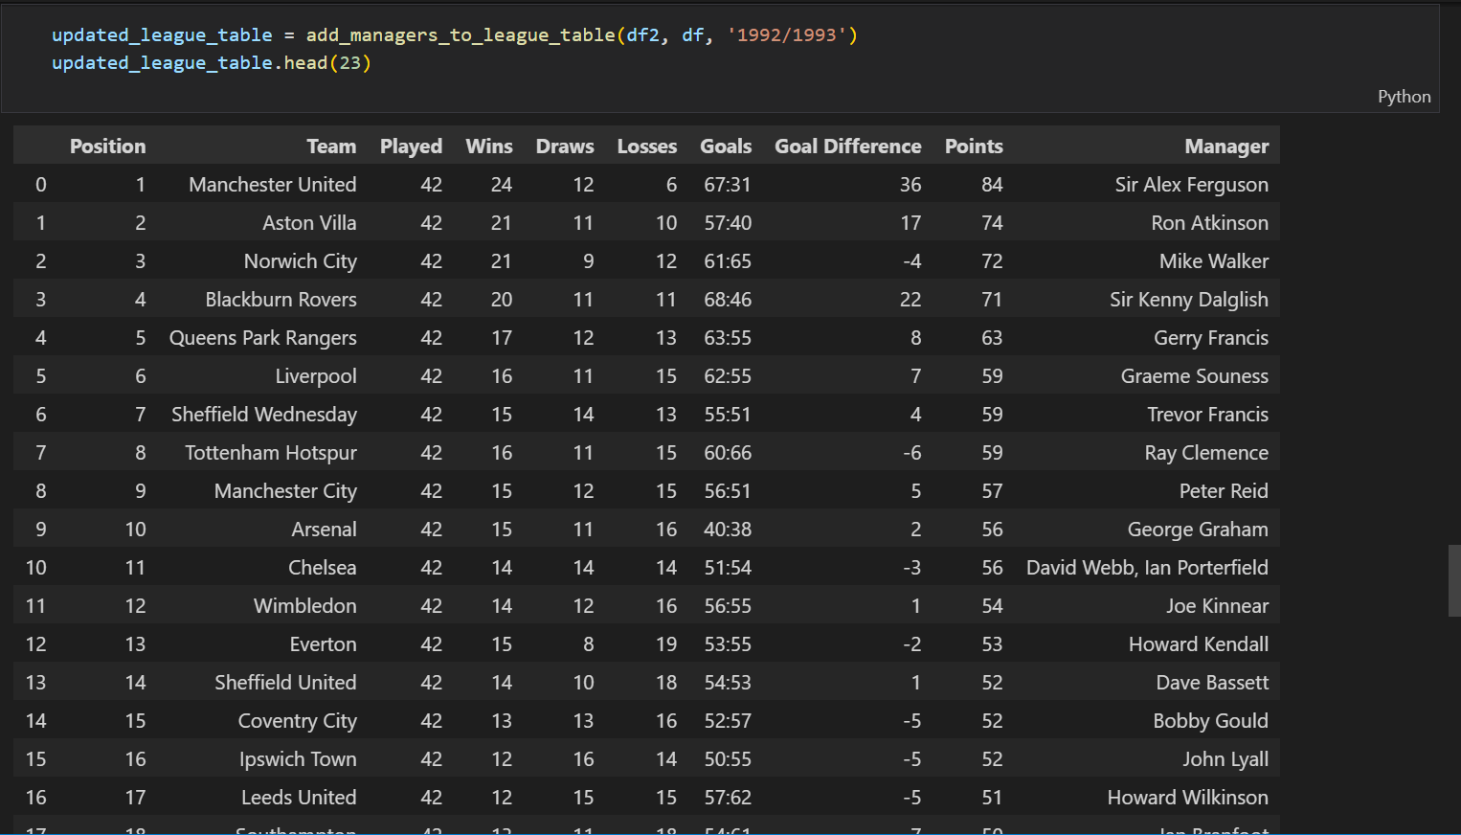

Now the last we’ll do is map the correct team ids to their respective teams and also add a column to indicate which season the league table belongs to. We will also import the manager history table.

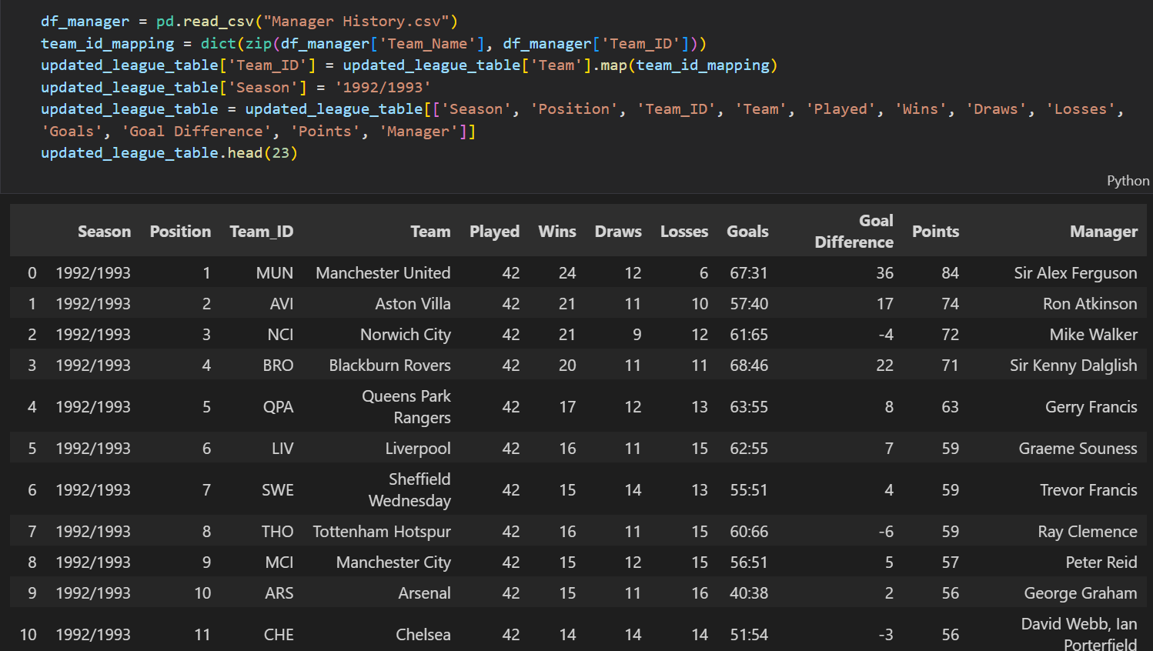

**THANK YOU FOR YOUR TIME**